November/ December 2009
NEWS FROM IAN AND SIMEA MELDRUM in BRAZIL
Birthday! 16 years of evangelistic outreach and 8 years as an organised Parish!
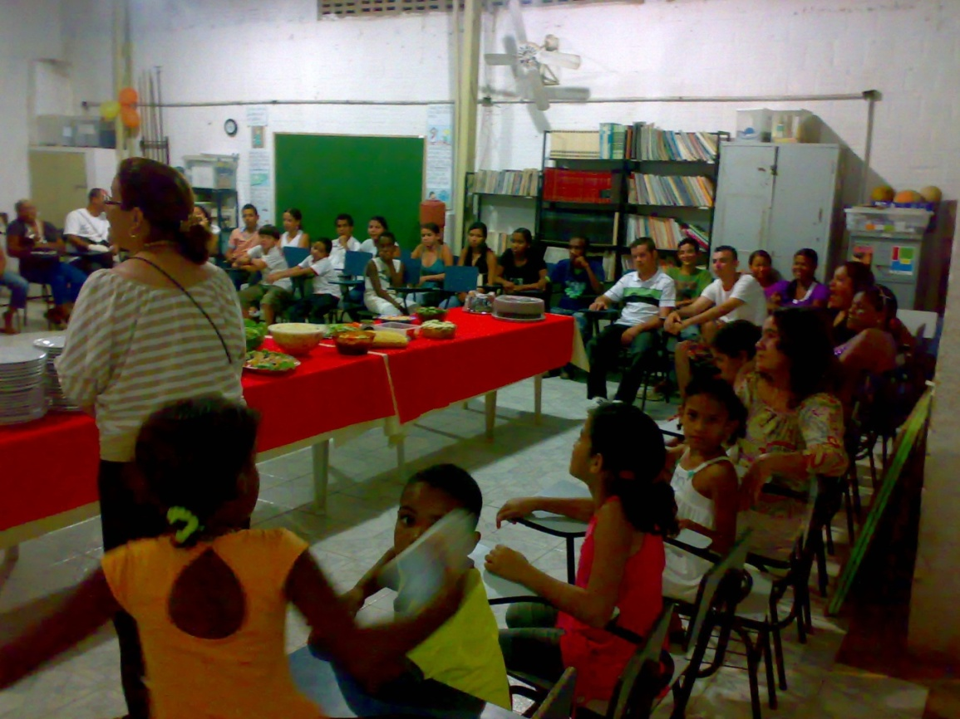
Photo – Members Meal - 16 October, 16 years working in the Olinda tip.
This year we felt the need to celebrate in a more intimate way. Generally in Brazil, the churches turn their Birthdays into big celebrations, with outsiders invited to preach, and with a great deal of publicity. But, with so many problems in the community we felt that we need to be nearer to the members, and make our celebration week a more intimate affair, with members’ Holy Communion on the 15th, on the 16th an evening meal, and on the 17th we went out into the community to invite people from the more dangerous areas to watch an evangelistic film. Six people gave their lives to the Lord, and the church was full and well behaved. On Sunday the 18th, the church was once again full, 11 people gave their lives to Jesus and are now firm worshippers at our services. We invited an evangelist, called Moses, to speak. He used to be a murderer & drug dealer, with more than 70 murders to his name and more than 800 years’ prison sentence. And by the grace of God he was transformed by the gospel of Jesus Christ 15 years ago, and has been allowed out on parole to preach in the prisons. A beautiful night!

Yet another ministry: Senior citizens Group.
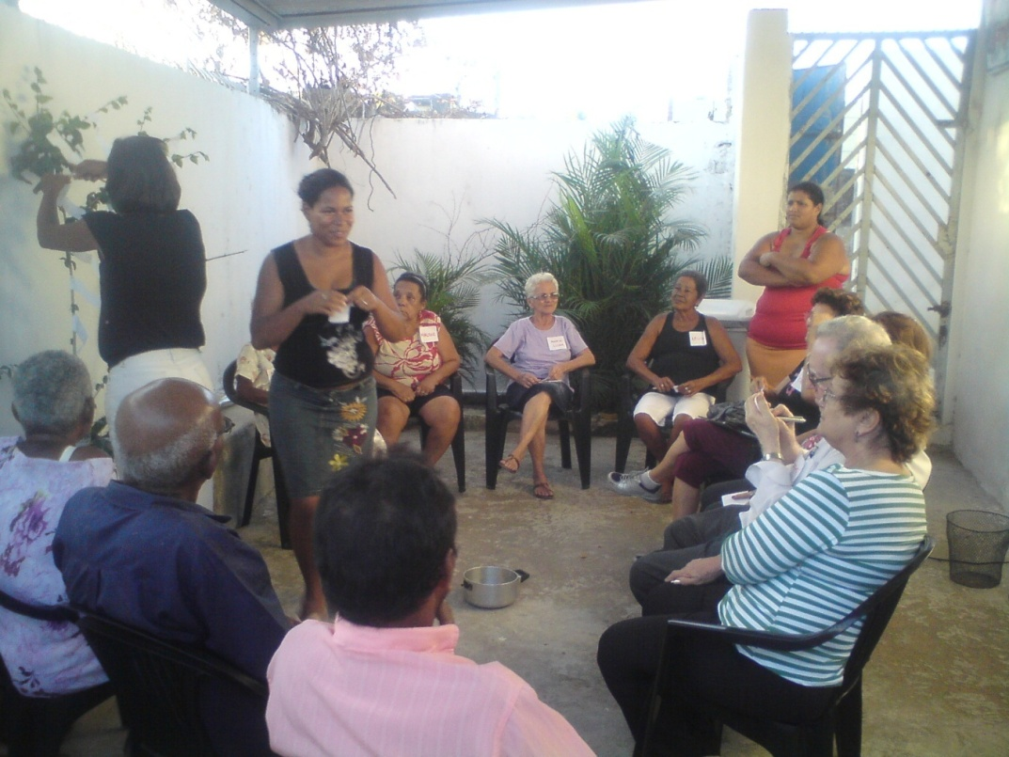
Photo of our first group meeting of seniors.
A terrible thing happens in our communities: the number of teenage deaths grows at a frightening rate. In Little Waters, 4 teens a week are killed due to drugs debts. In the last six months the number has increased and Little Waters has become the second most violent area in Brazil, with regard to violent teen deaths.
Visiting the families we discovered that in many of them there is an elderly person. People with a completely different background, values, principles, and many with a regular monthly income from a pension.
We discovered 13 seniors in our street, all over 65, intelligent people, and unhappy with the life led by their grandchildren. From this we realized that these people could help their families! But they needed encouragement, motivation, and strength. None of them were going to a church, just two were Christian and all had walking difficulties.
We invited them to an afternoon tea, and they came; some we had to collect from their homes. Juraci, our nurse, helped us as we checked blood pressures, glucose levels, weight and measurements of each one. This care and attention was much appreciated. A psychologist and a PE teacher brought group dynamics and I gave a short Bible study and invited them to unite in defence of their families. We had a blessed afternoon, our friendship is growing, and five of them have begun to come to Sunday services. Alleluia!

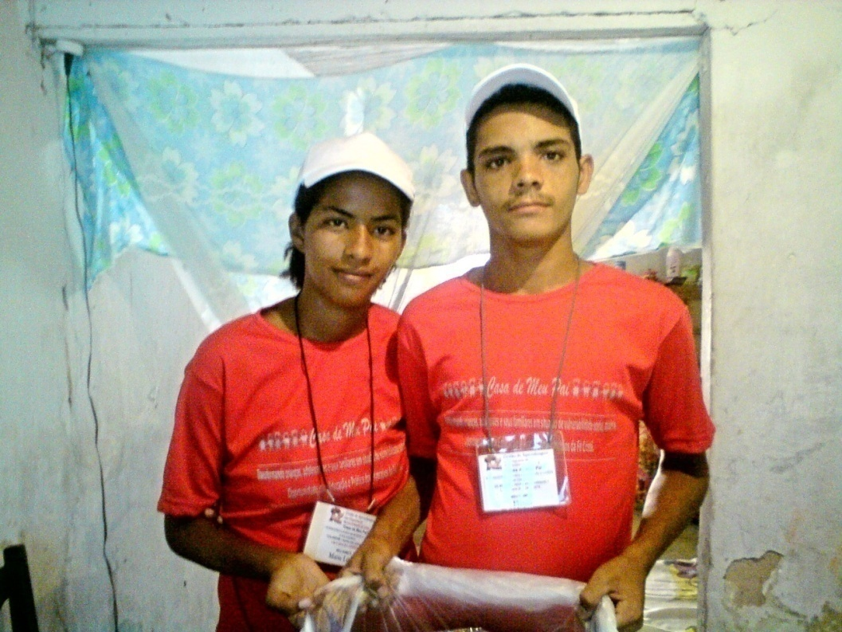
Flávio and Maria Lúcia. (Confidential! Just for prayer)
Maria Lucia is 18 and Flavio 18. Both have come to Sunday school since children, and were members of our Peace Brigade. Because of the church routine and their experiences with Christ, the two of them have managed to complete their basic education. But when they reached their teens, their families, many involved in alcohol, drugs etc, managed to involve them both first in drink and then drugs. Flavio began to associate with one of the drug leaders in the area and said that he had never seen so much money arriving every day. His associate, Geroan, Dedé and Flavio had to hide. The two families ran to the church for help. This can be very dangerous for any person who knew where they were, as those who collect the drug debts, in order to show their strength, can kill anyone who is involved, to show that nothing is impossible for them.
We rented a room for them and bought Popcorn sweets and water for them to start selling on the streets of a different suburb. We have formed a small team to enable daily visits, a short Bible study, simple accounting for their sales and domestic routine. We have organised a programme to be submitted to our NGO, My Father´s House,as the church’s name should not appear in this type of project. The NGO has all the necessary documents to function.
Flavio and Maria Lucia are happy and doing their best to keep within the rules. They ask for prayers that they may continue firm and faithful. And we need wisdom, patience, and perseverance. We have asked Andy and Rose Roberts to help us, but we need more people who have sufficient love for this work because it is not easy to be available all hours and they continue to be very vulnerable, have no domestic training or routine.
Maria and Flavio are our first students for this new project: Learning mentoring, teaching personal skills and self-sustainability. They have been given a uniform and a badge so that people interested in knowing more about the project can reach us.
Please pray for this project: we are preparing to seek help from the local authorities as there are many teens in the community in similar situations that could become part of the project. This will cost us around £600-00 a month to pay a teacher, materials and lunch. This is a challenge on top of what we already have.
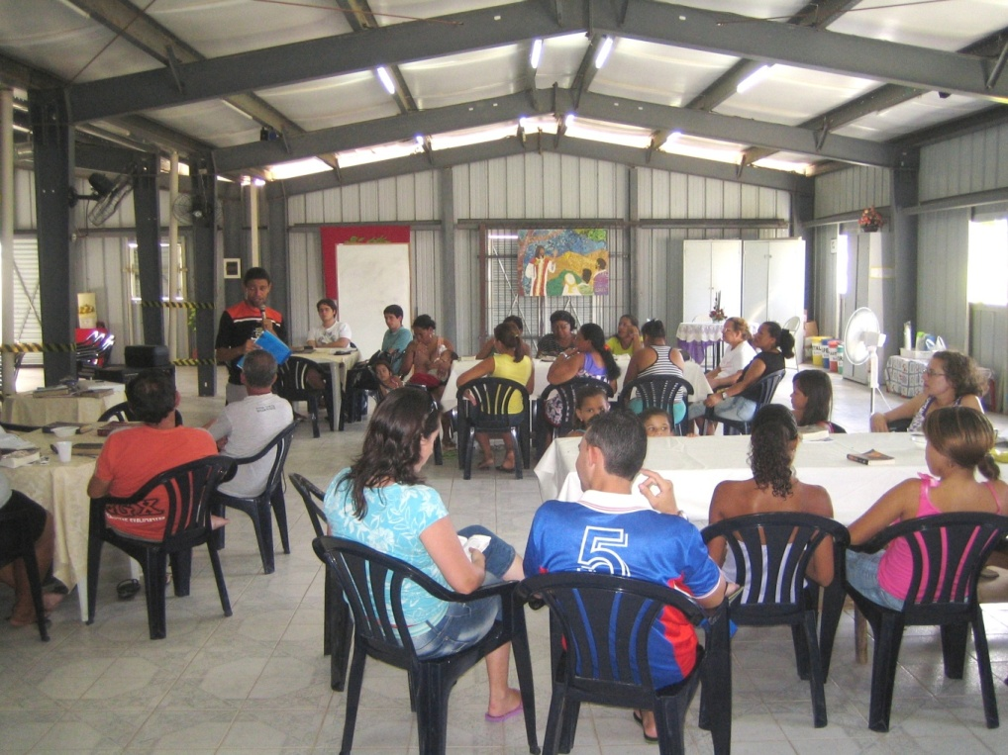
Photo: The Church Leadership group, studying on Saturday afternoons.
Training leadership in a poor community is our greatest challenge, especially for the Anglican churches. Other denominations have different methods to ours. We are much more in involved in social care. Better written studies .... a routine that requires perseverance , organization and agenda.... and this routine is not known within this community. Other churches begin their services more than 30mins late, the preacher is decided on the spot and pastoral care is done by the members, which make for considerable role confusion.
As we are entering a culture with no agenda, no preparation, planning or evaluation, we feel the resistance of these people, especially when it comes to planning, and the study of the Word is also difficult to introduce in a deeper and more systematic form. They begin to come but within a short while other priorities take precedence, which causes much frustration.
We began “Growing Together” on Saturday afternoons with over 35 people; today only 19 take part the majority of whom are teens. Even the top leaders who make up the Parish Council have become busy with other things such as visits to the Shopping Centre or domestic chores etc.
We ask for your prayers for our leaders. We feel that it is a major challenge to keep them in a routine, with planning and continuity; we cannot rely for ever on outside leadership! We do see that this church will become a sowing ground for future leadership for other areas for the honour and glory of His name.
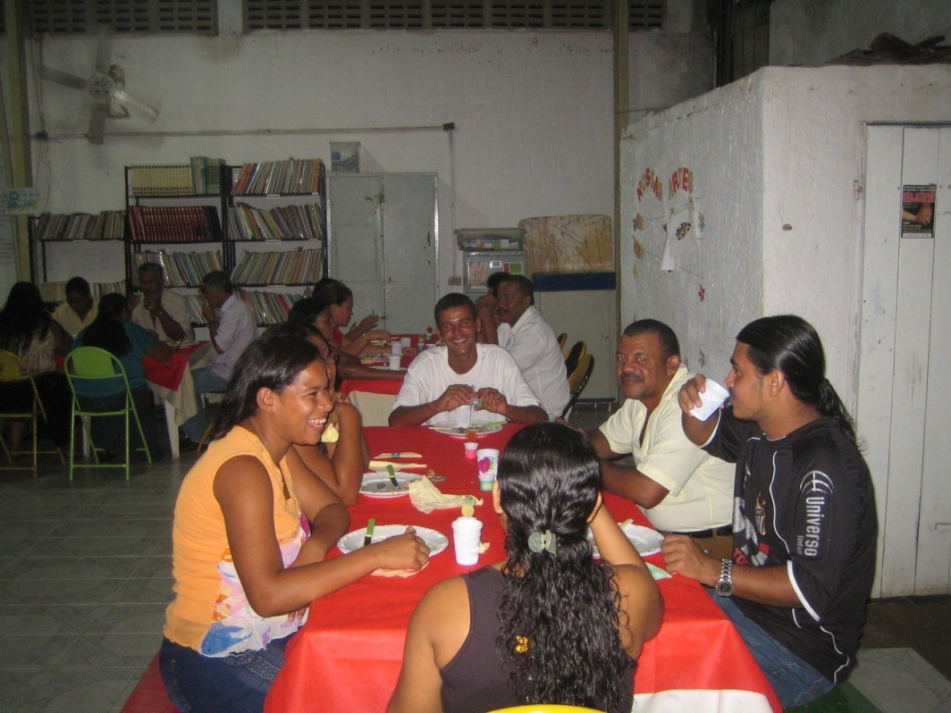
Photo: Married couples’ Meal.
We praise God for the results of four evangelistic meals for couples, as we already have four new couples who have given their lives to Christ and also some couples who are preparing for a joint wedding on Dec 12.
We have just held our 5th monthly meal together!
Transformation is a challenge and apparently impossible because it involves changing habits, culture, family etc. But we believe that fatherhood and motherhood, the love between couples, children and their parents is a necessary part of God´s creation. Work with families is a great challenge in this post-modern world, but the church must not be intimidated, as the transforming word of Christ and the witness of lives being transformed open the doors to the hearts of many. So we ask for your prayers that couples may hear the word of God.
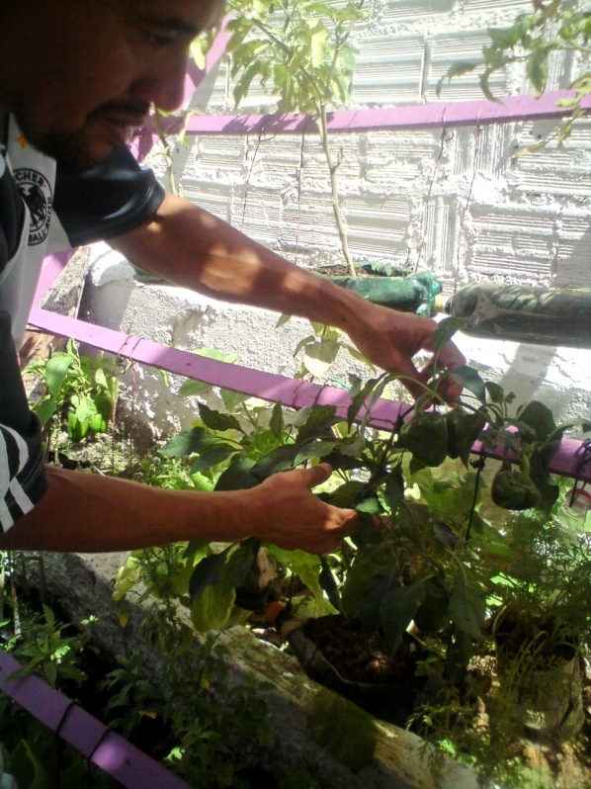
Partners that complement our Evangelism
So that the love of God become real in extremely needy lives, it is often necessary that the preaching of the Gospel be holistic, involving concrete actions like: education projects; work skills training; family health, therapies for drug dependents; and various actions that bring opportunities to families to find ways for growth and development.
We praise God for the NGO, founded by some of our members, called “My Father’s House”, through which we have access to the various social action councils and may set up social projects with partners from governmental and non-governmental departments. But also we have been establishing partnerships with other churches.
Day to day these partnerships form a network that can make the Kingdom of God visible, leaving behind earthly fame to give all the honour to the only name that has any real power to transform - The Lord Jesus Christ.
This Photo Sows Enoque, Living Waters Church Warden and monitor for our home horticultural project. Together with Claudinha and Claudimir, he gives lessons to the children of 120 families, teaching and visiting these vertical home vegetable and salad plantings, which aim to help with family nutrition.

Our Family
Photo below: Luiz Philipe [our nephew] and Ian Hudson [our youngest son]
Since July they have been in England, learning to live with an English family and trying to work and learn with The Message Trust. And we praise God for the family of Robert and Sally and the members of the church that are giving them support so that Hudson and Philippe can bring back enriching experiences to our work in Olinda. Please pray for them as they return on the 28 Dec.
John continues working, playing drums in church, and is serving as youth member of the Board of Directors for My Father’s House.
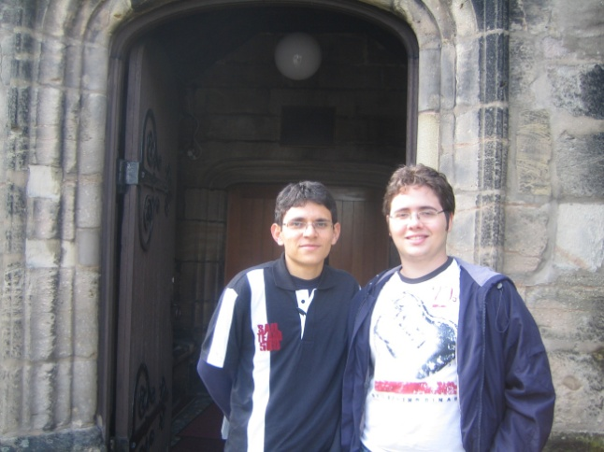
Timóteo is now 29 years old and is still our great family challenge. Calmer and trying to live with bipolar disturbances, he does not accept medication but feels that he can live a normal life. We help where we can and pray for him, believing that God has a purpose for his life. Please pray with us.

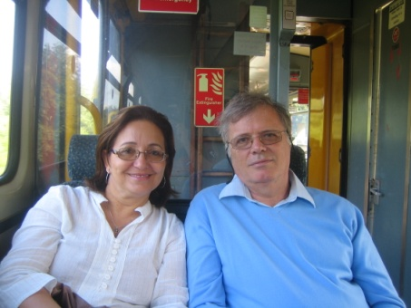
HEALTH
With age comes fragility. I am now 50 years old and note that I am more sensitive to situations that involve much stress and adrenaline . Yesterday I had tests that told me that I have gastro-enteritis As I was going into the exam a mother phoned me and told me that her son had just died. She needed our presence there but I was in the hospital with Ian. In order to look after others we need also to look after ourselves. Where is the time? And where are the other leaders, as the harvest is plentiful?
Ian is working more than ever after his retirement: leading My Father’s House, writing new projects seeking more support for the Christian Family Support Centre, meetings of the directors, leading services in the parish, teaching the Growing Together group. We really do need to find more workers to divide the load a little.
SAMS/CMS The recent visit of Bishop Henry and Josias Júnior much encouraged us. We have worked long and hard in Brazil and with the changes in SAMS/CMS we were feeling a little like strangers in the nest . We had a day with them and had sufficient time and attention from them to begin to feel part of the family. How important it is to receive visits of encouragement in order to continue. As Ian officially retired from SAMS , but not from the work, I have been taken on as a Latin Partner and we trust that our link churches will continue to support us in the same way that they have done for many years. To all of you who have walked hand in hand with us over the years, our deepest thanks and praise for your faithfulness, love and care. In the difficult moments your prayers have been our strength. May God continue to bless you as we go forward together into new challenges and gospel adventures.
Siméa, Ian, Tim, John and Hudson.

