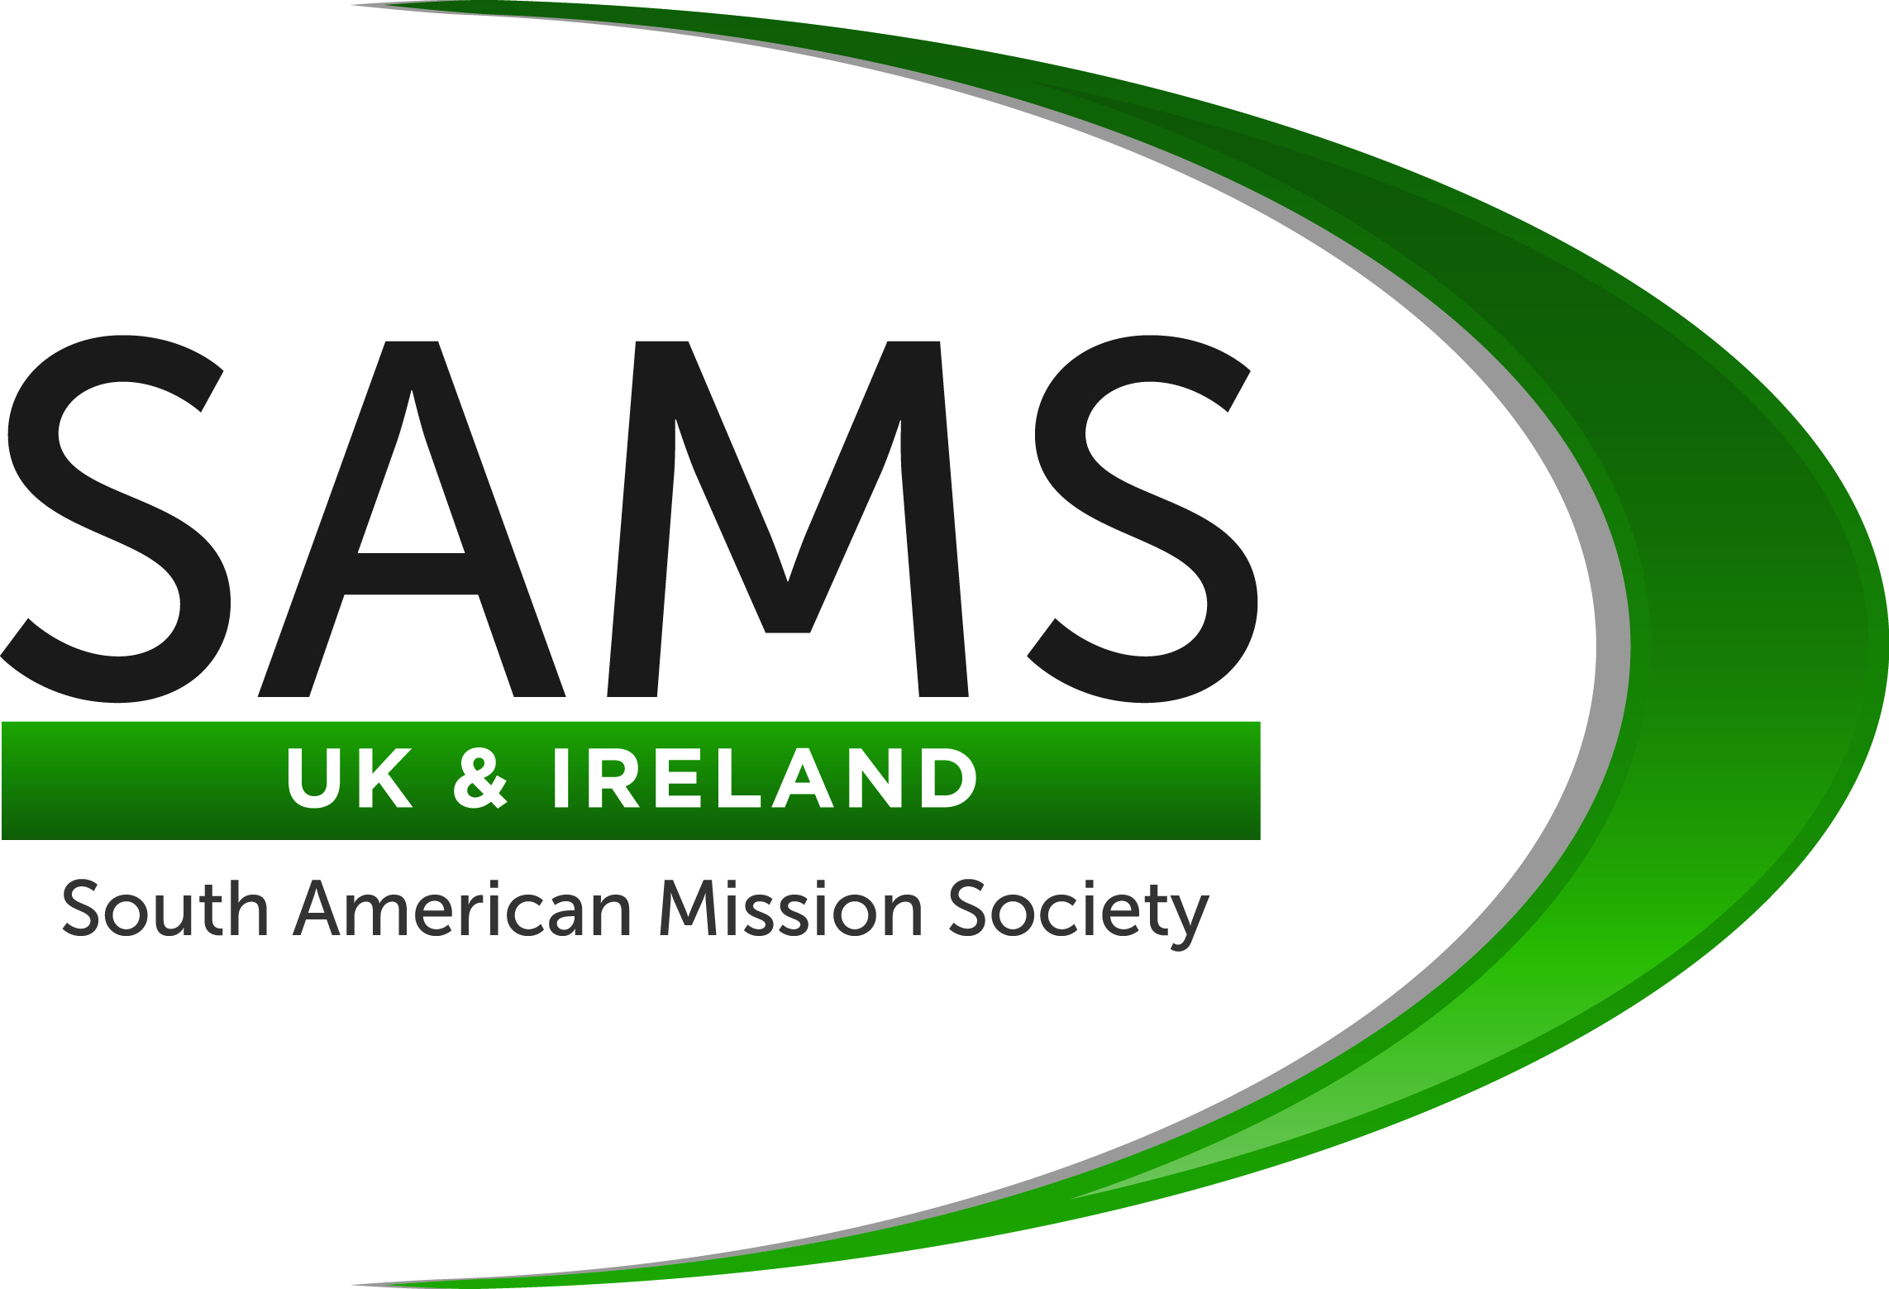

SAMS Enquiry Form

Personal Information

Name as it appears on your passport: __________________________________________________

Address: ___________________________________________________________________________

_____________________________________________________ Postcode: ________________

Home Phone: ____________________________ Mobile Phone: __________________________

Email Address: ______________________________________________________________________

Date of birth: ______ /______ /__________ Marital status: __________________________

Passport No: __________________________ Expiry date of passport: ___________________

Nationality: ____________________________ Are you currently employed? _______________

Your occupation (if a student, please state your intended occupation): __________________________

Next of Kin/Emergency Contact Details

Name: ____________________________________________________________________________

Address: ___________________________________________________________________________

_____________________________________________________ Postcode: ________________

Home Phone: ____________________________ Mobile Phone: __________________________

Email Address: ______________________________________________________________________

Relationship to you: __________________________________________________________________

General
Details of your home Church.
Please enclose a note/letter from your minister in support of this application.

Name of Church: __________________________ Name of Minister: __________________________

Minister’s Address: ___________________________________________________________________

_____________________________________________________ Postcode: ________________

Home Phone: ____________________________ Mobile Phone: __________________________

Email Address: ______________________________________________________________________

Do you have a particular role in your church? If so, please give details: ________________________

____________________________________________________________________________________

____________________________________________________________________________________

Do you speak Spanish? ______________ If yes, to what level? ______________________________

Do you play a musical instrument? If yes, please detail: _____________________________________

____________________________________________________________________________________

Do you have a first aid or other medical qualification? If yes, please detail: ______________________

____________________________________________________________________________________

Do you have any medical problems? If so, please give details below. (Having medical problems will not necessarily prejudice your application. All details will be kept strictly confidential).

____________________________________________________________________________________

Are you taking any medication: If so, please specify: _______________________________________

____________________________________________________________________________________

________________________________________ Blood Group (if known): _____________________

Do you have any special dietary requirements or food allergies? If yes, please detail: ______________

____________________________________________________________________________________

Do you have previous experience working on mission projects? If so, please give details below:

____________________________________________________________________________________

____________________________________________________________________________________

____________________________________________________________________________________

Please note down details of any skills, training, or experience which you feel may be of particular value.

____________________________________________________________________________________

____________________________________________________________________________________

How do you feel this experience will be of personal benefit to you and your sending church?

____________________________________________________________________________________

____________________________________________________________________________________

____________________________________________________________________________________

SAMS will do all it can to place a suitable volunteer but placements depend on the needs of the Church at any particular time. Short-term placements (including all travel, accommodation costs and medical insurance) are financed by the volunteer. All volunteers will be required to attend an orientation event prior to travel.

I confirm that all the information given upon this application form is true.

I have read through and understand the conditions of this Application Form.

Signed: _____________________________________________ Date: __________________________

Please return this form as soon as possible to:

SAMS House
1 Irwin Crescent, Lurgan, Craigavon, BT66 7EZ.

