
The South American Mission Society
Allen Gardiner Cottage, Pembury Road, Tunbridge Wells, TN2 3QU

news about

Julio and Norma Montoya in Lima, Peru, Harvest 2009

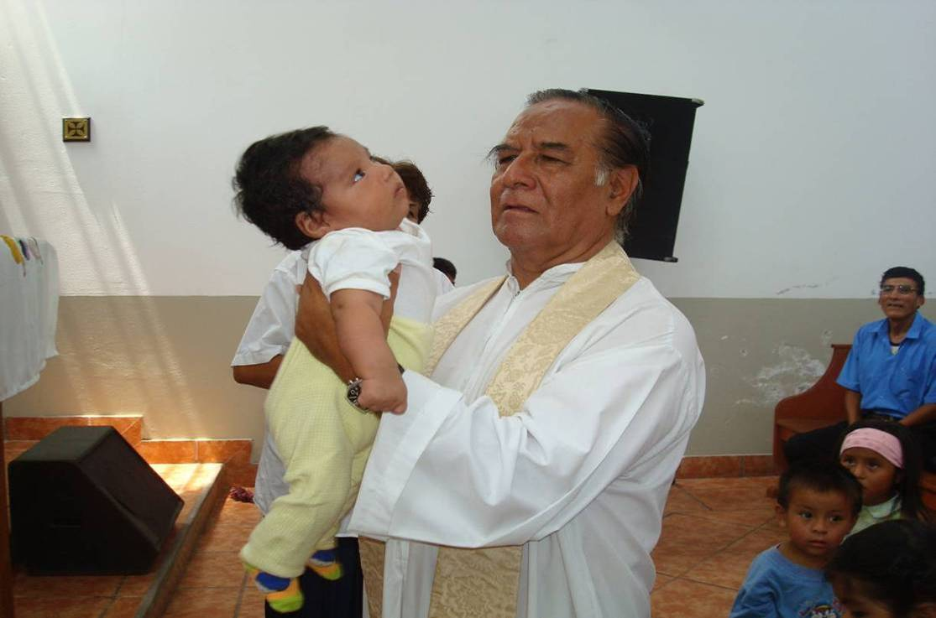
Dear brothers and sisters in Christ,

In these days of cold and rain we have been going to visit some homes that are falling. Our calling is to continue helping them. Thanks to you for your provision.

I report that in our church (Holy Trinity) we are working in the prayer groups three times a week. It is uplifting to pray in the homes of our brothers and sisters. And with the grace of God we continue working in the missions in this period of cold. We raise up the word of our Lord Jesus Christ. Alleluya. May our God be exalted for ever. [As I edit, I have received an emergency call for material help for 10 collapsed homes – 22 July 2009 Gerry – we have sent immediate aid]
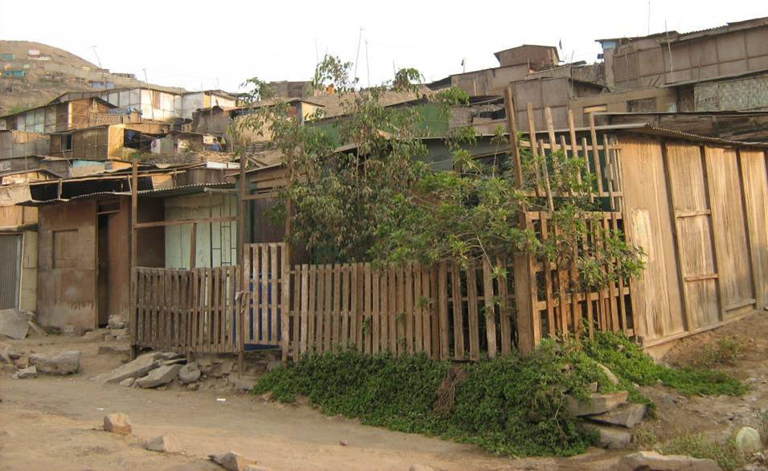
A typical home in the areas of the missions

We are working in ‘The Valley 2000 Mission’, ‘The Summit Mission, ‘The Rocks Mission’ and ‘St Paul’s Mission’ (the Chancheria). We are happy that the people turn up every time we hold a service of adoration (praise) to our God. In the week that passed we bought plastic sheets and shelter for them and they left very happy. Our daughter Erika visited the elderly. She took them food and shelter. On the other hand we are working in prayer groups with some parents of children in the Child Day Care Centre that we are visiting.

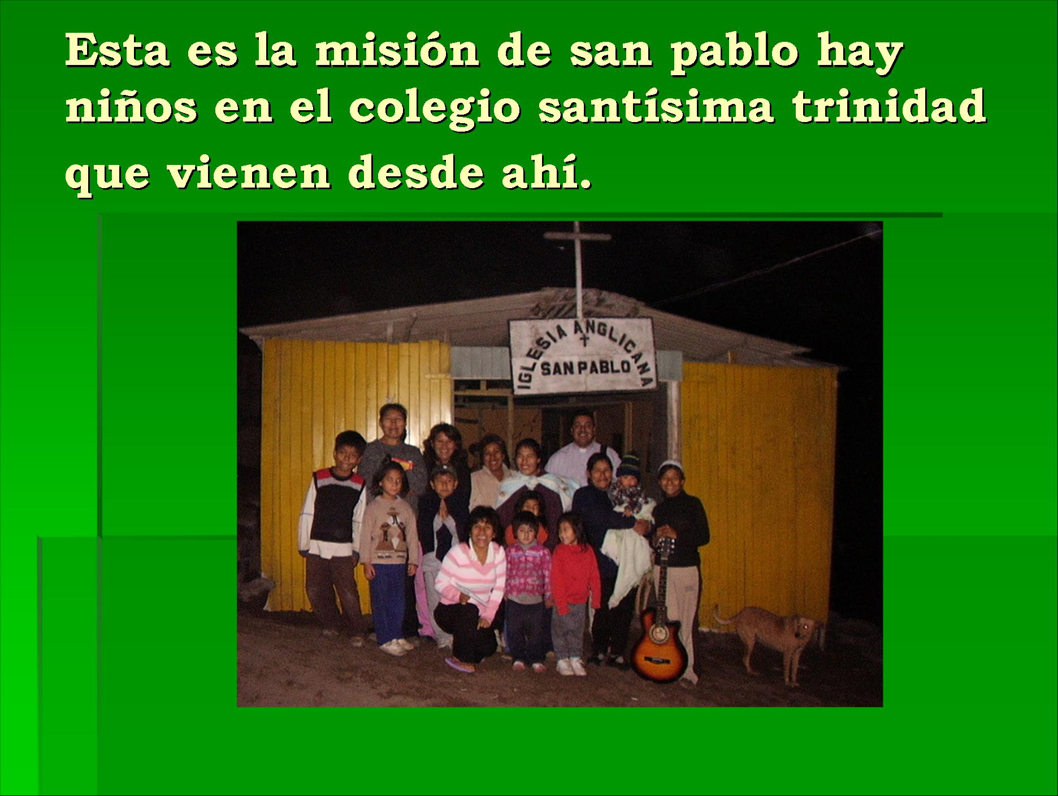
‘This is St Paul’s mission. Some children in the Holy Trinity School come from here’

Thanks to Evelyn and her prayers some people feel committed and strengthened in their faith in continuing praising God. Each Sunday we must pray for the work among the poor; we must pray for supplies and for the people that give us their love like yourselves.

In Christ Jesus

Pastor Julio Montoya Lira 21 July 2009

News from Isabel Montoya regarding the Day Care Centres in Arequipa

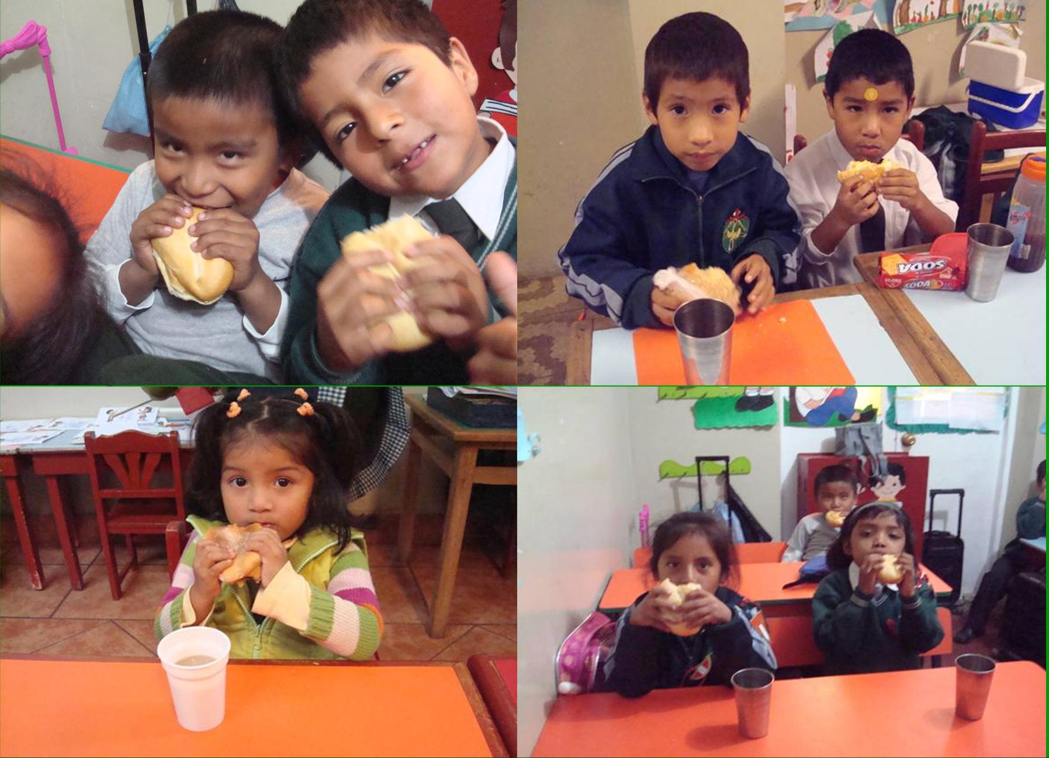
Beloved in Christ Jesus,

I share with you that we go on giving breakfast to the children and we make it very nutritious. They are growing healthy and strong, ready each day to receive their lessons. The past week we weighed and measured them. All are well, thanks to God and you. The breakfast is very important since it helps the child to be better in their lessons. Before they would even sleep and grew tired very quickly.

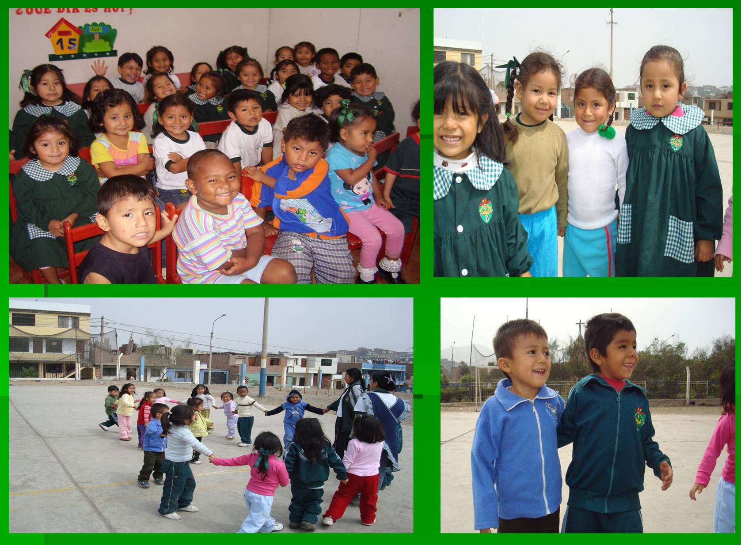
Now we are in a period of cold. There is much fear in the population about bronchial illnesses and a virus like H1N1. Already many are infected, and several are dead from this sickness. We must lean on God in prayer that he protects his people. We are teaching the children to prevent illnesses through educative talks in a suitable way with our community’s health post. Also the children were vaccinated against influenza.

Day of vaccination against hepatitis B
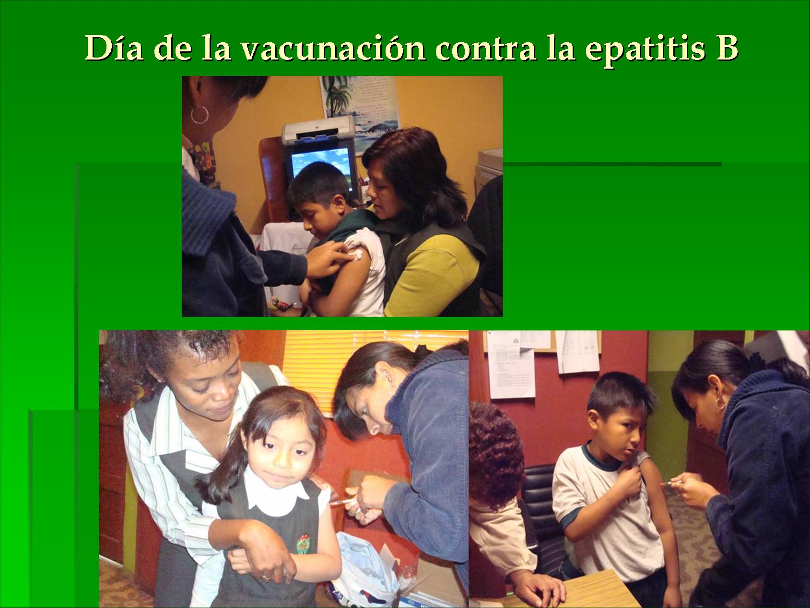

Thank you brothers and sisters for your help, your gifts.

Thanks to all those who help us to increase each day in the work with the children and their families.

The Lord bless you and fulfil the desires of your hearts.

Blessings.

Isabel Montoya de Sanchez 17 July 2009
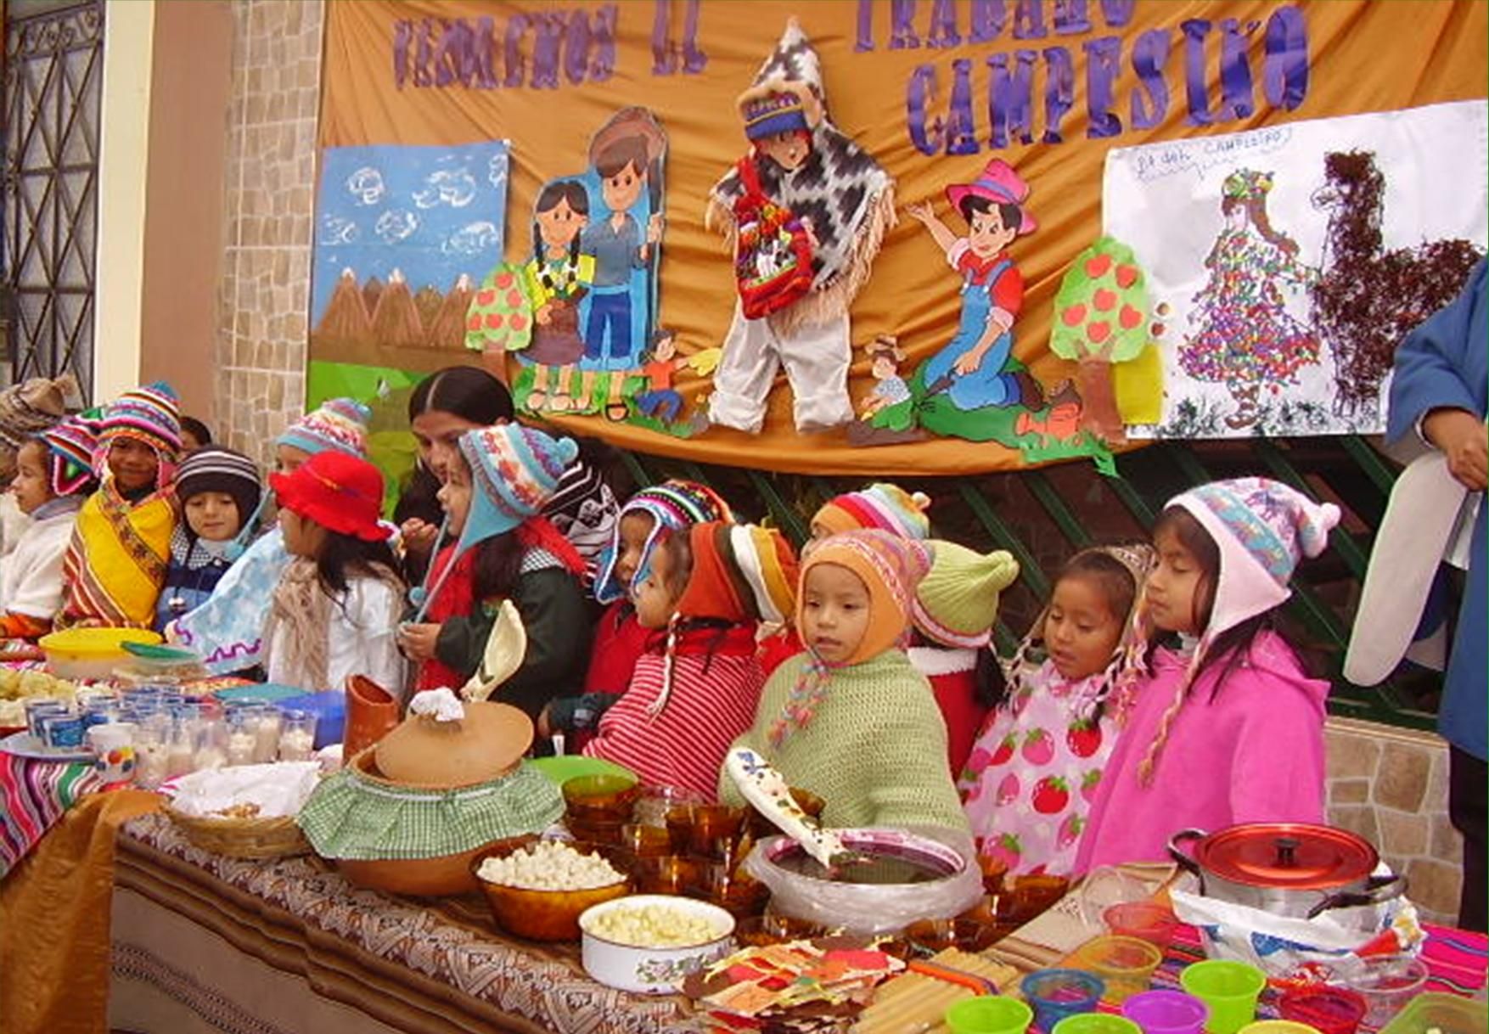
Celebrating the harvest of Peruvian countryfolk, in traditional dress

The South American Mission Society
For support through SAMS for Latin Partners please SAMS at:
Registered Office: Allen Gardiner Cottage, Pembury Road, Tunbridge Wells, Kent, TN2 3QU
Tel: 01892 538647 Fax: 01892 525797 Email: finsec@samsgb.org

