Hi everyone,
In our last news we mentioned and asked your prayers for Ivson Who was due to have an audience on the 26th 04. In fact that audience was canceled after a four hour wait at the court house! However this last week the audience took place with the following result:
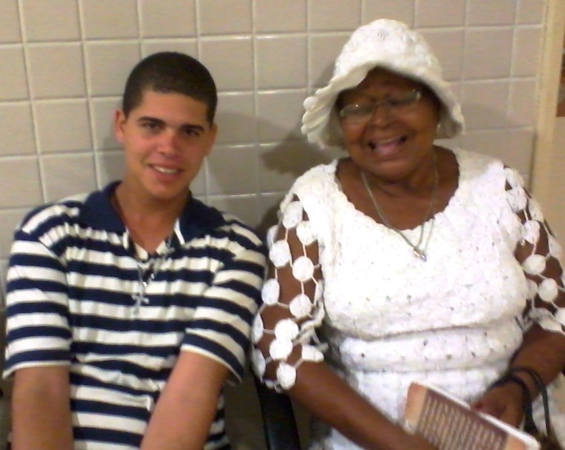
Ivson and Dna. Jo - Two transformed lives
When we first met Dna. Jo she was a very different person, a “Mãe de Santos” Spiritist leader involved in divination and black magic. As a result her life had become one long tragedy, losing four sons through violent deaths, and a daughter Ivson s mother with severe mental health problems. Through the ministry of Siméa and Living Waters Church today Dna. Jo knows and loves the Lord Jesus, and lives a completely transformed life.
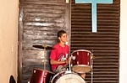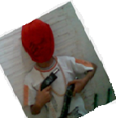 Ivson came to MFH when he was 12 yr old, the photo on the left shows him at that time holding homemade guns provided by the man who was living with his mother at that time. During his five years with us he has excelled with his musical talents playing guitar and drums.

The top photo taken with his grandmother while waiting for his audience with the Child welfare Judge.MFH has built up a good working relationship with the lady judge over the years and our recommendations were fully accepted by her.
So Ivson is now living with his grandmother and MFH has agreed to supply two monthly reports on his progress for the next six months.
For five years of tour prayers and sacrificial giving with give thanks to the Lord and to you all in Jesus name.
Many thanks,
Ian and Siméa

