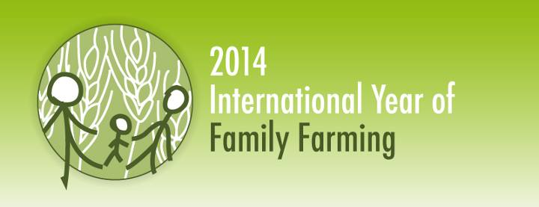
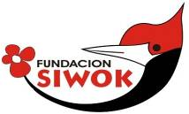

“YACHUYAJ WO” GARDEN PROJECT
JUNE 2014
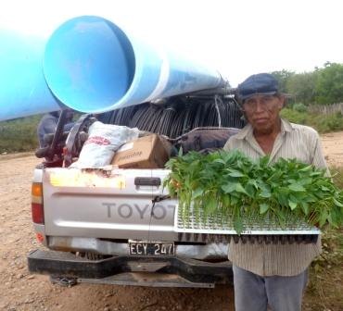
Access to water and family agriculture, basis of our service to the Wichi.

After our Christian testimony to the Wichi, it seems that helping the people have better access to good water is second in the list of our impact with the Wichi families. Having understood this has meant that we are putting more effort to provide this better service. We have now hand tools to bore wells and 3 perforations have been made.
This has been part of a project we coordinated between 4 institutions: The Misión Chaqueña Wichi Community Association, INTI (National Institute for Industrial Technology), CREAS (is an initiative of the Church World Service, an echumenical organization) and Fundación Siwok.
The results are very positive with 3 pumps made and a 4th one (done deep in the forest with a solar pump) is on the way.
You can see how the tools work clicking on this link:
https://www.facebook.com/fundacion.siwok#!/photo.php?v=477147275744364&set=vb.100003472876345&type=2&theater

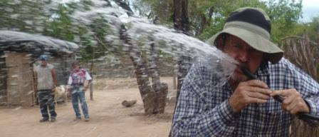

And 2 pumps working:
Nak Wo crafmen pump:
https://www.facebook.com/fundacion.siwok#!/photo.php?v=483014708490954&set=vb.100003472876345&type=2&theater
Diaz family pump where the water never got to:
https://www.facebook.com/fundacion.siwok#!/photo.php?v=512054545586970&set=vb.100003472876345&type=2&theater
A 3rd perfortation has been made to study the aquifer and have technical data that can be used for government projects. If you understand Spanish this is the explanation of the INTI technician:
https://www.facebook.com/fundacion.siwok#!/photo.php?v=502568833202208&set=vb.100003472876345&type=2&theater

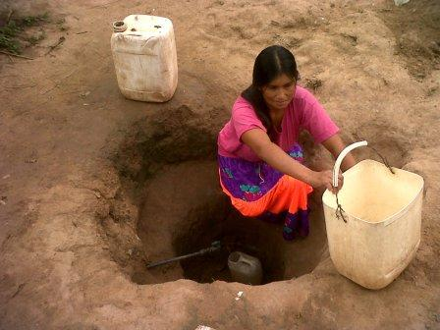
Results show that these 21 meter wells produce 6000 liters per hour. This is very good and could eliminate all water problems for the Wichi in this area near the Bermejo river.

The photo here where women have to dig for water in the main pump should be history. We are proving that there are no excuses for lack of water in this zone.

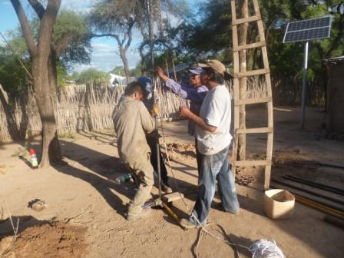
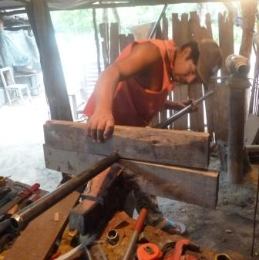

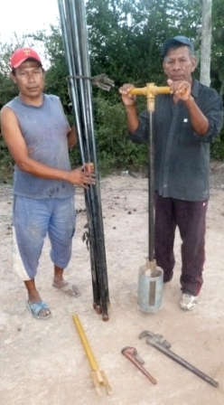
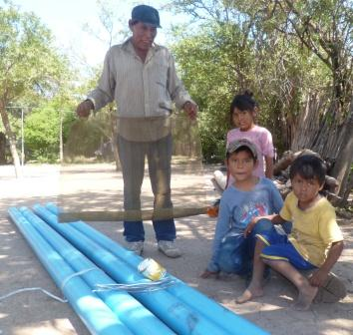
Water for Misión Chaqueña.

Here tools and materials for underground filter.
Water is pumped by a ¾ HP electric pump.
If we have water we can have agriculture products. That’s the idea…

Here below plastic for green houses, piping and tomato seedlings. Below left our working horse with 6 1100 litre drums. My wife said she would not drive with me this way!!

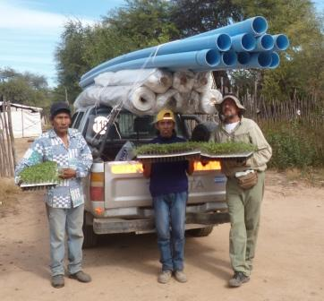
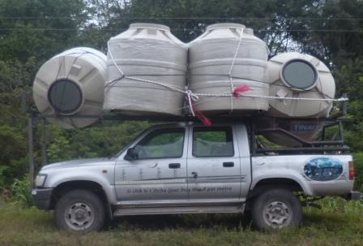
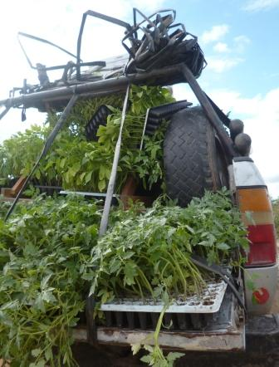
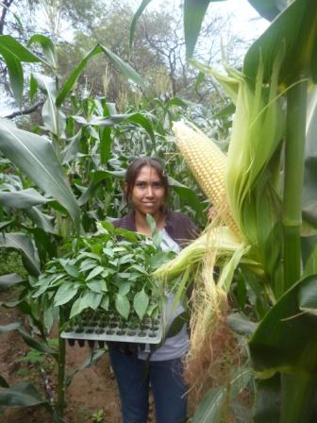
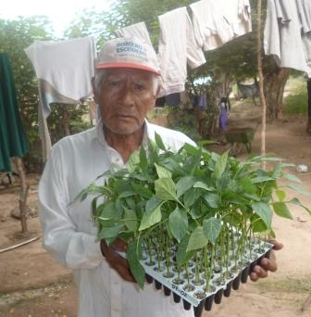
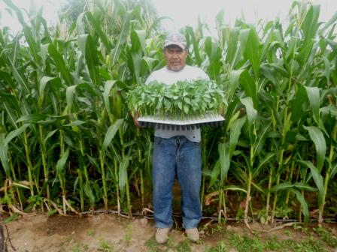
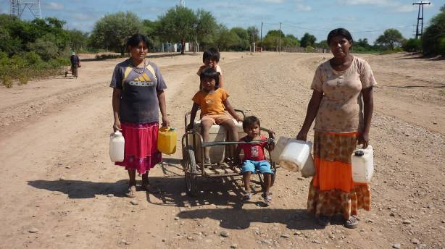

Gardens don´t just appear by chance. We have to help the people to have the water, tools, seed and the “know how” to be able to do the job.

Here left, a classic shot, are women going to the water well to fill their containers.

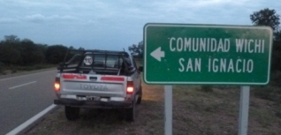
Our work in the San Ignacio land is going well. This land, bought in the 70s by the Anglican Church social program has been off the beaten track as to development and we are going ahead with the same type of economic development based on agriculture. The Wichi way to avoid conflict is to leave and set up home somewhere else. This is part of their nomad culture and is happening in this land. We have helped a big group that resettled here now with seed, irrigation equipment for maize and pumpkin in the summer and now the winter crops with plastic covering.
+
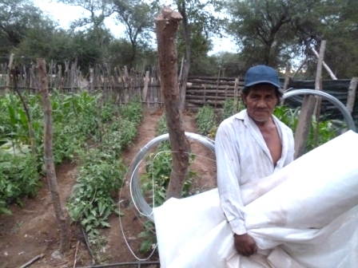
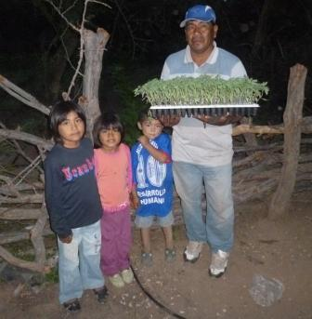
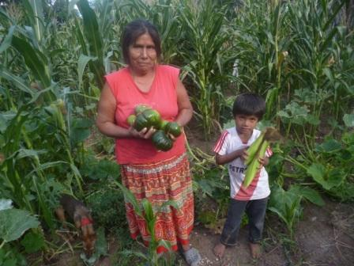
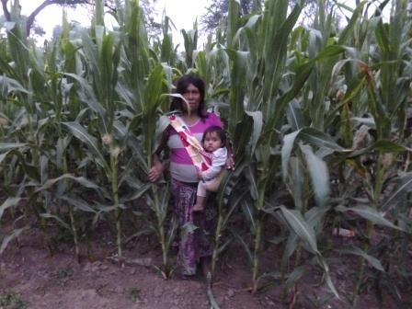
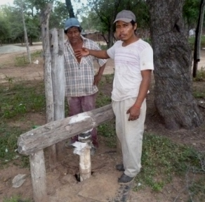
As they are on a national highway they for sure will be able to sell their products direct and that will give them the needed income. There are two abandoned hand pumps (photo below
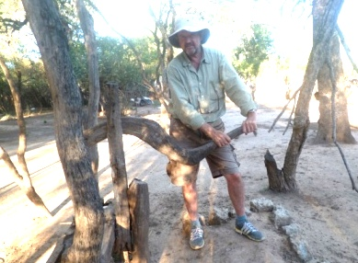
left) which puts all the effort on the only electric pump. We hope to put to work our hand drilling equipment here also and do a new well.
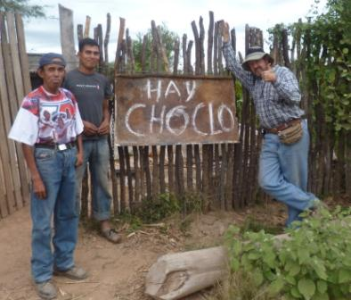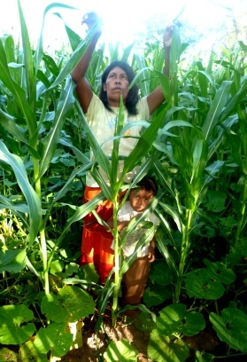
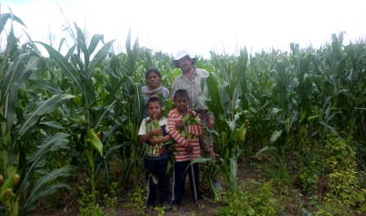
“HAY CHOCLO”: There is maize on the cob. I love the sign! It means that we´re working!
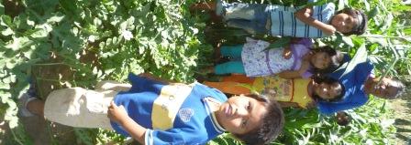

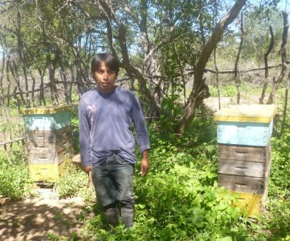
These are summer crops that have just finished harvest. Here left is a photo of Pento Cabral, a young Wichi that we sent to the south of the province of Buenos Aires to gain practice in honey production. He now runs these hives but wants to learn more as honey (with crafts and this new agriculture) is the proved method of generating income/food and combines well with family agriculture. At this moment (3rd of June) we are having a training course for interested Wichi in honey production with a long time friend NGO FUNDAPAZ. Working together should be the way ahead.
Below photo of Antonio Gomez, our right hand man in Misión Chaqueña. See Antonio´s greenhouse clicking: https://www.facebook.com/photo.php?v=539423299516761&saved
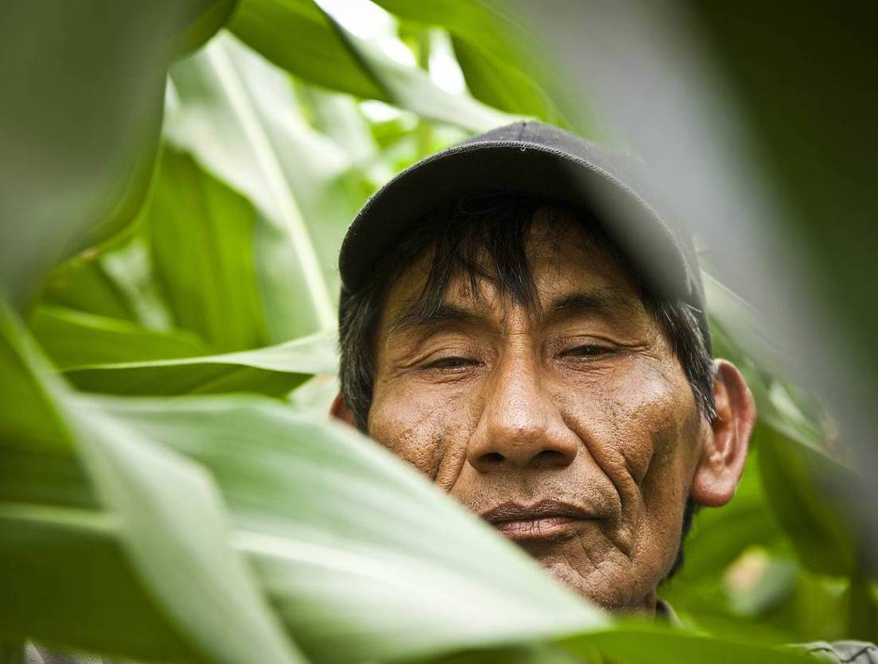
Maize production is culturaly acceptable, simple and highly productive with good seed, goat manure and water. See these crops with no insect attack due to the good seed.
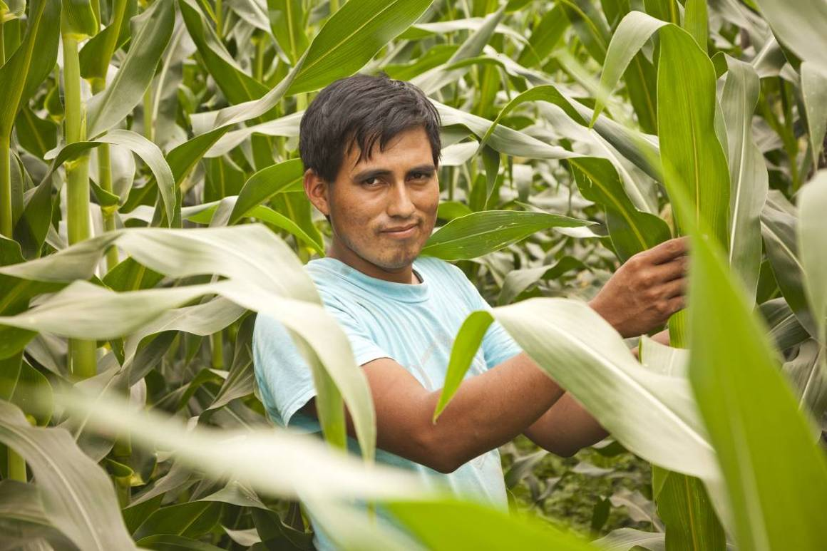
Juan Herrera above in the maize plot. 2 Fotos thanks to Alejandro Wirth
Pilcomayo
In my last trip up to the Pilcomayo comunities I had seen a big need for new hoses to take the water from the pump to the gardens. I had made a point of not going back without these 2” hoses because I had received strong words from the family chief.
https://www.facebook.com/photo.php?v=463999360392489&set=vb.100003472876345&type=2&theater
So I took 600 meters of piping on the roof of the truck plus tomato seedlings and some plastic to protect the plants from the coming frosts. It was a muddy road and the trip that should have lasted 3 hours took 7:
https://www.facebook.com/photo.php?v=539413842851040&set=vb.100003472876345&type=2&theater
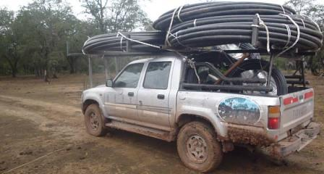
There are big needs in all the Chaco communities and it´s little that one can do alone. We are getting together with other 8 NGOs to present a program to put water needs high on the agenda for politicians.

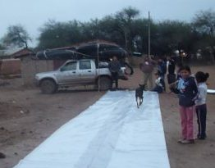
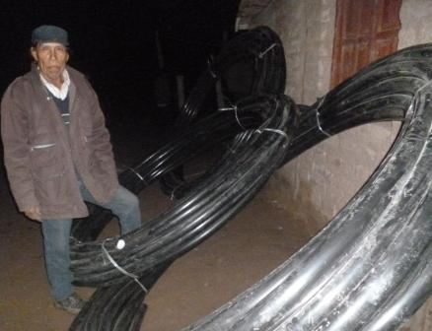
Here left we are measuring plastic to cover the seedlings. In 80 days they should have a good harvest, if the frost doesn´t burn them. Left my friend and brother Facundo with hoses we were leaving in the community. I had to get to La Curvita on time because we had organized a meeting with the three NGOs working the area. Fundapaz, Asociana (the Anglican Church´s social arm) and Fundacion Siwok. Us three, with the coordinator of the Pilcomayo Communities Organization Lhaka Honat. This is the land the Wichi are asking as theirs and have been in conflict with the government for the last 25 years. What had happened was that there were funds available for “reconverting production” for the criollo cattle man and funds for the Indian communities. They asked Lhaka Honat what they wanted to do and the answer was that they wanted Siwok´s agriculture. This comes from the Wichi and is VERY IMPORTANT for us, showing the value the Wichi are giving our “Yachuyaj Wo” project.
It´s in Spanish but you can hear Rogelio (treasurer of Lhaka Honat) speak of their decision: https://www.facebook.com/photo.php?v=539279409531150&set=vb.100003472876345&type=2&theater

Here below the empty truck outside Cris and Helena´s house in Santa María. Having them there has been a real blessing as it has connected us to the local church and that has been a vote of confidence.
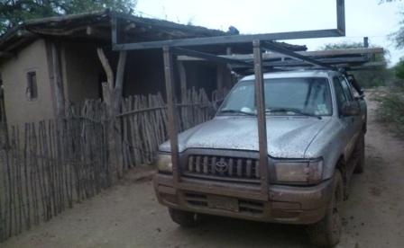
When we started this nobody believed that we could do agriculture with hunter gatherers but we have proved them wrong. I believe the main reason (which is difficult to explain to government officials or development workers) is that we are members of the Church.

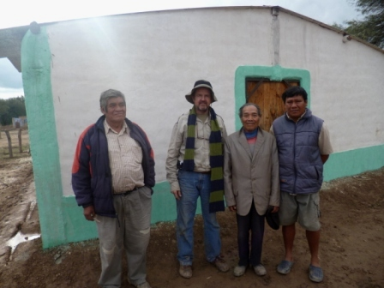
Here is an example of what I mean: This group (photo right) is Francisco, the pastor and his son, and me. They were just about to inaugurate this church building behind us, recently painted.
Cris had told us that they needed plastic for making a protected area for the visitors that were going to arrive from far away for the inauguration event. I was out looking for this thick plastic that is used now to store grain in rural Argentina and when used is ideal for roof and walls.

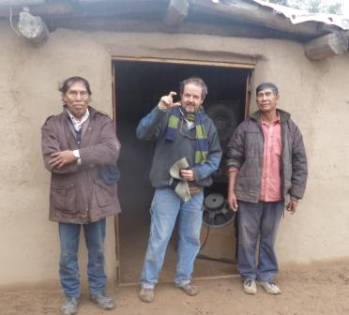
Facundo, my companion on the trip, is a true believer and when I mentioned this just before leaving his house in Salim. He thought about the problem and went into his home and brought the plastic we needed for the church.
This group of Christians that received the gift were very gratefull and the door is open now to do development work with family agriculture.
It´s interesting, I now get text messages from this far away place saying that they are all ready to sow once the frosts finish. Nobody in this work has this privilige.
Here above is Facundo and Constantino with another curch building about to be inaugurated in Santa María. Here the music: https://www.facebook.com/photo.php?v=539334326192325&set=vb.100003472876345&type=2&theater
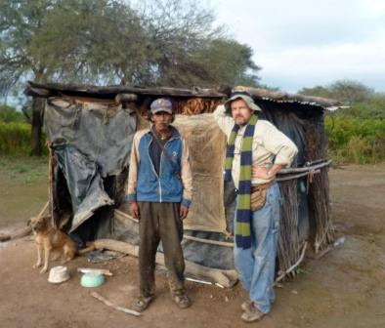
This man in extreme poverty has his own garden compound but no support for seed or tools. He is very thin and Francisco suspects it TB. We will be helping him this coming season.

In the link below you can hear Francisco Perez talk about this Project and the future for the communities. https://www.facebook.com/photo.php?v=539208619538229&set=vb.100003472876345&type=2&theater
He says: “I´m F. P. coordinator of Lhaka Honat (Our Land). I think it´ll be a short time till we are given our land. We have to have a plan for development and we have to experiment on what to do. We are doing this same experiences in various plots with agriculture. With the Siwok Foundation we are working for over 2 years and the results are positive. It´s positive because the people are happy and are able to harvest some 3 times, others 2 times, other 4 times according to the work of the person. Now we are in the month of June and waiting for the frosts. We also see another problem… its water. Somebody must come and help us with drilling equipment because there are places where there is a need for water. If there is water we know that the result of the small agriculture is positive. If we don´t have water we will have to stop”..
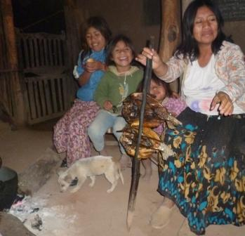
.
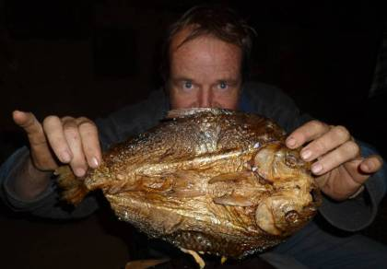
Fish cooked wichi style at Helenita´s house.
Pilcomayo fish are said to be far tastier than Bermejo fish. It´s possible.

Palo Santo wood
Our craft side of the work has suffered a severe blow as one shipment was detained at the Ezeiza International Airport because there was no “management plan” in the boxes. This has been a new law that the forestry dept did without taking into consideration the Wichi craftsmen from Salta province. It seems they only knew industrial palo santo lumber industries on the other side of this large Chaco region. On the Eastern side there are no craftmen, most of them are on our western side. It was only when I discovered this new law and had very strong words with the palo santo officials that they sent a team up to Salta to study the situation and talk to the people.
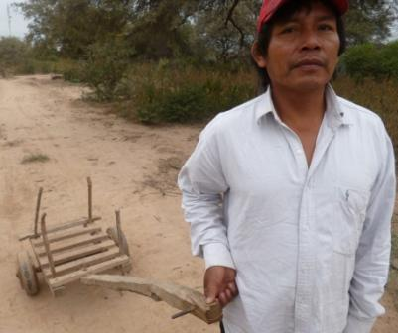
They also had a meeting with me as we must be the only organization that has been exporting crafts to foreign lands for over 20 years. Plus we must be the only one with a sister organization that sells crafts in Europe. See: www.siwok.org.uk

I must say that although it was a hard blow for us to lose the shipment (it´s not lost yet but the costs of storage must be far over the cost of the crafts). In addition they must understand that this affects generating needed work.

This law is something we were asking to happen because all this good wood was being shipped in bulk to China with no value added. This is a video we did on the subject seven years ago: https://www.youtube.com/watch?v=UCtJxkIfZow
The law now says that all wood that is exported has to come from forest that has a technical study so that you can only take away what grows. This makes it sustainable.
In theory this is very good but in corrupt Argentina it is very difficult to put into practice. With a plan from one plot they will sell wood that comes from another. There are no police or any sort of control in the Chaco, it´s no man’s land. Photo top left shows Fidel Cobo off to the forest to look for wood. He can never fit into this new law.
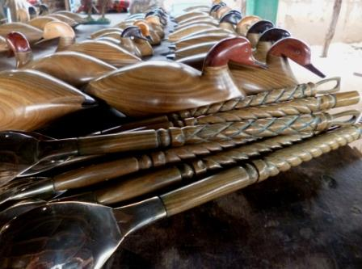
Photo left are the last crafts that have been produced before closing the shop due to prohibition to export.

WE PROPOSE THAT PALO SANTO BE OF EXCLUSIVE USE FOR INDIAN COMMUNITIES. With rampant corruption all laws will be broken and the loss of wood will continue.

Here in the link below is the mixture of crafts and agriculture that we promote.
https://www.facebook.com/photo.php?v=490187051107053&set=vb.100003472876345&type=2&theater

Packing the crafts that have been stopped:
https://www.facebook.com/photo.php?v=502414609884297&set=vb.100003472876345&type=2&theater
This is an example of how wood is stolen and taken to a local sawmill with no documents. Impossible to control as police stations have no vehicles, and when they do, they don´t have petrol.
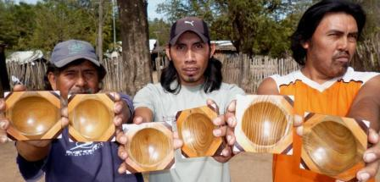
https://www.facebook.com/photo.php?v=540654029393688&saved

People are very angry because they have not been consulted.

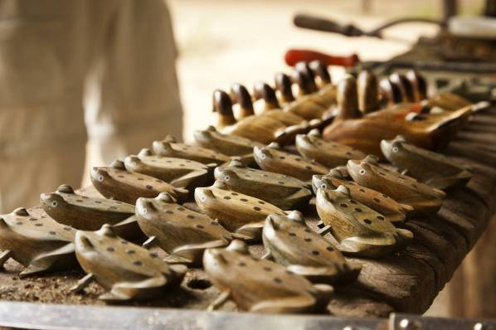
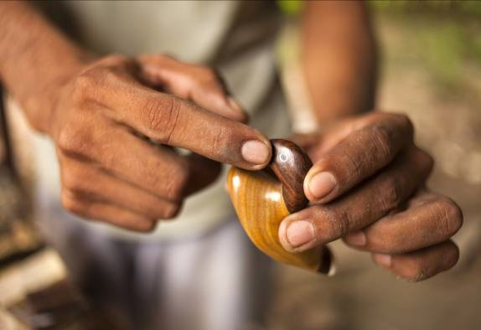

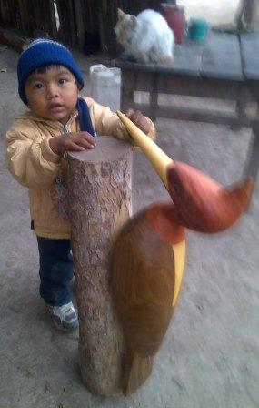
HERE THE SIWOK ON THE WORKBENCH:
https://www.facebook.com/photo.php?v=502458219879936&set=vb.100003472876345&type=2&theater

EDUCATION

According to the National Evaluation Procedure (Operativo Nacional de Evaluación), taken every 3 years, that divides results into high, medium and low performance 100% of Wichi students from Misión Chaqueña School are in the lower ranking in maths and language. The same thing happens in other schools (Hickmann, Salim and the Pilcomayo) that have a high population of Wichi students. Results get better in social science and nature (30% are in the medium level of knowledge) but all are disastrous in maths and language.
These are objective results, taken and corrected by external personel. This is not what happens now - exams are taken and corrected by the school professors and everybody gets through withour knowing the curricula. It will have disastrous long term consequences as it will keep the Wichi in the lowest rung of society with the worst social statistics (malnutrition, infant mortality, etc).
With this in mind I asked for a meeting with the minister of education but obviously got a meeting with a lower ranking official. We had the meeting and she didn´t like what I was putting my finger on. She was more concerned with the question of who gave me the results and not the results themselves!
For those interested in education here some links:

1) Balducho Villafuerte:Need to change school currricula to a more practical education that can give the students a working degree like electrician, building knowledge, mechanic, etc.
https://www.facebook.com/photo.php?v=483014708490954&set=vb.100003472876345&type=2&theater#!/photo.php?v=454497131342712&set=vb.100003472876345&type=2&theater
Balducho on the bad results of Wichi students: https://www.facebook.com/photo.php?v=483014708490954&set=vb.100003472876345&type=2&theater#!/photo.php?v=489802287812196&set=vb.100003472876345&type=2&theater
2) School director on results (always there is someone else to blame…).
https://www.facebook.com/photo.php?v=483014708490954&set=vb.100003472876345&type=2&theater#!/photo.php?v=489814421144316&set=vb.100003472876345&type=2&theater
3) There are now 2 Wichi medical doctors that got their degrees in Cuba. This month a 3rd Wichi student from Misión Chaqueña is going to get her degree. Applause for Cuba and disgrace for us! Here Magdalena, M. Chaqueña nurse talking about her daughter, future doctor. https://www.facebook.com/photo.php?v=483014708490954&set=vb.100003472876345&type=2&theater#!/photo.php?v=512113042247787&set=vb.100003472876345&type=2&theater
There´s a long way still to go but some light shines in the tunnel.

WICHI PAINTING
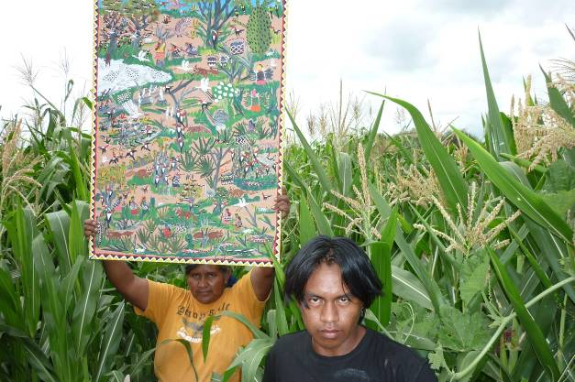
Painting is an 18 year old project that started with Litania Parado and still gives a living wage to a couple of families.
It is very sad that Laura, Litania´s younger sister died a month ago. One of those deaths that shouldn´t have happened. She goes to the hospital with a liver problem, they don´t attend to her well and she goes back home offended. Doesn´t come back till things are very serious and then it´s too late… Grrrr…
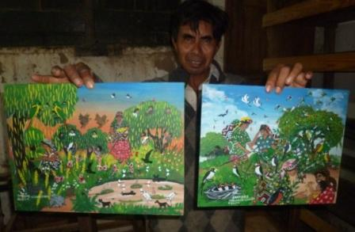
We carry on supporting this work that documents an ‘eronding cultura’ for the future and generates income without cutting the forest. If there are gifts to be made remember you can buy wichi paintings from us. It´s a gift with a meaning…
The 8th Wichi Marathon is on it´s way!

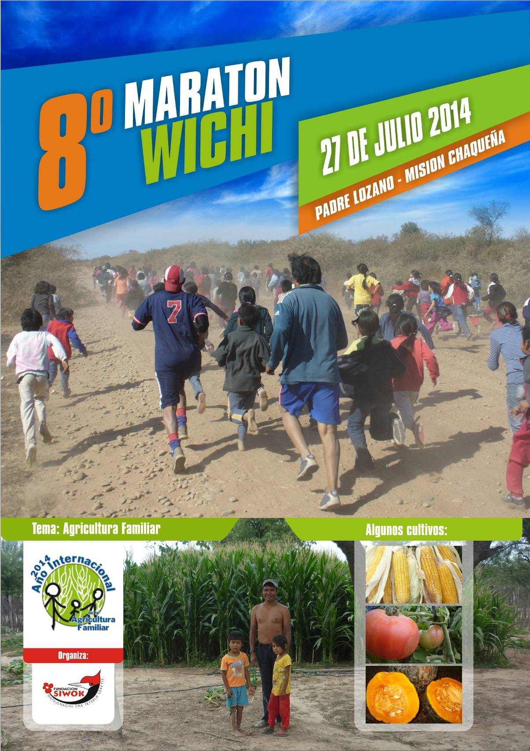
PRAYER LIST

- In the International Year of Family Agriculture we pray that our work may be extended to many more families by the involvement of institutions with stronger shoulders. We are showing the way but there is a need for a bigger institution putting together a master plan.
- I will have a meeting on Monday with the head of Agriculture in the province. That I may convince them that with access to water we can produce food and thus help change the health statistics of malnutrition and infant mortality.
- The same thing with education. That the problem of low results may be taken seriously and that all schools with Wichi population may be supported so that they come up to the country average, at least.
- Since before Christmas the government has promised support for family agriculture but still we are waiting. Pray that the money be transferred urgently so as to help the work that is being done.
- Pray that we can work close to the church and it´s leaders and that it can be understood that it is brothers helping brothers.
- That the health situation will change for the better, with sensitive personel that can take attention a step further with the Wichi. Being more patient and solving problems - not just filling in forms. We have had deaths of young brothers and friends that should not have happened.
- That the palo santo wood prohibition to export can be solved fast and that our shipment can be retrieved.
- That we may get a vehicle for the project. My personal ten year truck is now used but this is not sustainable.
- We have started work in Formosa province (650 km away from Salta city) coordinating with another NGO where there is much interest in doing drip irrigation agriculture, pray that this team we set up can focus on getting the job done and not on other problems.
- Pray for Ivon, Lucas and the rest of our family that the Lord may be ever present in their lives.

SOME CONCLUSIONS:

- Work is going well. There are more than 100 families that are now harvesting summer crops 3 and up to 4 times in their plots and we have over 20 family greenhouses that will produce tomato for sale, generating needed income. This has never happened before and there is a huge amount to grow.
- Water is where we must put our effort. Digging our own wells will solve the water problems in the Misión Chaqueña area.
- The years of work with crafts give us the know how of this trade in the country. Therefore we have a big responsability to influence public policy with new laws for palo santo wood care.

Alec Deane
alecdeane@yahoo.com 0054 9 387 5096482

PS: In our Fundacion Siwok Facebook page we upload most videos and images that show how work is progressing. I encourage you to look us up so that the info goes to you direct as another “friend”.
Some extra links:
https://www.facebook.com/photo.php?v=539431122849312&set=vb.100003472876345&type=2&theater

https://www.facebook.com/photo.php?v=539391102853314&set=vb.100003472876345&type=2&theater

https://www.facebook.com/photo.php?v=539846312807793&set=vb.100003472876345&type=2&theater&notif_t=video_processed

