THROUP – SHORT UPDATE

Hi everyone,
Here’s a summary on us, thanks for your support and prayers!

(Marcus) spoke in a conference on the “DNA of Global Christianity”, which went well. As ever I’m preaching/leading/presiding on Sundays, assisting the Dean, and leading midweek Bible studies, nurturing people in their walk with Jesus. In the Theological College I’m teaching preaching which is great fun (and nice to be able to use my own book as a textbook!). PhD research demands in depth Bible study and this is enriching my ministry. I’ve also managed to publish a couple of articles in journals, which helps establish my credibility as a theological educator.

(Tamara) I’ve enjoyed work but have missed spending more time with Rebekah and have found this really difficult. Although she’s a really good baby, Marcus has also found it very tiring being primary carer to Rebekah on top of all his work. Consequently, we’ve decided that it’s best that I hand in my notice so I can be at home with Rebekah. It was a hard decision and even though finances will be tighter, family has to come first!

(Rebekah) I’m now 6 months old and can crawl quite well all by myself – sometimes in my sleep! I’m enjoying solid foods and juice, so far I like everything I’ve been given (apart from star fruit juice). I can pull myself up by holding on to the side of my cot, and I can remain standing up. Sometimes I like to do this while giggling and yelling at the same time – at 4am yesterday this was what I was up to! P.s. I’m attaching a photo of me!
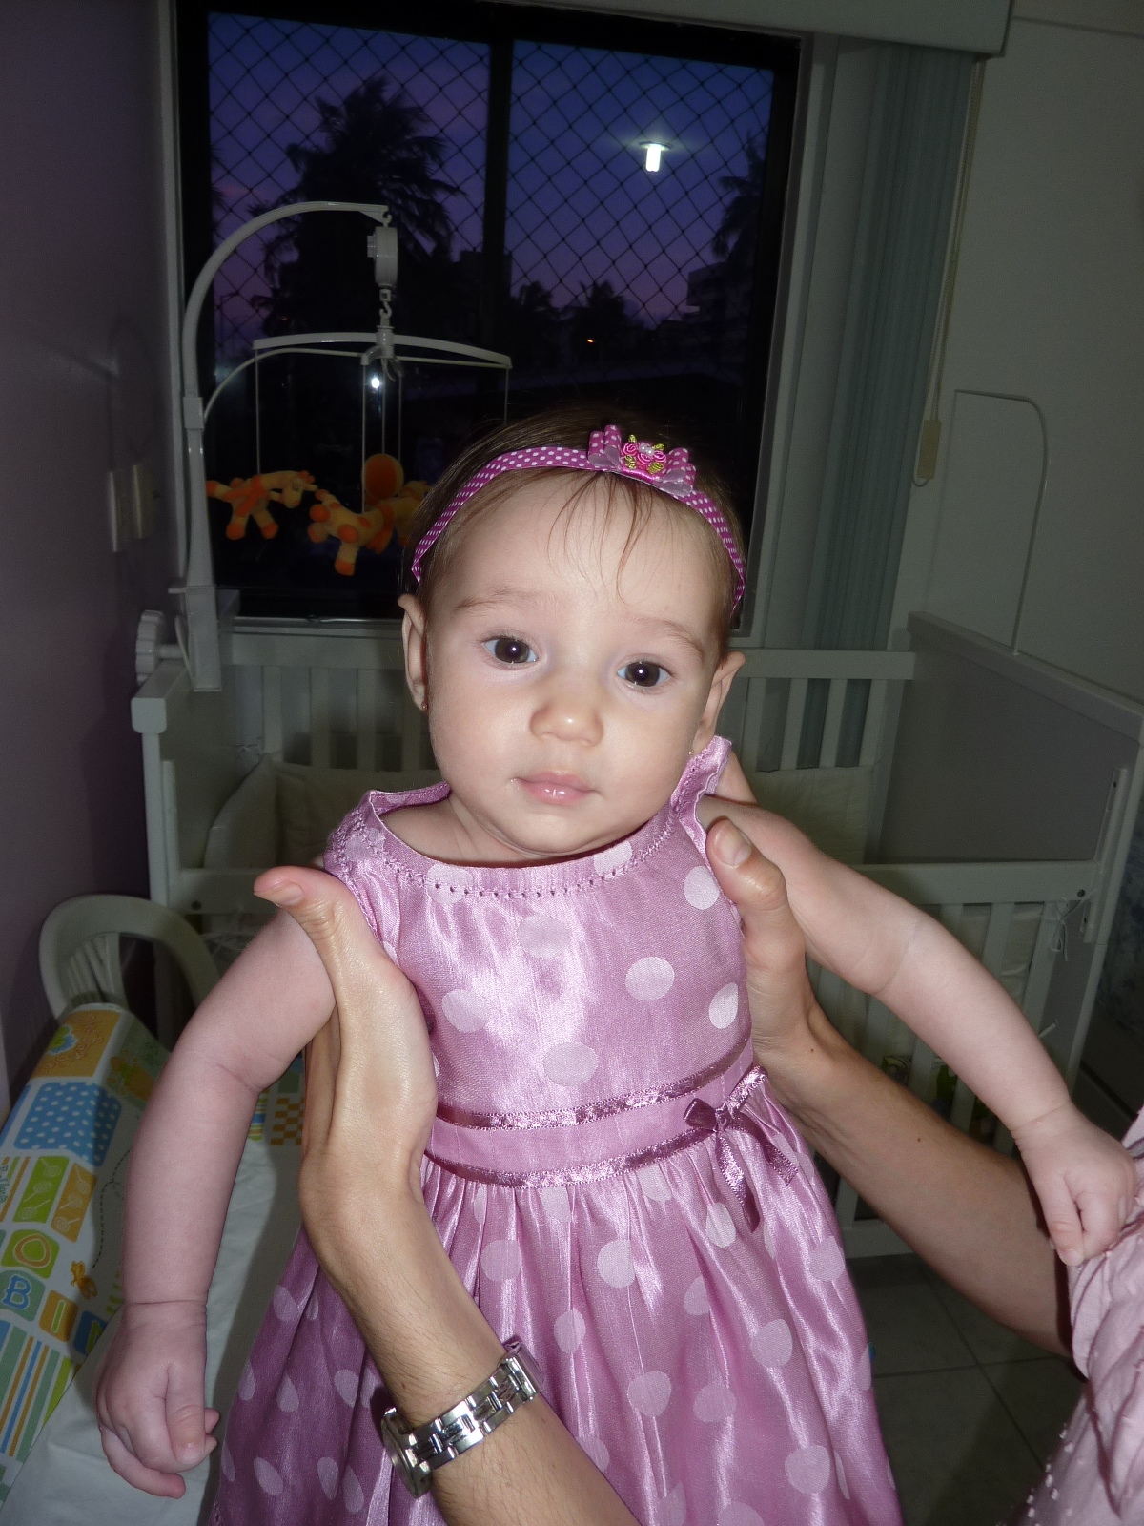
BRAZIL
Presidential and state elections take place on October 13th. – we suspect that one candidate in our state “Jehovah” may have an unfair advantage! Please pray with us that those elected to lead the nation may do so justly.

Rebekah Throup

CMS encourage Mission Partners to send out both full prayer letters and short updates – our next full prayer letter will be heading your way November/December time.

