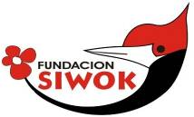
“YACHUYAJ WO” GARDEN PROJECT PILCOMAYO AND MISIÓN CHAQUEÑA 8.05.2013
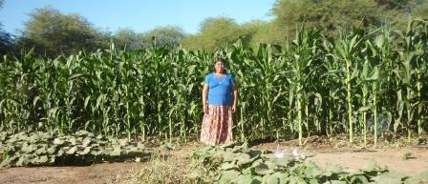
I left early for the Pilcomayo river on the 8th of May. My plan was to go to Santa María and other costal wichi towns as we have been doing for the last 2 years. I would on my way there and back make a detour and pass also by Misión Chaqueña and Hickmann communities. All in all around 1400km.
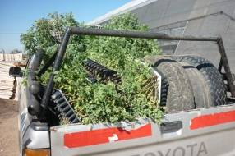
As usual I pass through a nursury garden in Pichanal where I stack up with overgrown tomato plants. They are very appreciated by all Wichi. I took four trays (around 1000 plants) to the Pilc and the rest left in Misión Chaqueña. I have been doing this since Febuary so now there are around 15 to 17 gardens with these plants growing and tomato fruits are showing… beautifull!!

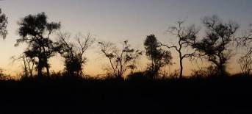
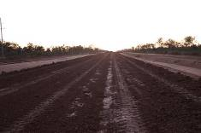

Photos above: scenes of the dirt road to Santa María. The government is working full blast to pave the road from the highway that leads to the international bridge at Misión La Paz connecting to Paraguay. This is a huge investment that goes right through the heart of Indian lands and will change for ever the situation for the wichi. As with everything there is a bad side (loss of natural resources, loss of culture, etc) and a good side (economic development, better access for health workers, less isolation of schools, etc). For our agricultural development it will be positive as the trip is very trying for the vehicle (and chauffeur!). It was dark when I got to the local chief Palestino in La Puntana and slept in the truck that night.
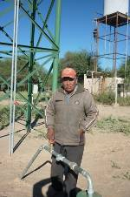
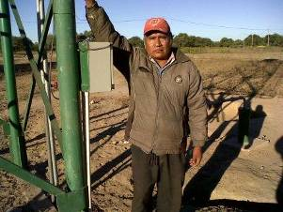
The theme we talked about around the fire that night was the two new drilled pumps that had produced salty water. A real blow for the people as they had fought for these pumps. You can hear Palestino talk clicking below:
https://www.facebook.com/photo.php?v=338141382978288&l=5877940294943401440
There is also a few words said by Solas Nilo on the water problem. Hi´s sons can´t drink mate at home and have to go to grandparents! Shows the situation. Both are in Spanish. https://www.facebook.com/photo.php?v=338144496311310&l=2221685711116997778

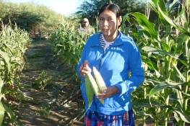
Lack of water also will affect our Garden Project. Here left we can see a family garden in Puntana that is near the school pump. This is their second harvest of maize. Many families I visite on this trip were harvesting their 3rd crop on their little patch of ground. You can produce 1600 maize cobs in a 20x10mt plot and you can do this up to four times a year. With this way putting goat manure is essential in these sandy weak soils.
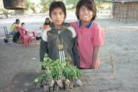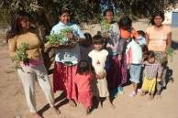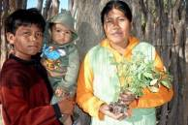

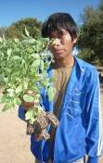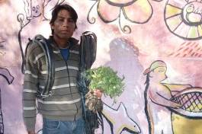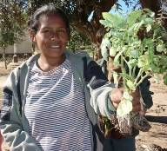
Here different families with tomato plants ready to go into the ground. They had never seen them, other than fruit in the local store. For insecticide I suggested boiling tobacco and once mashed throwing the dark water on the plants. Plant must be soaked and covered with old plastic if it will freeze that night.
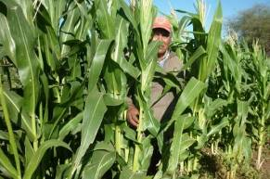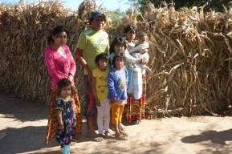
Above a plot of maize in Puntana Chica. Their new pump has produced good water there and they have taken up the idea of producing with drip irrigation with enthusiasm. It shows that if water is available, healthy food can be produced by the people.

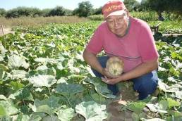
After getting stuck in the sand (it´s been a very dry summer and all inner roads were thick with loose dust) I got to La Curvita where Cornelio Segundo received me and showed me his neat garden. This 77 old grandfather has been brought up as a gardener. He talks of his grandfather taking him to the forest where the man had his rainwater fed garden and telling him: “This area is yours, do what you like with it” From then on, Cornelio says, he never had to ask for maize of pumpkin. He would yes have to help the old women pack their net bags on their backs with the harvest and send them home.
He has been able to understand the value of drip irrigation and is showing fruits for all.
Interesting that he also says (you can hear him clicking below) that all traditional gardens failed this year due to the extreme drought the Chaco went through.

https://www.facebook.com/photo.php?v=338203396305420&l=8804527080375170938

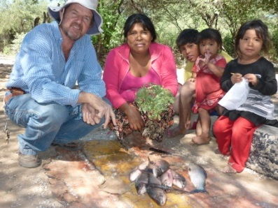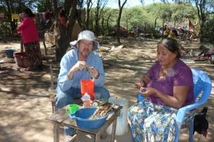
I was hungry bythen and there was fish around so I sat down to the feast! The Pilcomayo has definite times where fish come upriver and they had arrived so it was a good time to be there!
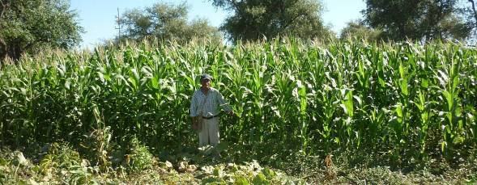
I carried on to Santa María where I had my second lunch at Cris and Helena Wallis. There the gardens, although we are getting to the end of the season, were looking very good. Here above Victor Ciriaco with his 3rd yearly harvest of maize looking great. Once again, if we have water we can prove that the Wichi can produce their own food. It fits in well with the other survival strategies (fishing, hunting, gathering fruits in the forest, etc). Francisco Perez mentions this point in his video tape below.
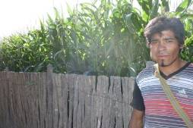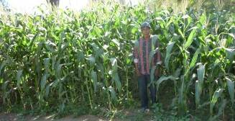
All the Ciriaco family have adopted this system of producing with drip irrigation. We give them good seed and materials and they do the job. Here above a grandson and son in law of the family leader, Ceferino.
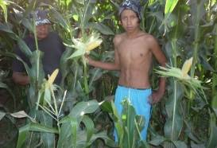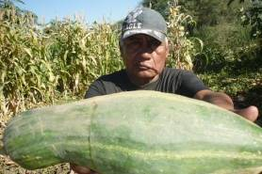
Ceferino here with another grandson in his daughter´s plot and giving me a pumpkin as a gift. A few months he got this sort of nervous malady where the side of his face dropped. Bishop Nick arrived to see him one day and he said that he was struck by this problem and felt very ill but at least he had food thanks to Siwok! You can hear Ceferino speaking in Wichi clicking: https://www.facebook.com/photo.php?v=338212182971208&l=1622474314893851047
I still don´t know how to put words on the video so as to translate but my non perfect version of what he is saying would be:
I´m in Santa María, my name is Ceferino and I´m at my home. I´m happy that I can sow these days and happy with the road of the water (Tr: he´s talking of the drip irrigation hoses). I thank Siwok and I thank God for this idea (?) that helps us. I´m very glad because I have maize and pumpkin, indeed I have much. I´m happy and this helps the good of the rest of the Wichi.
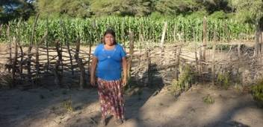
There were other nice gardens there but I had to plow on so I went to see Hector Miranda´s home. This man has shown much interest in agriculture last year and I wanted to see how his new plot (left) was getting on as a few months ago his first sowing had failed (photo below).
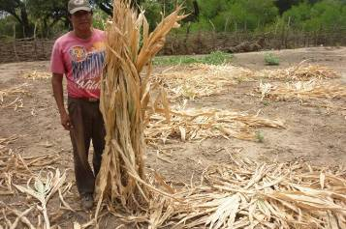
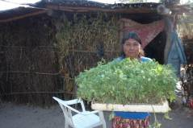
I left a tray of tomato plants there knowing that they would be well managed. The strategy is to help the leaders show the way, family and community (in that order) follow later.
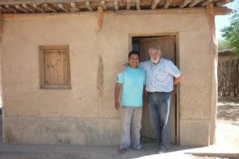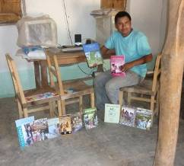
In Santa María Cris Wallis works coordinating Indian Education Affairs for ASOCIANA. (Anglican Church Social Work). Here above we see him with his right hand man, Eduardo Perez that in their adobe cool office showed me all the published literature in wichi language. Here above right he is showing some of the books printed.

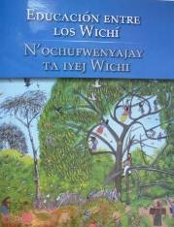
The last one done (launched around a month ago) is a book called “Wichi Education”. It´s Wichi leaders and elders talking about different themes, written in Wichi language and translated into Spanish. The talks are grouped in these different themes:
a) Education of our forebears.
b) How we live: good manners.
c) How the wichi teach.
d) How and what missionaries taught us.
e) Problems we have today.
There is also a chapter on advice and warnings.
Eg: Beware if you laugh much, somebody will think you are mocking him. ☺ I can orgainize sending the book if you would like it. The cost would be around 10U$D. Postage not included.

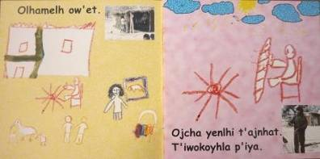
I was really impressed with the quality of work done by Cris and Eduardo. The fruits of this work showed respect and love for the people they were serving.
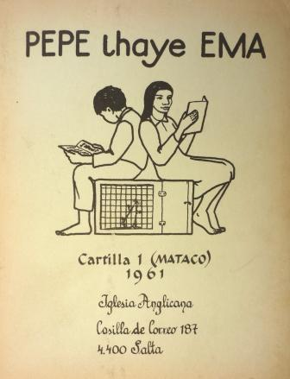
Also on the shelves was (photo left) the first printed booklet of wichi literacy teaching (1961) “Pepe lhaye Ema” done by Barbara Kitchin, another work of love and respect. Above is a page of a set of five little booklets for first graders. Lovely wichi kid drawings. This one is titled: “My father is a fisherman”.
Formal education has to get better if you want the malnutrition and infant mortality to be lower. Official statistics say that 8 of every 100 children will not get to 5 years old in these wichi communities. This is a scandal knowing that the average for the province of Salta is that 1 %. There are other factors also that affect this statistic (access to water, lack of work, medicines, etc) but bettering formal education is a must. Two examples show there is a serious problem: a) in Alto de la Sierra 86% of secondary students (14year olds) failed to get from 1st to 2nd grade. In Misión la Paz, 60km away, 100% got through. I travelled last summer with a teacher from La Paz (who helped me get through the mud) and he was telling me that in that school if a teacher does not pass the student, the parents put pressure on the headmaster so that that teacher is sacked. Obviously this has happened here…
It would be ideal that Cris and his team give counsel to the authorities on how to manage the bilingual education but in this ideology obsessed country this would be politically incorrect I suppose!

On the side line I must mention that I´m starting to move strings so as to organize an English institute in Misión Chaqueña. It would be politically incorrect also but it would be very helpful for the Wichi´s future in the long run. And that´s what my work is all about. ☺ If there are organizations on that end that would like to team up for this venture please contact. Gracias!
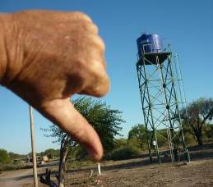
After Santa María I headed for Franciso Perez´s home in S. Victoria. He leads the Indian land rights association Lhaka Honat and helps us with the agricultural project.

He was not in but I could see that his water tank had not been yet connected. It´s two years since the well was drilled and still it doesn´t work. A monument to wrong priorities!

We are insisting with burocrats in Salta that is finished. Difficult task…

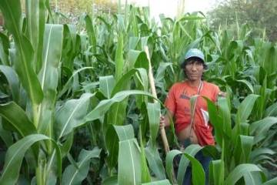
I carried on to San Luis and Arenal where many were in their 3rd harvest like this happy man at right.
Lovely healthy plants!

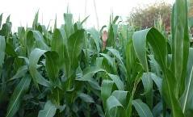

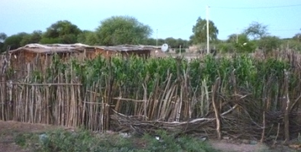

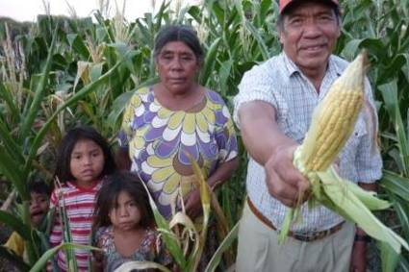
I like to see the green maize in the brown dusty chaco.

Here is the pastor of the community giving Siwok some of his produce. He also was in his 2nd harvest on the same plot and very thankful and enthusiastic to carry on.

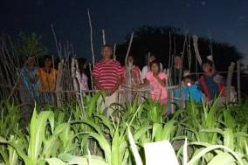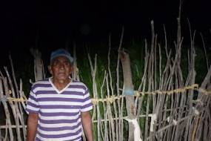
Light was getting dim when I went to see Felipe at left and Calixto right. A pity you cn´t see Calixtos plants as they were spectacular. His fence would need some wire though…
After doing the rounds I went back to Francisco´s house. He had arrived and had much on his hands as the next he was to receive the American States Human Rights envoy direct from Washington. They had started a lawsuit (assessed by Asociana) against the Salta government with regards to owning their ancestral lands at this international entity and won the law suit. The envoy was coming with provincial authorities. I know by now that the visit was positive for the Indians and that they (in theory) would be pushing authorities to hurry up the giving the land to their historical owners.
Under a dim light you can hear Francisco speak on the agricultural project clicking: https://www.facebook.com/photo.php?v=338511856274574&l=7157927541408099109

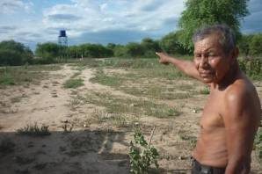
Also on the incomplete water tank and pump: https://www.facebook.com/photo.php?v=338645652927861&l=4897319731665166286

Here left we see a very ill humored neighbor of Francisco pointing at the unfinished tank.

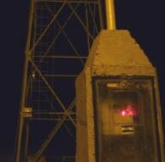

Dinner with Cris and Helena and early next morning off back to Misión Chaqueña 300km away. I couldn´t resist stopping at Padre Coll another community where 4 months ago there was also an incomplete pump. I was happy to see it had been connected. Here at right in the dark of morning. Good news!

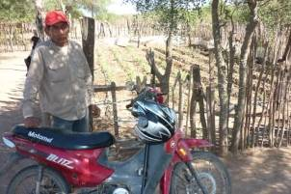
In Hickmann we are trying to get wichi to produce their own food with drip irrigation technology. This we are doing in with another NGO called www.cloudhead.org This community is very poor, lives on donations and logically for many years had very high malnutrition levels (around 20%). Antonio, my wichi agriculturist waited for me there on his scooter
He travels from Misión Chaqueña 45minutes away on the motor bike (that is now in the mechanic needing repairs). It´s a suffering ride for these cheap Chinese bikes but that´s what´s available ☺

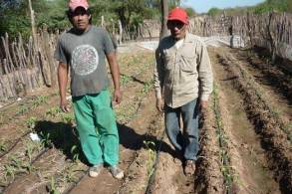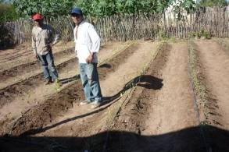

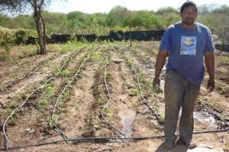
We are working now with 3 families that have shown enthusiasm with the Project. There are more interested but water pressure is the problem.
We need to push authorities to bore another pump here.
We are now planting tomatoes and peppers but they have been harvesting maize, melons and pumpkins since December. We take materials they put their work…

While I write this I know that Fernando´s plot (up left) is now covered with plastic. This will protect from the upcoming frosts and bird attack on the peppers. They don´t like tomato leaves but love peppers.

Having visited them I left Antonio to do his work and carried on to the Mission on the gravel road.
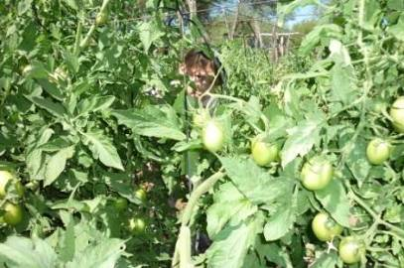
There, at Balducho´s plantation the tomato plants were doing great.

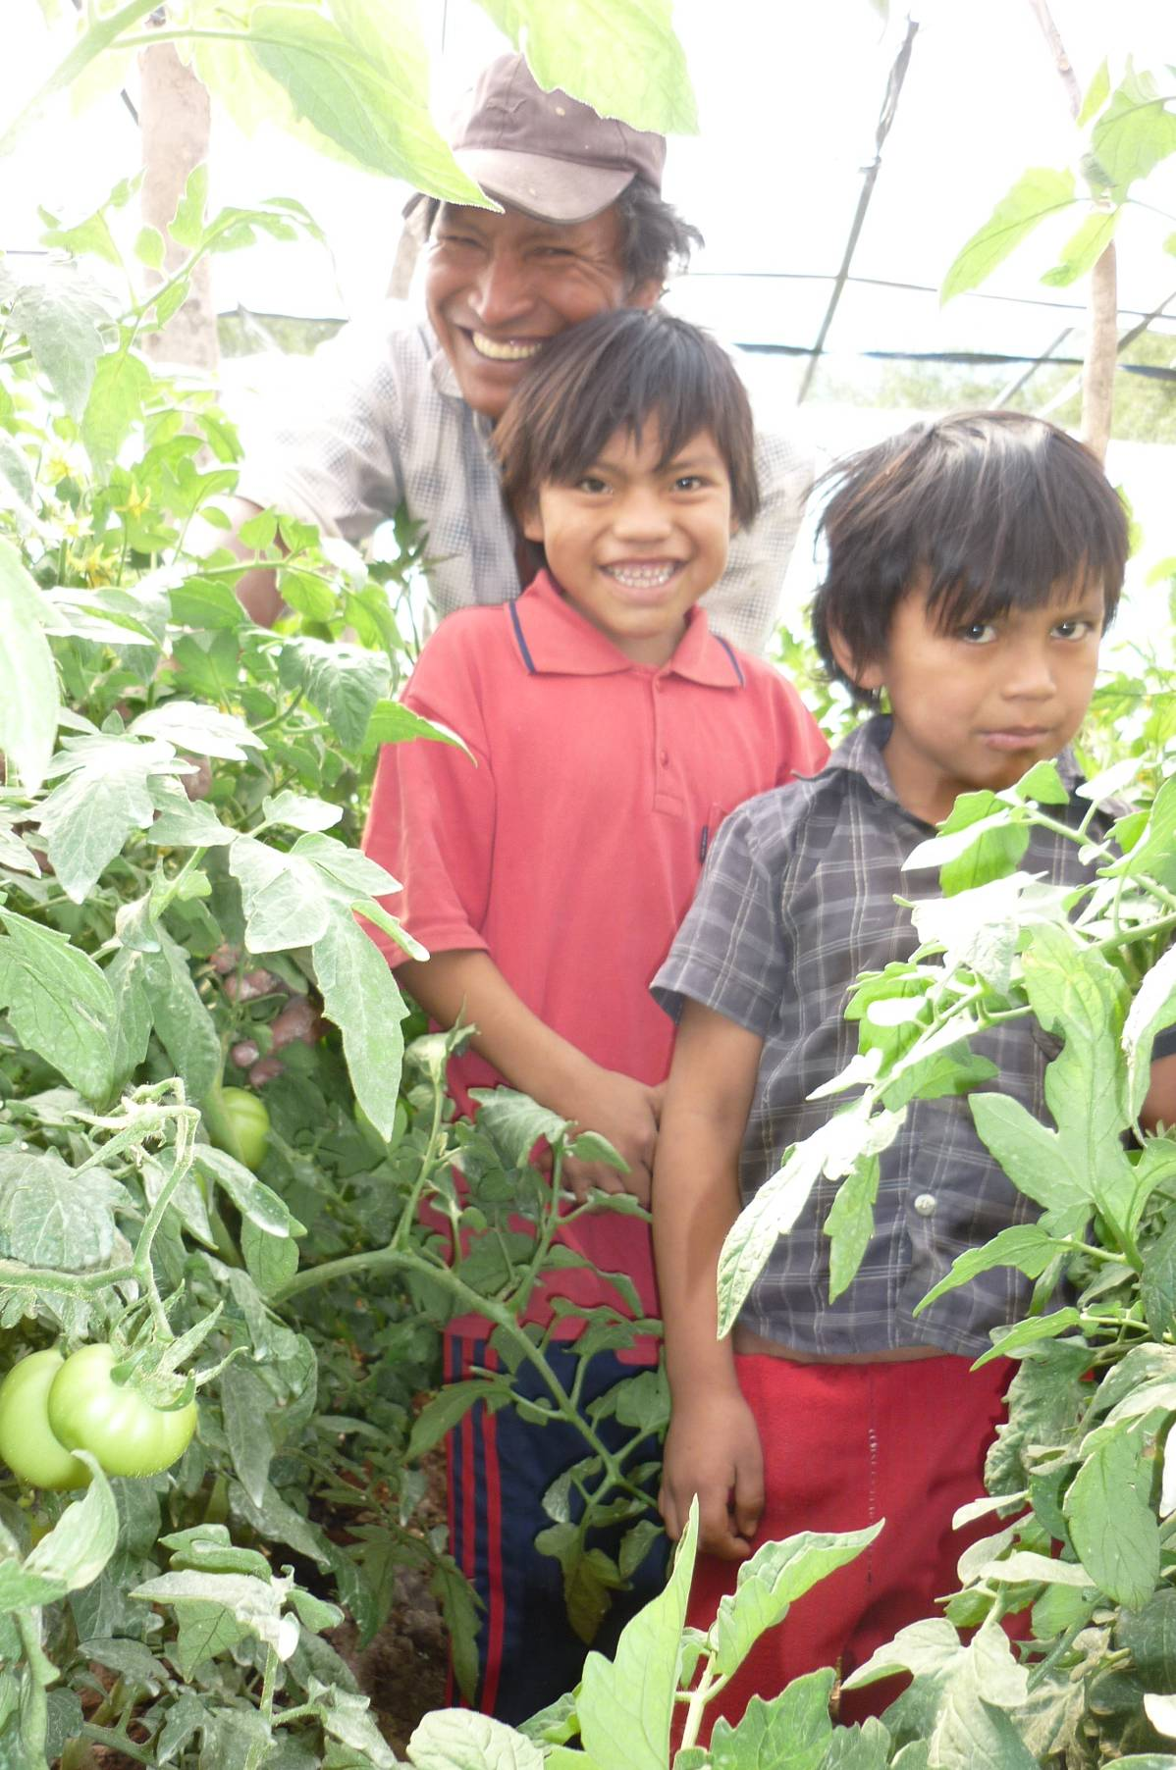
This is Pedro with his two sons and tomato plants now under plastic.

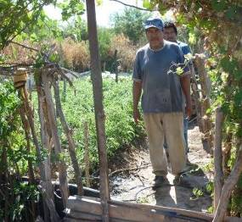
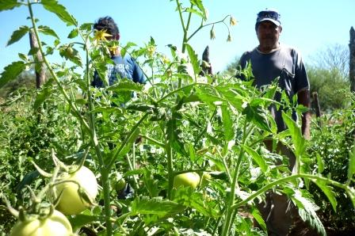
Naldo and son here with their first try at tomatoes. They are growing very well. He is one of the first craftmen and now is showing needed flexibility and changing to agriculture

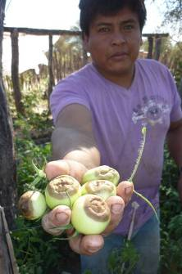
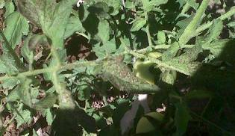
There are two sanitary problems we are finding with these very sensitive plants. One is thrips (little insects that suck the juice) and the other is a rot that sets on the end of the tomato (photo left). It seems this last problem is due to calcium deficiency and or lack of water. We thank the local agrochemical firm from Pichanal that they give us advice on these problems.

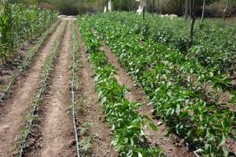
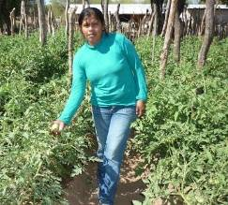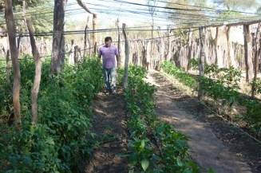

Above left: Antonio´s daughter in law who helps with the family plantation.
Top: Orlando from La Esperanza community with his tomatoes and peppers on the right. Last year he lost everything due to the frost. He had tied the plastic in a wrong way. It won´t happen this year.
Left: a neat patch of peppers and tomatoes at Landito Espinoza´s place. It´s all irrigated with solar power that we were able to get through the Agriculture Ministry.

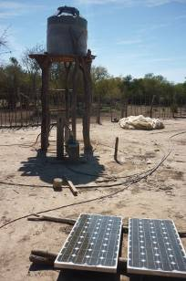
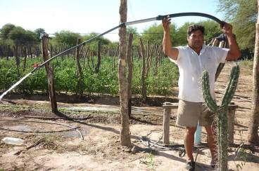
The wichi have discovered that you can pump direct to the drip irrigation hoses. Balducho at top installed pipe from his fan on the thick hose and then a smaller pipe till the 1/2 inch one and now it works direct from the pump to the drip irrigation. The same with the solar pump, it´s not going to the tank but is pumping direct to the drip hoses. Solar power can be a great solution for places with no electricity and ground water. We are showing the road ahead with this practical experience.
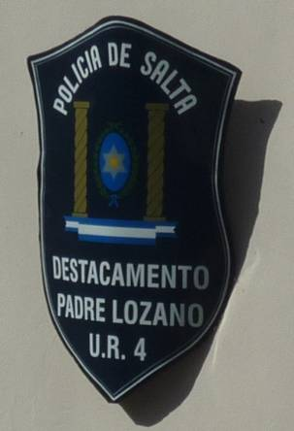
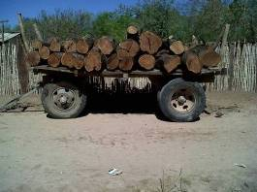
Part of my time there was going to the new police station in Padre Lozano with the two groups at Mision Salim that either protect the forest or want to chop it down.

I was trying to get the police involved so that they could support the group that protects the forest. In theory that´s what happened but I sadly suspect that problems will finish when there are no more trees standing on the land.

CONCLUSIONS

WATER: When I started going to this Pilcoamyo area 2 years ago there were 8 pumps unfinsished. Last Febuary there were 6 and now there are 3 that don´t pump. It goes slow but we are advancing… This report in Spanish has gone to some public employees that I hope will take note of needs and get ideas on what can be done.
AGRICULTURE: We are showing the road ahead as to how to do agriculture with hunter gatherers and there are fruits to show. But it´s clear that water is the key to all this development. If we have the resource the Wichi can produce their own good food and change a bleack reality. We will be knocking on government doors so that this happens.
SUSTAINABILTY: Producing with the wichi communities in the extreme climatic conditions of the Chaco forest is possible but without a network of support this would not happen. On the long run, for this to be sustanable it should be supported by a national institution. We are working on this, trying to get the INTA (National Institute of Agriculture Technology) onboard. The idea would be to create an “Indian INTA”. Next report I will give you more info on results of this initiative.

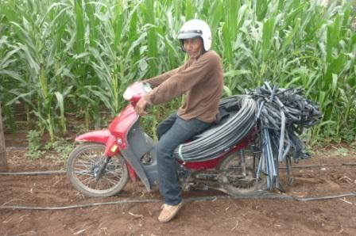
EXTENSION WORKERS:Antonio and sons are not on budgets but are strategic for the outcome of the project. I´m knocking on doors at government agencies and NGO´s, for support, but all this (many times burocratic work takes time). Antonio would receive arround U$D150 a month. Any help here would be highly apreciated.
His bike also need a change… ☺
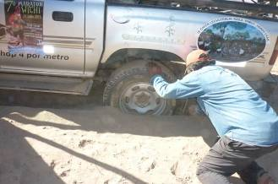
MOBILITY: I have mentioned it before and I will repeat, using my own 10 year old vehicle is not sustainable either. Three weeks ago I got a first message from the truck as the top of the cilinder block (don´t know how to say it in English!) fisured and air was blowing into the cooling system. I changed that thanks to a gift from a friend but alarms are sounding. Here stuck in the sand at Palestino´s in La Puntana. Killing for all moving parts.

CRAFTS: I´ve got to mention that paralell to the agruculture I´m buying crafts so as to generate needed income for the wichi. These are sold mainly in the UK. Buying them pulls a very long chain that finishes in Misión Chaqueña plates. Contact www.siwok.org.uk
OK, that´s all for now, thank you for your patience and support!!!

Alec D. Deane
alecdeane@syahoo.com
Cel: 0054 387 5096482
BONUS:
AS YOU CAN SEE BELOW (AGAINST ALL LOGIC ☺ )WE ARE ORGANIZING THE 7TH WICHI MARATHON FOR THE 21ST OF JULY.
THE THEME OF THE MARATHON OF 5K, 10K OR 15K WILL BE BETTER ACCESS TO WATER. WE WILL BE PUSHING THE GOVERNMENT TO INVEST IN WATER INFRASTRUCTURE (AND NOT IN BAGS OF FOOD AS FRANCISCO SAYS IN HIS VIDEO!!)

SEE POSTER AND PRIZE GRID BELOW
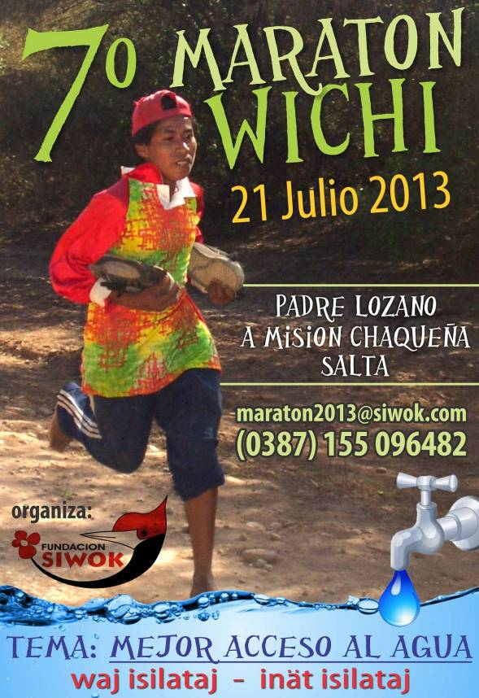
MANY THANKS TO ALL THAT WANTS TO HELP!!!
PRIZES 7th Wichi Marathon – 21st July 2013
CATEGORY | 1ST PRIZE | 2ND PRIZE | 3RD PRIZE
MINIS BOYS (<12) | SCHOOL RUCKSAK KIT U$D30 | READING BOOKS U$30 | SHOES U$25
MINIS GIRLS (<12) | SCHOOL RUCKSAK KIT U$D30 |  | SHOES U$25
MINIS GIRLS (<12) | SCHOOL RUCKSAK KIT U$D30 | READING BOOKS U$30 | SHOES U$25
MINORS BOYS  (12-15) | SCHOOL RUCKSAK KIT U$D30 | READING BOOKS U$30 | SHOES U$25
MINOR GIRLS  (12-15) | SCHOOL RUCKSAK KIT U$D30 | READING BOOKS U$30 | SHOES U$25
INTEMEDIATE BOYS (16-17) | 600LT WATER TANK  U$D85 | CRAFTMAN TOOL  U$D30 | SHOES U$25
INTERMEDIATE GIRLS (16-17) | BED COVER U$D35 | CLOTH U$D30 | SHOES U$25
ADULTS MEN  (18-39) | CASH U$D15 | CLOTH U$D30 | SHOES U$25
ADULTS MEN  (18-39) | 600LT WATER TANK  U$D85 DONE A.C. | CLOTH U$D30 | SHOES U$25
ADULTS WOMEN  (18-39) | CASH U$D15 | CLOTH U$D30 | SHOES U$25
ADULTS WOMEN  (18-39) | 600LT WATER TANK  U$D85 | CLOTH U$D30 | SHOES U$25
SENIORS MEN  (40-54) | 600LT WATER TANK  U$D85 DONE R.S.S. | CRAFTMAN TOOL  U$D30 | SHOES U$25
SENIORS WOMEN (40-54) | BED COVER U$D35 | CLOTH U$D30 | SHOES U$25
SENIORS MAX (>55) | BED COVER U$D35 | CRAFTMAN TOOL  U$D30 | SHOES U$25
SENIORS WOMEN (>55) | 600LT WATER TANK  U$D85 | CLOTH U$D30 | SHOES U$25

WHERE TO DEPOSIT:

USA:
Key Bank of Maine ,
627 Main St.
Fryburg,
Maine 04037 USA.
ABA code 011200608
Swift Code: KEYBUS33
Acc Title: Alejandro Deane
Acc Number 129 04170

Ireland & UK

Contact Jill Hamilton direct at: samsirelandhouse@btinternet.com
telephone: 028 3831 0144
post: 1 Irwin Crescent, Lurgan, Craigavon,
Northern Ireland, BT66 7EZ

ARGENTINA

Banco Santander Río, Cuenta Corriente “Fundación Siwok” #165- 8906/7
CBU: 0720165920000000890672
CUIT Fundación Siwok: 30-70833146-1

MY PHONE: 0054 387 5096482
alecdeane@yahoo.com

THANKS FOR YOUR SUPPORT!!!


