Monday 9th May 2011

Hello,
After 4 months of promising myself that I would “definitely write a newsletter this week promise!” I am finally writing to you! Sorry for the delay.
I can’t believe I’m already in my 4th month here. Time has just flown past. I also can’t believe I’m writing an actual newsletter. I read lots of other missionaries’ newsletters but never thought the day would come when I’d be writing one myself. This time last year I had no idea I’d be here; isn’t it amazing the way things work out? I suddenly feel very grown up, let’s hope this new found maturity is permanent!
As you know, after a couple of months in Quito studying Spanish verbs (horribly evil and boring) and generally settling in I have now moved to Santo Domingo and am finally working. I am living with Pastor William and his family who are lovely and looking after me very well.
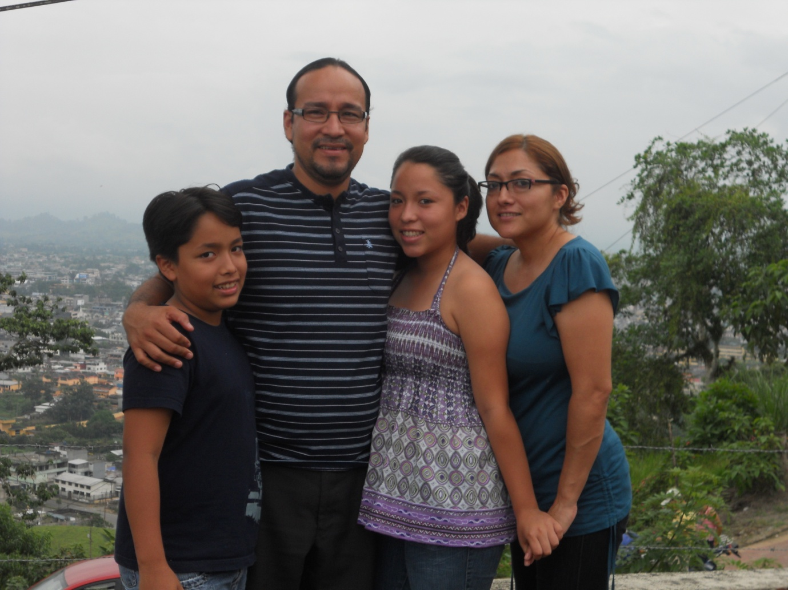
After psyching myself up to rough it for the year I find myself living in a very nice house and all my meals cooked for me-I don’t get this treatment at home!
Here I’m working in a small school for children with various disabilities. It’s a new experience for me and I’m finding it....interesting! I spent all of my life swearing that I wasn’t hugely keen on kids and would never EVER work with children so of course I’m now working in a school! Who says God doesn’t have a sense of humour? The thing is, I’m loving every minute of it and am proud to be part of this amazing project.
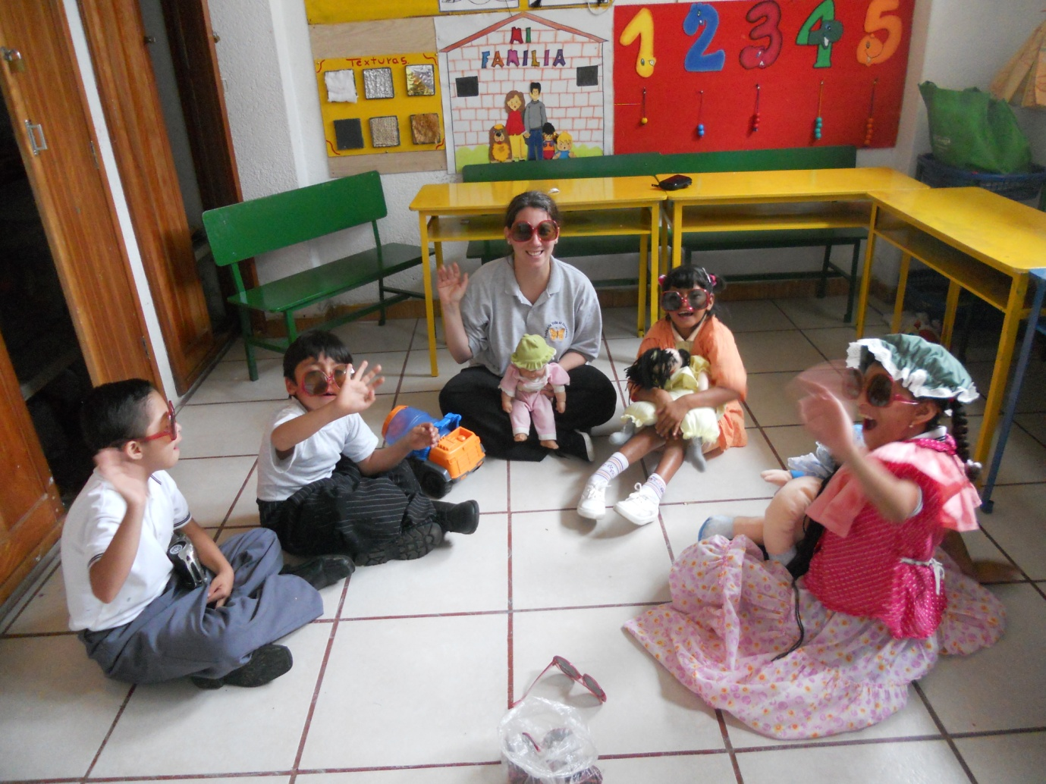
The school has a mini bus and every morning we go to collect a group of children and then take them back home. I’m the chaperone which I don’t mind (in spite of the evil 6am wake-up needed) but it certainly keeps me on my toes. 2 fun packed hours of “sit down”, “No! DON’T touch the door”, “don’t hit/bite/kick” and the constant “put your seat belt on and yes it is important to wear it.” Of course all of this is in Spanish; it’s amazing how quickly you learn certain words!
A very proud moment for me today-I did my first 1 to 1 therapy session with a child in my class. It was discussed a couple of weeks ago; the opportunity for me to carry on the work of last year’s physiotherapist. I’ve been dying to do more work and was excited at this chance but really nervous too. What if I do something wrong? What if my Spanish isn’t good enough to explain what the exercises were? In spite of my pitiful Spanish and wobbly nerves today went fine-thanks to God!
In spite of my struggles to learn Spanish I need to press on and do some more work. I get by but I know that I’ll be a lot freer to work more, socialise and build up relationships when I’m better able to communicate. The problem is...I find struggling through all those verbs and different tenses boring and difficult! On a positive note though I managed to jointly come first the other week in all Spanish version of Trivial Pursuit. I reckon if can survive that then I can conquer anything!
I’m hoping to possibly do some work with the youth in the church but nothing is decided yet. I was going to visit the youth group this last Saturday, chat to some of the young people and see what happened but youth group was cancelled due to our big national referendum (yes we had one too.) I did a teenage girls group in Liverpool and possibly I might do something similar here. I don’t want to rush into anything though; I’ve seen well meaning people turn up and start projects they think are suitable but they end up failing because it wasn’t what was needed. I want to talk to the teenagers first and see what they think and want. I’d appreciate some prayer over this if possible please. Apart from the school; what else does God want me to do?
I made the huge mistake the other night of opening the insect protection screen over my window. It was only for a few seconds but even so my room ended up full of all sorts flying insects! I enjoy a spot of Entomology as much as anyone but when I was still awake at 4am throwing out HUGE Beetles and squashing Mosquitoes my enthusiasm was at an all time low! Plus I am now covered in horribly itchy insect bites. I have now decided that insects are evil. Nobody else seems to have half as many bites as I do; maybe I’m still a novelty for the Mosquitoes?
I have so much more to say but the battery is running is out on my computer so I need to go soon. Before I go, I’d like to say a big thank you to you all. I know you’ve all been praying and thinking about me and I really appreciate your support!

Goodbye for now and God bless

Victoria

