Julio and Norma Montoya in Lima, Peru, Christmas 2009

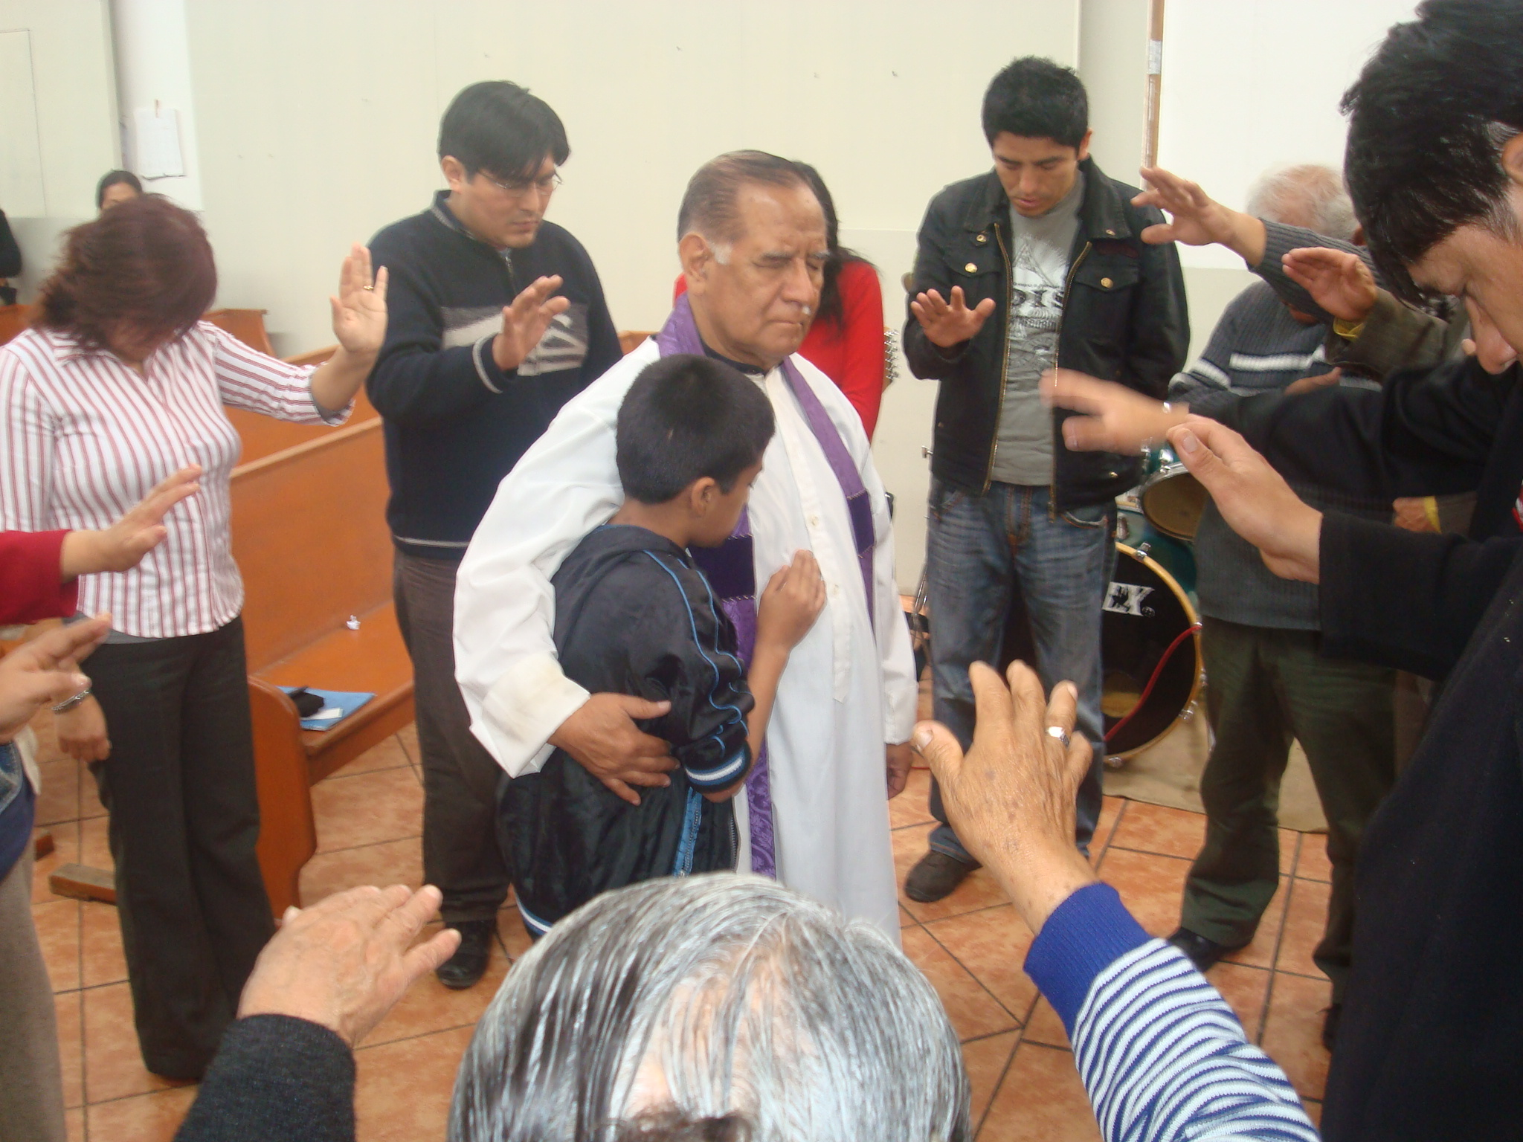
Julio at Holy Trinity Church

Hello Brothers and Sisters in Christ,
We wish you the Lord’s richest blessings at Christmas!
These last months we have continued with our pastoral work in Holy Trinity Church and in the missions. We have held some events: the 29th anniversary as an Anglican pastor; again the women’s conference (AMA) which they held in Good Shepherd Cathedral. It was a very pleasant time where all the women shared. We prayed to our God and we shared the Gospel with people. Again let us give thanks to God because in every moment he is with us protecting and healing and fills us with love and understanding, to be able to give to all who hear the word of the Lord. In some missions like Valle 2000 and Upper San Gabriel you know that we do not have a place to hold our services. In Valle 2000 we have worship in the people’s soup kitchen and in Upper San Gabriel in the street outside a soup kitchen. Let us give thanks to God because here are people, women, old people, children who join us each Sunday.
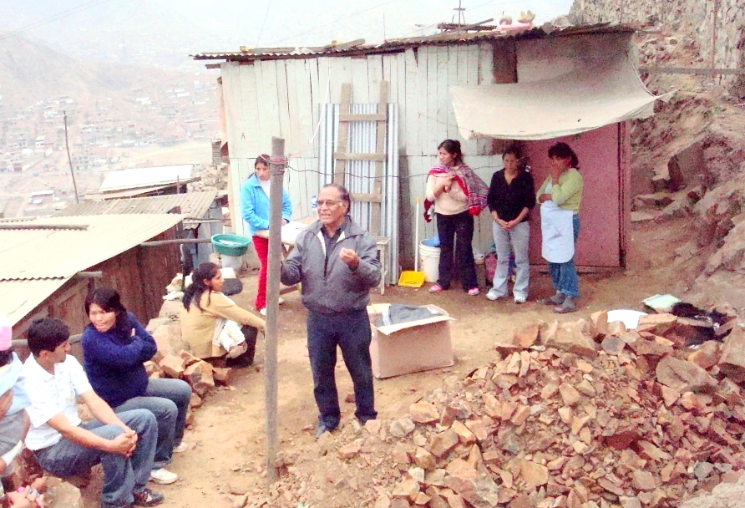
Julio preaching in Upper San Gabriel
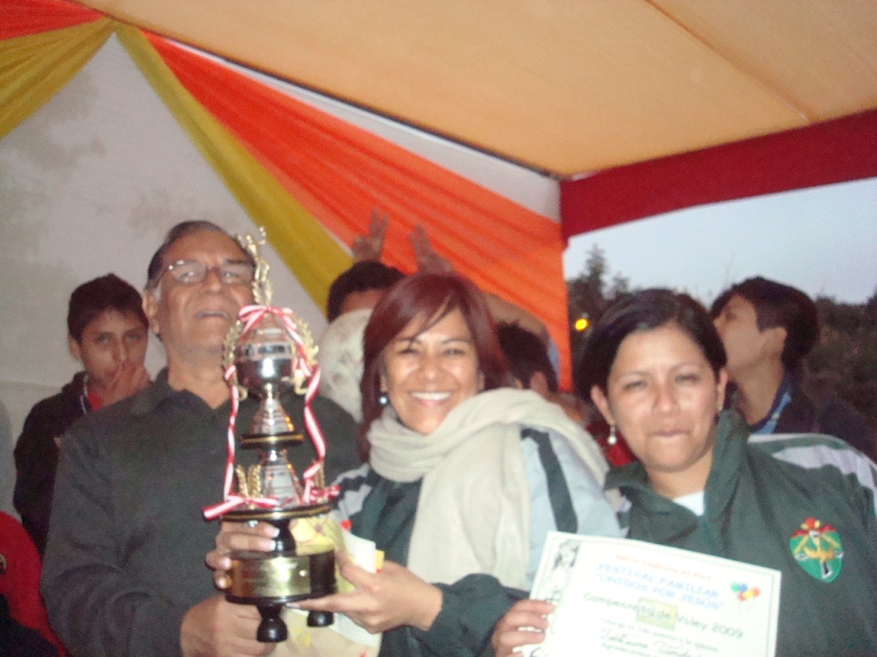
Julio, Isabel and Erika hold the championship cup
Also we had a volley-ball and football championship organized for all the Anglican young people in Lima. The venue was Holy Trinity church, where we were the winners of volley-ball. It was a time where our teenage young people enjoyed this important event, and it was healthy for us. With two months to go to the end of the year we have made a diagnosis and still we are short of covering some specific areas; that is, that everyone knows the word of God when we have visited homes, going to old people, children, women. They are always ready to listen and grasp the Gospel. In some cases they have a sick condition because of the poverty where they live. They are in the habit of falling ill with TB, bronchitis, pneumonia, and skin diseases since they live near the pigs. We have been engaged in making up for their sorrows. Already the climate is changing little by little. We are looking to God for this Christmas that on home tables may there be bread and a meal, people entertaining Jesus in their homes and in their lives.
We love you with the love of Christ. Julio and Norma 27 October 2009
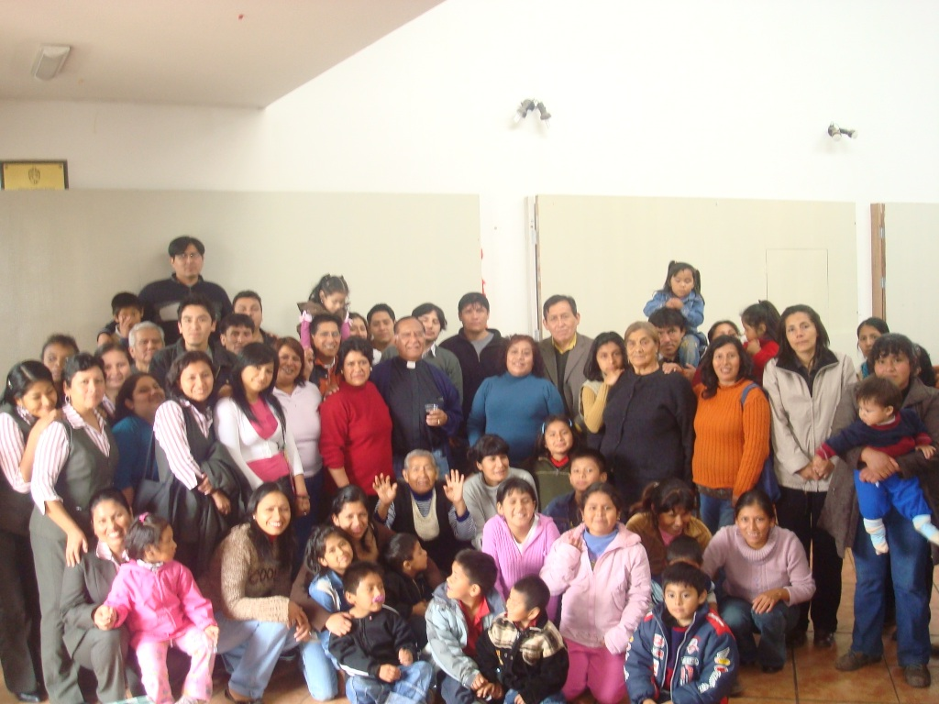
Church members at Julio’s 29th anniversary of his ordination

From the Director of the Infants School and Child Day Care Centre

Hello, beloved. We are giving breakfasts each morning, everything varied and nutritious, so that the children are well protected and healthy. Again there was a general clean-up and disinfection of each classroom.

We made visits to the homes of the children with the Social Assistant Erika Montoya, and there were various cases to follow up, since in several homes we could observe failure in security and hygiene where our children live. We got in touch with the health clinic of our community, and jointly with Erika they are seeing the way to support and to begin a work of supporting families of the most distant communities in Pamplona Alta, where vital basics for looking after health are limited and the families buy water from a lorry cistern.
Humidity is one of the problems that we are fighting in Holy Trinity. The church roof falls in each time the rain and the summer come. At present it is dripping and filtering water each time that it rains. Where we hold three classes two of the panels of the classrooms have fungus and we have to paint and tidy them up. We pray for the infant population that we, the Anglican schools, reach and we ask that the Lord provide that which is lacking according to his riches in glory.

We pray for you. Thank you for helping us and continuing forward in this project with children of our population in Pamplona Alta. In Christ Jesus, Isabel Montoya, 12 August.

We continue in the work that the Lord has put in our hearts. Brothers and sisters, economic matters in our diocese are bad on every front. There has been no money for a month. They cut back the lunch budget. We have been helped much by the UK gifts for breakfast. We do not know what will happen at the end of the year. We have to say goodbye to three people in the school because we do not have the money to pay them. The budget for September, October and November has been reduced, and we do not know whether there will be money for December. Only we trust in the provision of the Lord and in the goodness of your hearts. We shall continue praying, now even more in times of change.

Thanks for all your love for the children and economic and spiritual help for us.

In Christ Isabel Montoya 9 September

The school-child day care centre continues forward with a smaller budget. With your help we continue giving the children lunch through the funds for food which you sent last time. Already we are not giving breakfast to everyone; now only to a group of 30 children, the most, most, most needy.

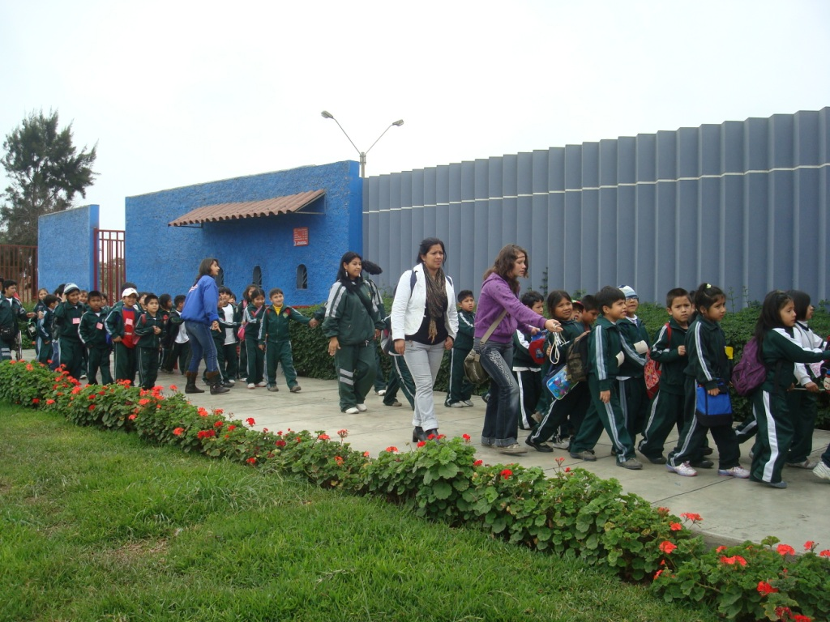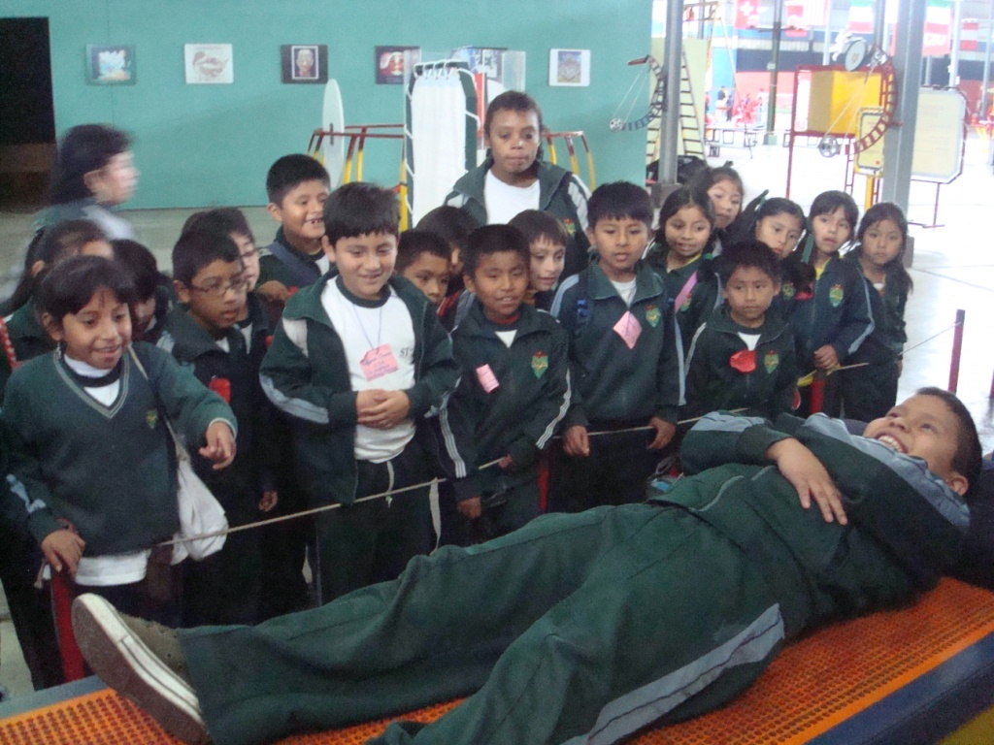
Entering the museum and enjoying the exhibits

Last month we had an outing to the interactive museum, called ‘Park of the Imagination’, which is located 90 minutes away from Pamplona. The children were able to observe the human body, the constellations, the sun, water, the earth, how we ought to take care of our world. It was more appropriate for study, but yet they were entertained greatly. They learnt a lot. It was on 16 October.

On Friday 23 we celebrated the day of blessing pets, teaching the children the importance of loving and taking care of pets. They were very happy showing their animals to their companions.
On Thursday 29 we celebrated an evangelistic campaign for children. We went on the streets of our community with posters teaching the community as we do each year the truth about Halloween, delivering leaflets and singing praises to the Lord.

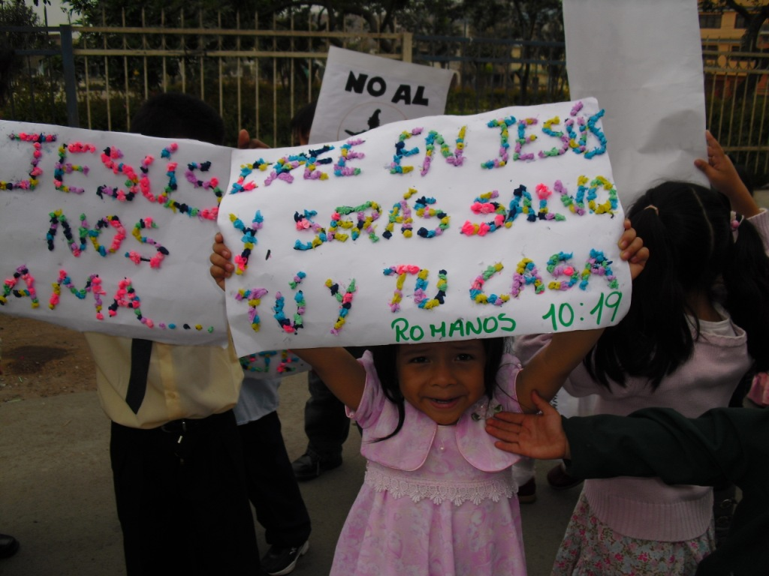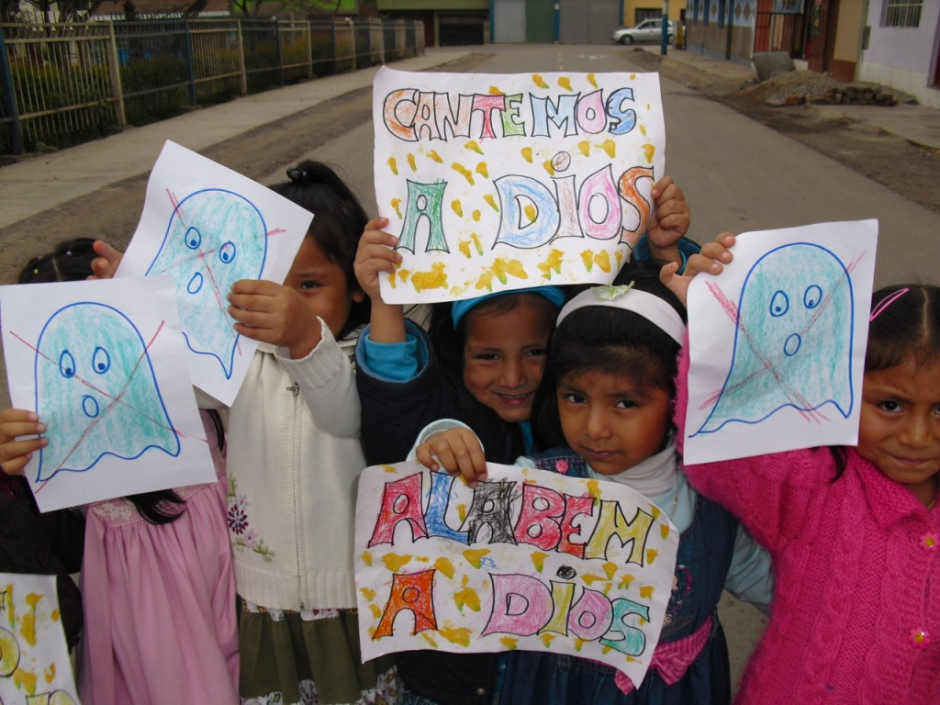
Evangelists witness at Halloween

Thanks to those who support us, who help us to continue serving and helping the children of Pamplona Alta. Please can you help us to find funds for Christmas and the following year in the summer? We shall begin, God willing, on 4 February. We do not have a response concerning a new location. It looks as if we shall continue using the church and the ground floor of the Vicarage. Since our economic situation in the diocese continues to be bad, next year we schools have the obligation to seek funds to support ourselves economically, since there are many who have given up supporting our diocese economically. But in spite of all that we see, we know that our God is sovereign; and he will fulfil his promises for his faithful people. In all ways you have been faithful in your spiritual support and the giving that has helped us very much. Thanks to you that you are our boost through the Lord. “Praise be to our God”.

Greetings from all of us. With a hug! Isabel Montoya. 10 November 2009

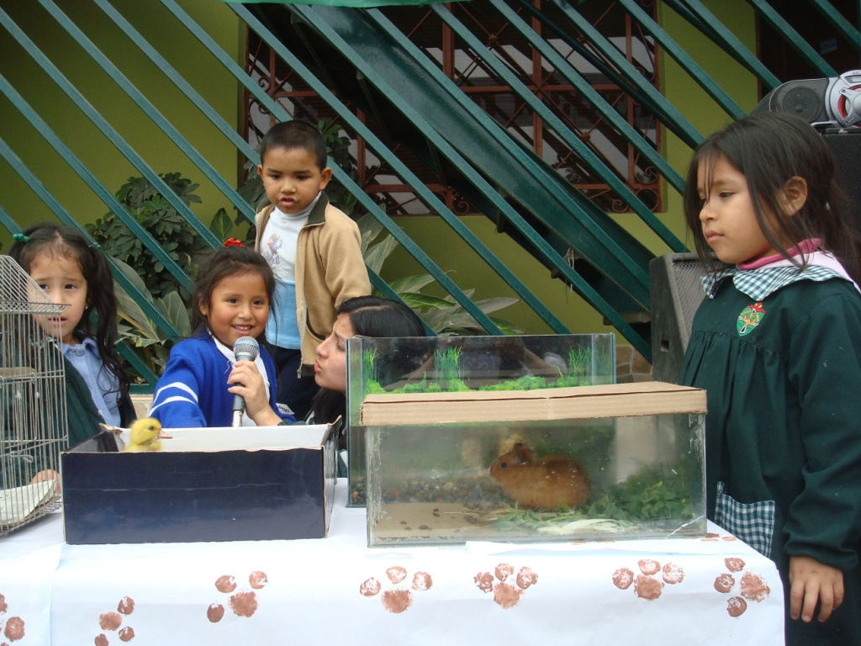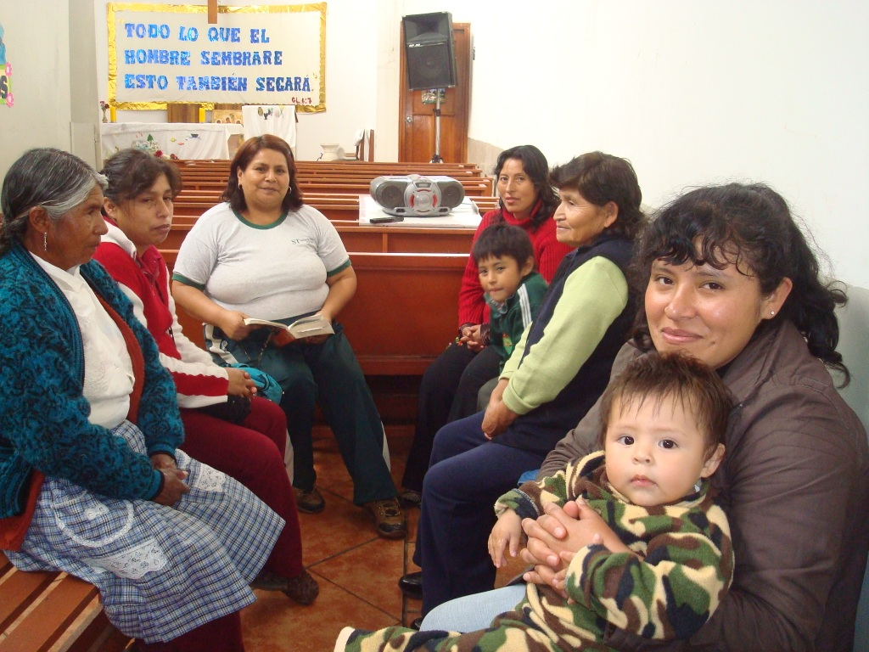
At Holy Trinity blessing pets, and a women’s study group

