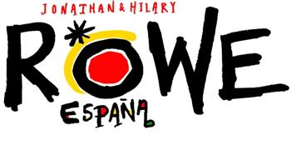
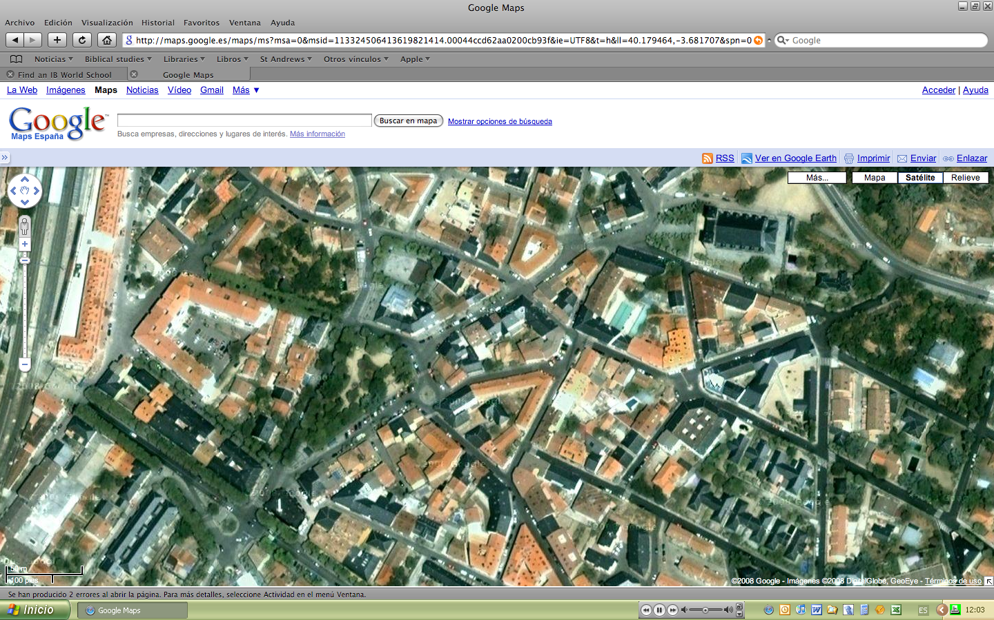
Easter 2009
Where are you?

Where are you? Are you in a prime location? Would the estate agents call it ‘desirable’, perhaps because it’s in the right catchment area? Location, they say, is the only thing that matters when talking about property. And this is also true of the Christian life.
Jesus died on a cross. This is the only place that matters when talking about God’s rescue of all people from their sins.
Christians are ‘in Christ’, which means we are with Jesus. It’s like being in God’s catchment area – we are sure of a place in heaven because Jesus has done everything necessary to get us to the top of the admissions list despite the fact we live a long way away.
We happen to serve God in Spain, in a town called El Escorial, on the outskirts of Madrid. The map shows some of our most important locations.
But whether in Spain, Britain or anywhere else, Jesus promised to be with his followers always. May we all know that this Easter.

For Prayer
For the witness of our churches this Easter, whether in Spain or elsewhere.
For completion of the building work on La Chimenea – it’s nearly done.
For Silvia, who attends our church, who has lost her sight following an operation to remove a brain tumor.
Jonathan & Hilary Rowe are seconded by the South American Mission Society (www.samsgb.org) to the Seminario Evangélico Unido de Teología, Madrid.
Our Church
The Seminary
Our Flat
Train Station
Town Hall
Village Square

