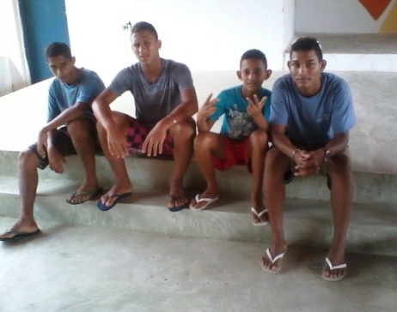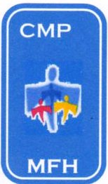CASA DE MEU PAI

My Father`s House

Av. Ministro Marcos Freire – 5657

Rio Doce – Olinda / PE CEP: 53.030-000
CNPJ: 07.027.470/0001-98

Fone: 3429.0278

CMASO 140/2006
www.olindamission.no-ip

Hi Friends,

From left to right:-
Renato; now 16 yrs old and living in the interior with his mother
Cleiton; now 18yrs old and living with his grandmother in Olinda
Arthur; Now 14 yrs old and living at home with his mother
Michel; Now 18 and living with his married sister. In the next town north called Paulista.

You may remember I mentioned these four ex boys from MFH. Since the camp Cleiton and Michel have returned to regular church activities, praise God.
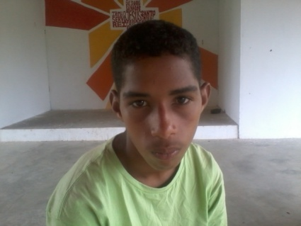

Renato is now recovering from serious emergency surgery to remove an abscess on his kidneys and will need time to convalesce.

March brought one new boy to MFH called Deybison
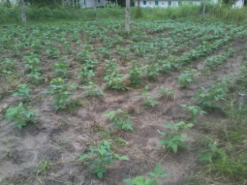
Out on the farm we have been busy preparing the land and planting new crops. This month we have begun to harvest our early beans ‘Feijão” which are part of the Brazilian stable diet and will help supplement supplies at MFH.

Staff changes at MFH. Andy Roberts is moving on and will no longer be part of the MFH team.
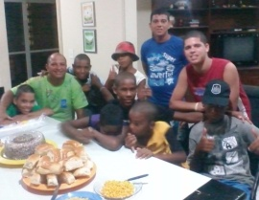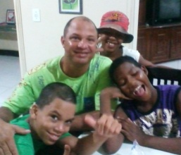
Jefferson has now completed a four year term as house father and is also leaving us. Please pray for them and their next steps and for MFH as we adapt to new situations.

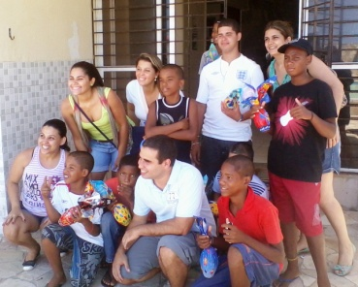Easter Joy! A group of lawyers visited MFH on Palm Sunday with Easter Eggs, which brought much joy to the boys, as well as a few tummy problems! Chocolate however brings only a short moment joy, may the true joy of Easter fill your hearts as you remember firstly the passion of Our Lord and the celebrate His glorious Resurrection

Happy and Blessed Easter

Ian, Siméa, Tim, John and Hudson

“For God so loved the world that He gave His only Son...” John 3 v 16

