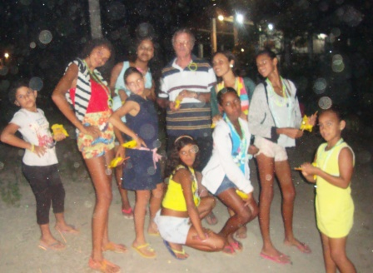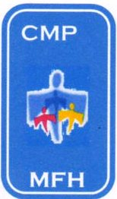CASA DE MEU PAI

My Father`s House

Av. Ministro Marcos Freire – 5657

Rio Doce – Olinda / PE CEP: 53.030-000
CNPJ: 07.027.470/0001-98

Fone: 3429.0278

CMASO 140/2006
www.olindamission.no-ip http://casademeupaipe.blogspot.com.br/

MFH Prayer News – January 2013
The hummingbirds go camping
You may remember that some time ago we had a volunteer from Lincoln called Debbie Adams. Debbie started a work with a very difficult group of girls, using gardening as an attraction. Hence the name chosen Bejaflor [hummingbird].Unfortunately, when she left, we were unable to find a volunteer here to keep the work going! However a short time ago we were joined by another UK volunteer called Samantha or Sam. Sam has been able to revive this group meeting with them despite her limited Portuguese. So last week MFH sponsored a three day camp for the girls in this group, and a great time was had by all! Now we are once again faced with the possible prospect of Sam returning to England, [in April] and the need to pray for someone to take her place. {Debbie come back!}
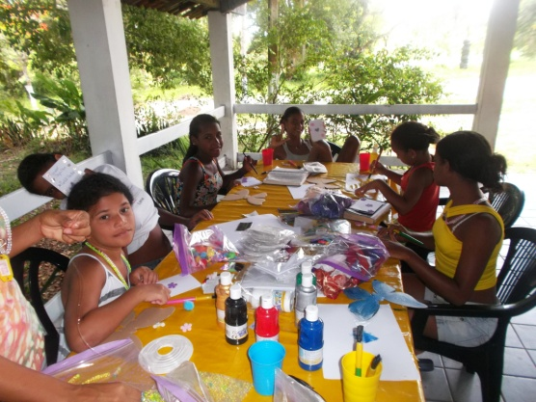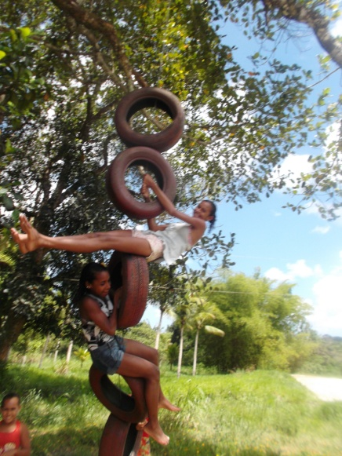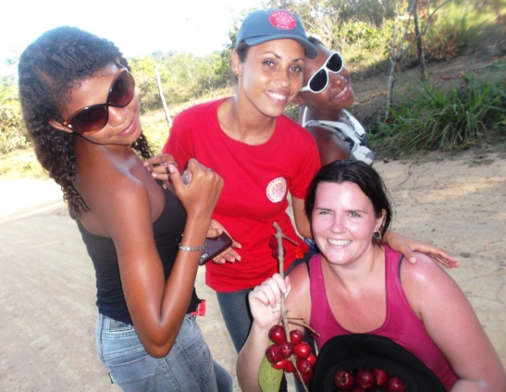

More news soon,
Ian

