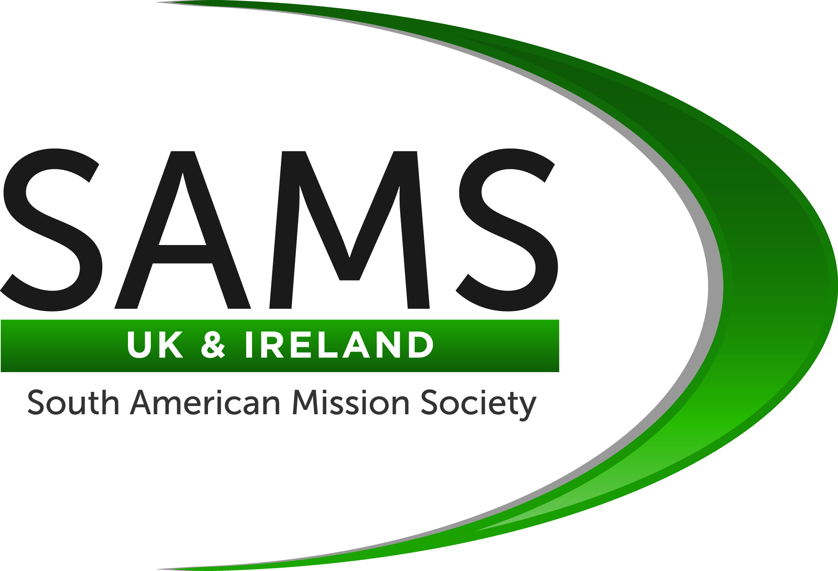
Mission Paraguay
2013 Report

Mission Paraguay works through the South American Mission Society UK and Ireland to support the Anglican Church in Paraguay by providing funds and a volunteer work force for:

- practical projects, usually buildings;
- activities with children and young people;
- community based work to relieve hardship and encourage self sufficiency.

Each year God calls Christians to build cross cultural relationships, and share the love of Jesus, while using their skills and experience working for three weeks alongside fellow believers living in different regions of Paraguay. Through our many supporters God provides funds and other resources to source a wide range of projects.

Working together, changing lives, growing in faith.

In July twelve people were based at the church at Roque Alonso, Asunción for two weeks and also spent five days in Concepción working with missionary Claire Holmes from Northern Ireland. They visited many communities in the Asunción and Concepción areas including some very marginalised Indian villages in the Chaco. Their programme included: evangelism, visits to families, sewing workshops, distribution of spectacles, activities with children and assisting with the mobile toy library which provides opportunities for play for children in some of the most deprived communities in Asunción.
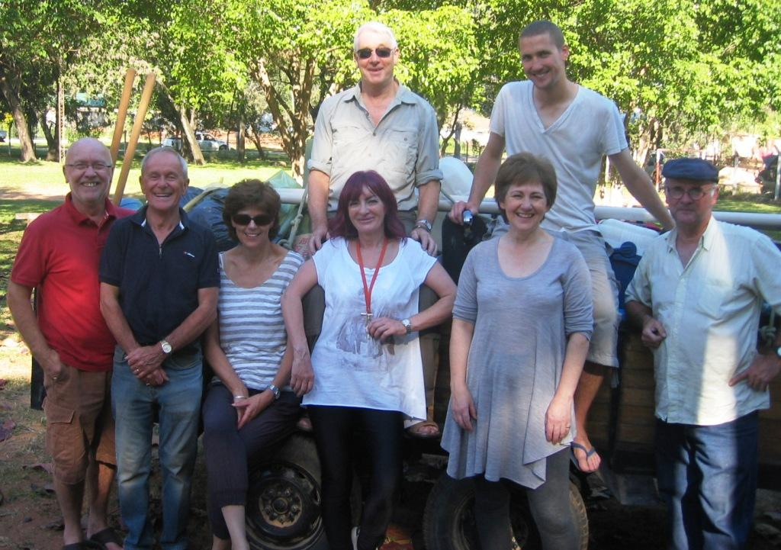

In August a group of four people worked at La Paciencia, a village in the La Patria Indian community in the Chaco, which is approximately 80km from the nearest tarmac road. Under the supervision of missionary Chris Hawksbee they assisted Indian builders to construct a new church and carry out a range of home improvements for families living in very basic circumstances.
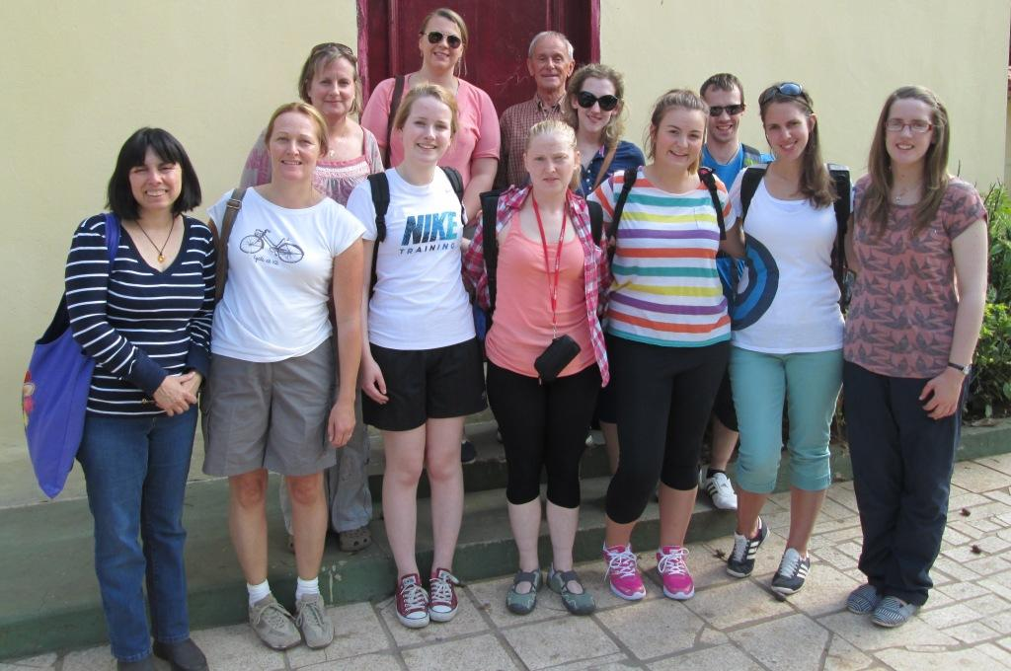
Another group of twelve people mainly from churches in Ireland was based at Concepción assisting Claire Holmes and the team from San Pablo Church as they visited different communities to work with children and young people, up to 40km from the church. They also repainted the hostel in Concepción used by Indian families and assisted with the distribution of spectacles sent from the UK.
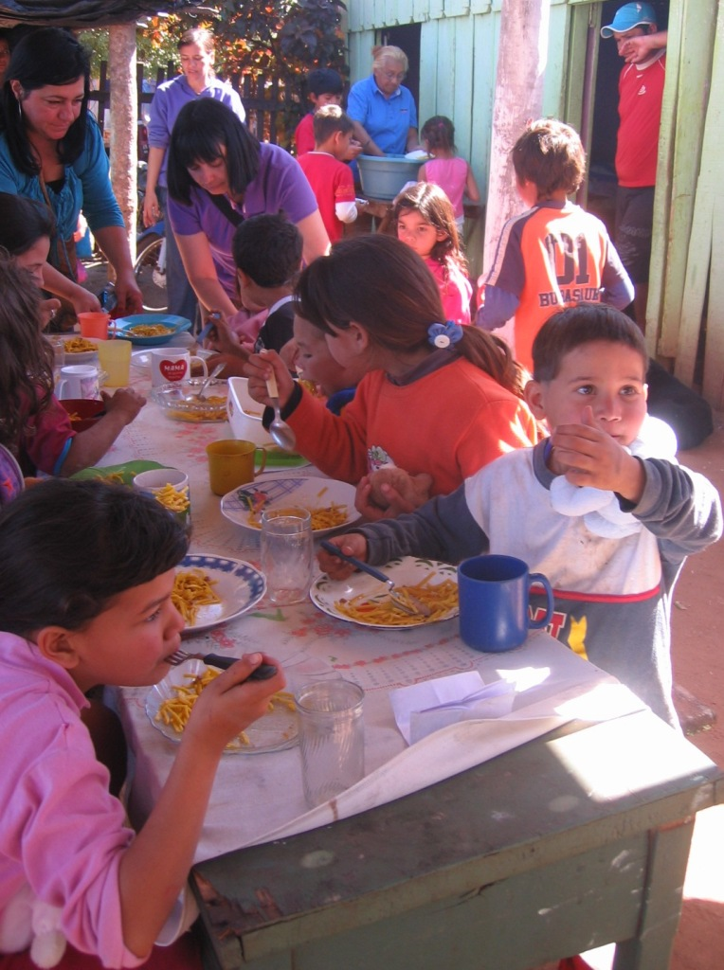
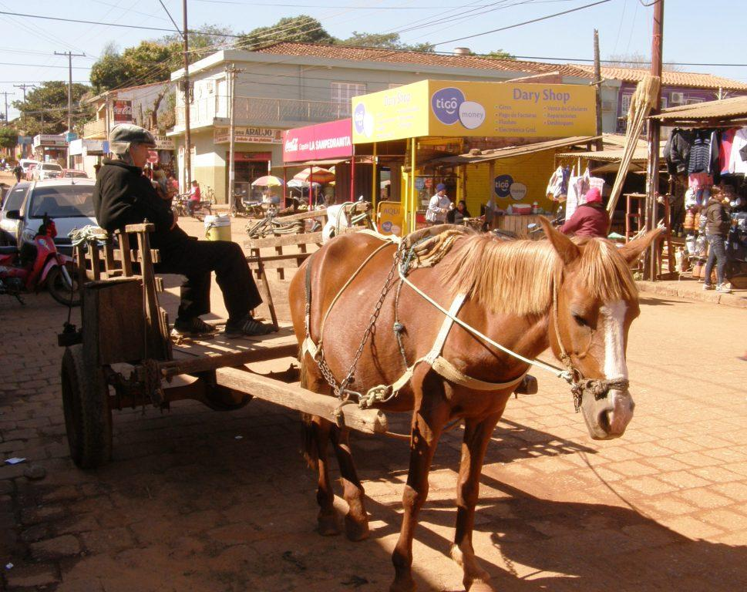

Projects funded by Mission Paraguay during 2013

Through the generosity of our supporters the following projects have been funded this year. Owing to the nature of some projects they will continue into 2014 when additional funding will be allocated to complete the work.
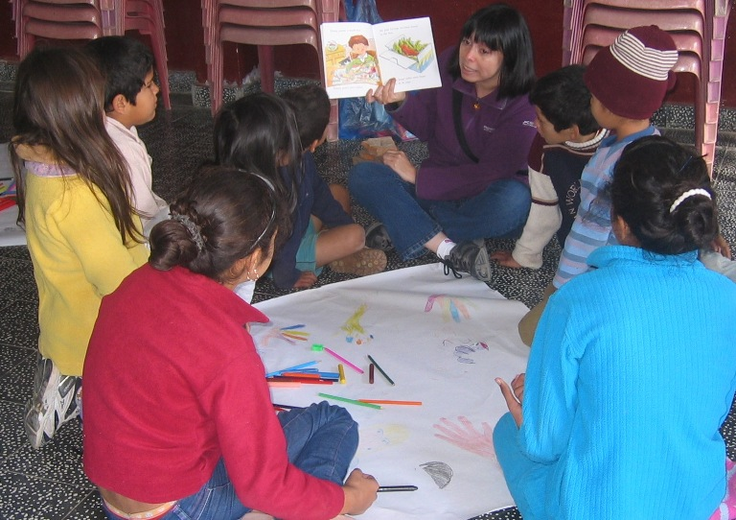
In Asuncion
- supplying materials to complete an additional room to be used for children and youth ministry at the church at Remansito. Church members will provide the labour to finish the work;

- funding repairs to a diocesan vehicle;

- supplying data projectors, screens and a laptop for diocesan ministry use;

- supplying materials for repairs and extensions to three basic overcrowded homes for families at Roque Alonso;

- funding materials for work with children in a number of church communities in the Asunción area;
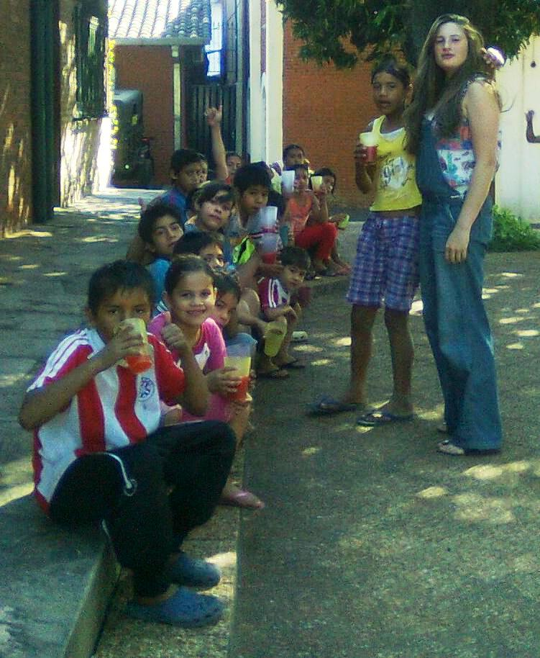

- supplying stationery materials for St Andrew’s Church;

- funding visits and supplying toys and dressing up clothes for the mobile toy library operated by FEISA Teacher Training College;

- supplying toys for children from the Chacarita shanty area attending the biweekly meal and events at the diocesan multi-use building;

- commencing funding the construction of a new church building at Mirador. The funding of this project will continue into 2014.

In Concepción
- supplying all materials for the completion of the church building at Remanita;
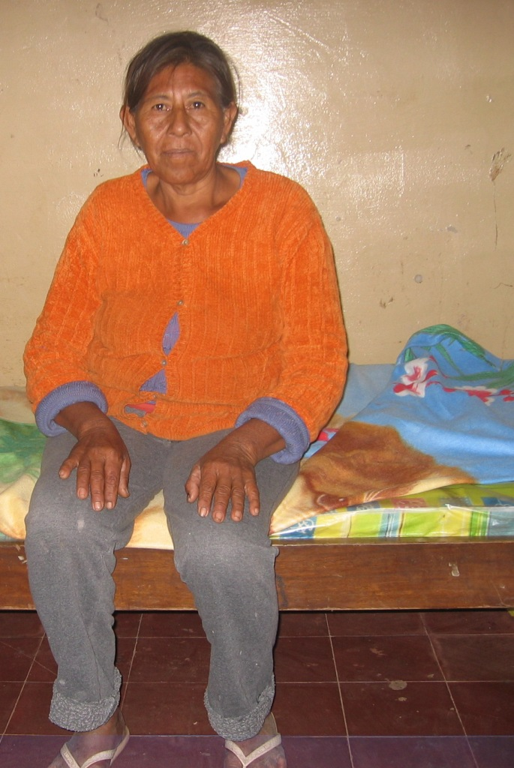

- providing 10 new mattresses for the hostel for Indian people sleeping on the concrete floor;

- providing funds for work with children and young people.

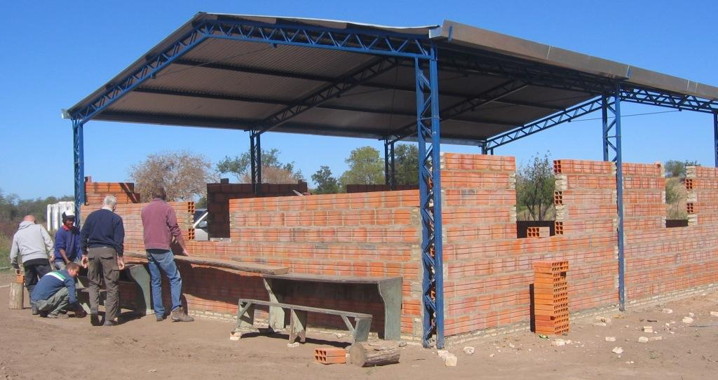
In the Chaco

- funding the construction of a new church at La Paciencia in the La Patria community;

- construction of a 40,000 litre underground storage tank at La Paciencia to collect rainwater from the new church for use during the prolonged drought periods;
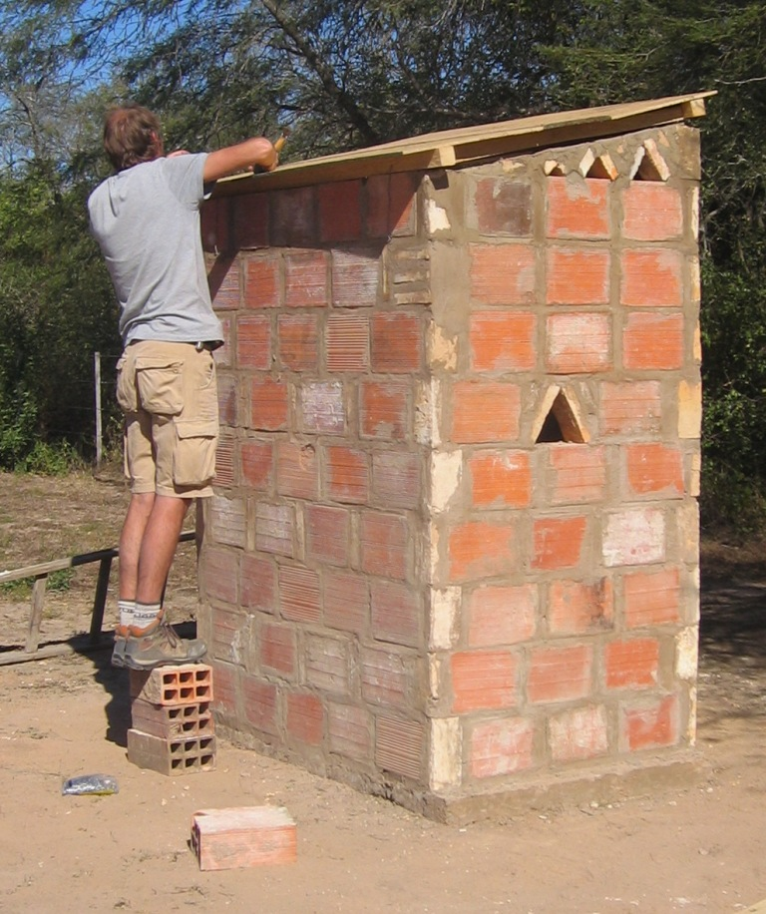

- repairs to an existing water storage tank damaged by tree roots;

- building a long drop toilet for use by diocesan personnel at Rio Verde;

- supplying a number of 14 solar powered battery chargers for use where there is no electricity supply;

- construction of up to 10 homes built of bricks with sheet metal roofs and concrete floors to replace overcrowded homes built of palm logs, plastic sheets and other discarded materials;
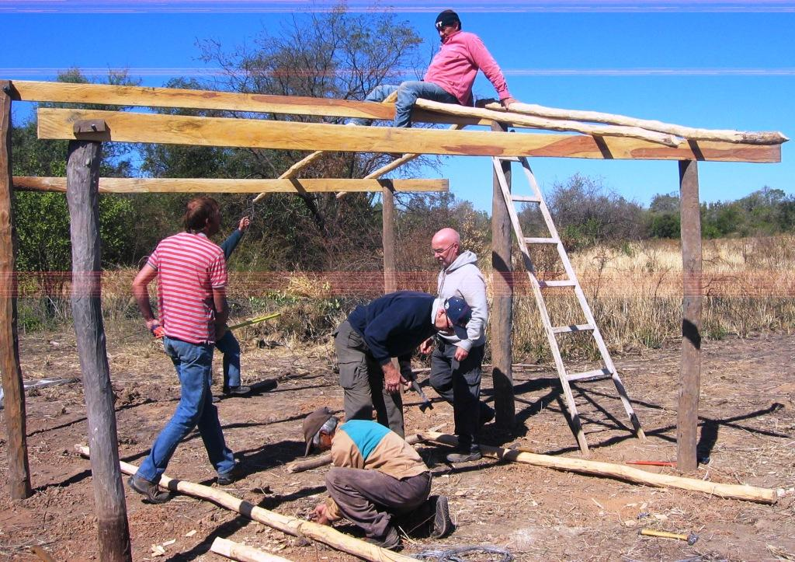

- funding the use of a diocesan vehicle for use by visiting pastors from Asunción to visit families and communities in villages in the Chaco;

- assisting to fund the employment of local expertise to work alongside missionary Chris Hawksbee to promote self sufficiency projects among the Indian communities;
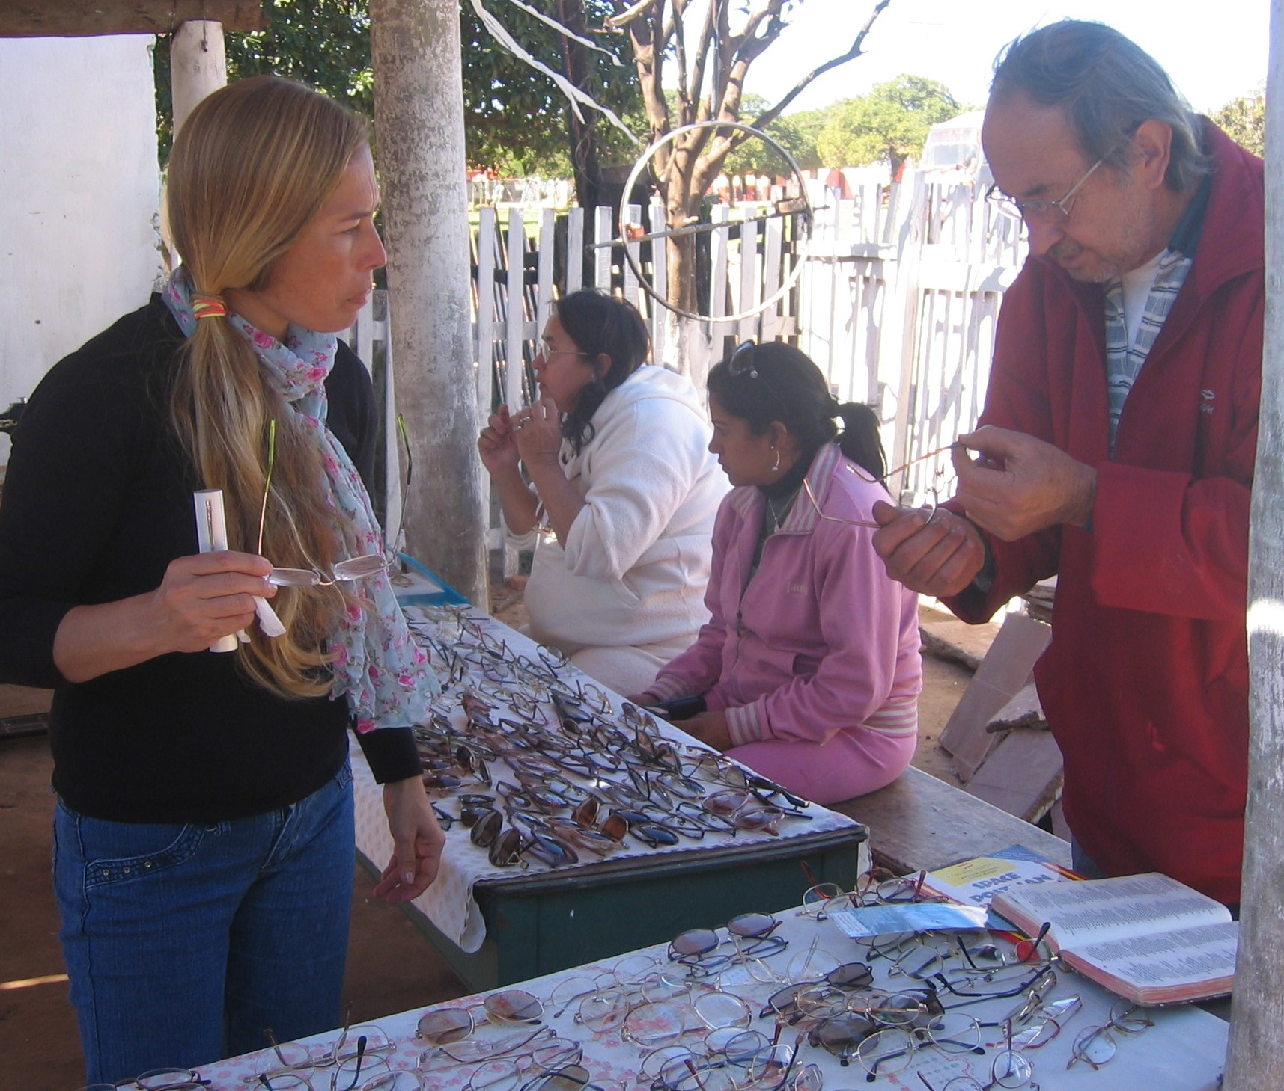

General items

- supplying and distributing over a thousand pairs of spectacles to communities in Asunción, Concepción and the Chaco;

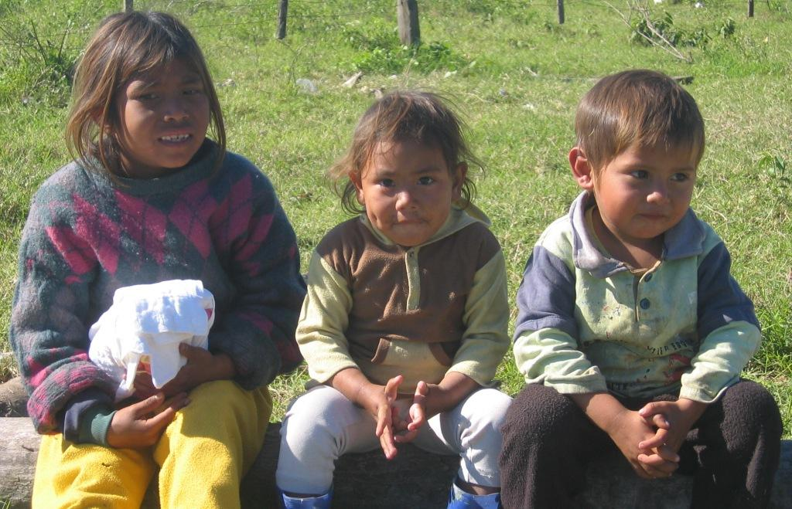

- supplying clothes, blankets, toys and other items for distribution to people in need. Some clothes are sold for a nominal sum to raise funds for work with children and to operate the Saturday comidor which provides a nutritious meal for children in a number of communities;
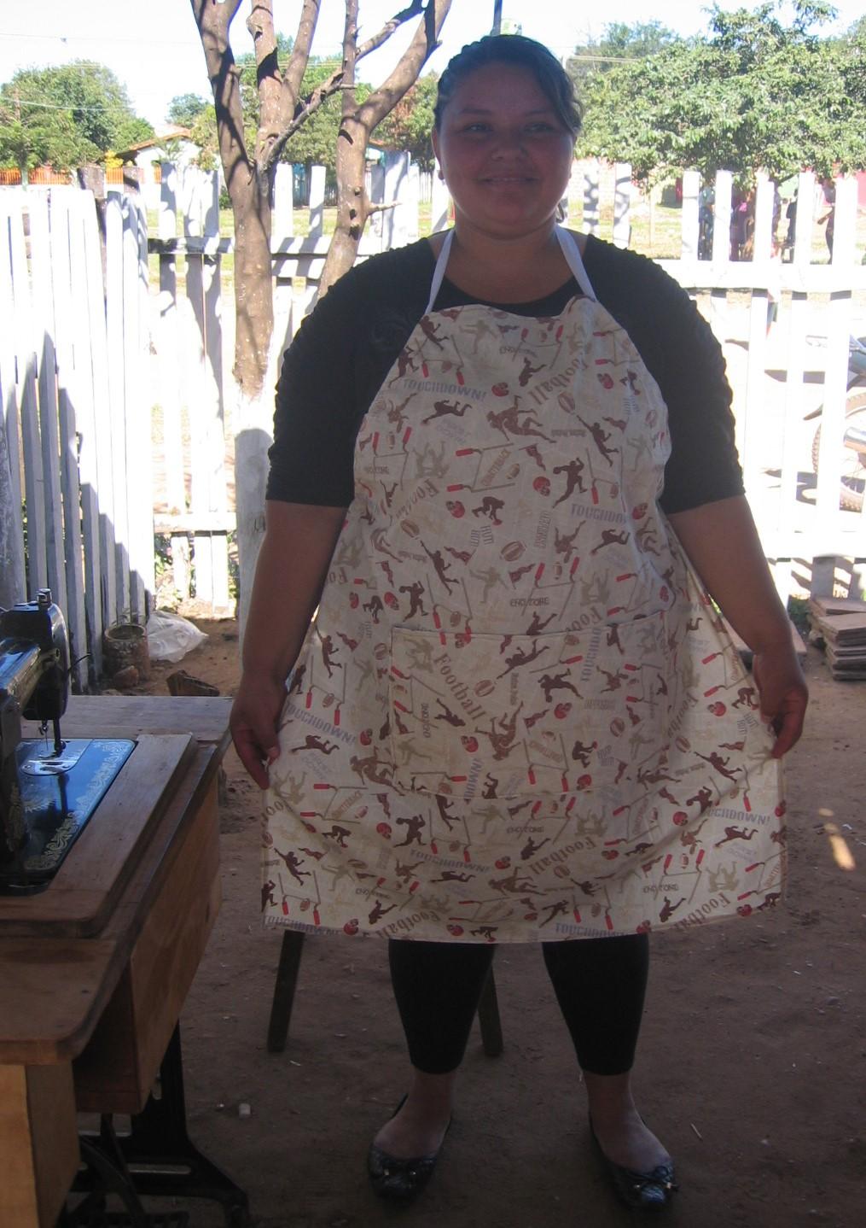
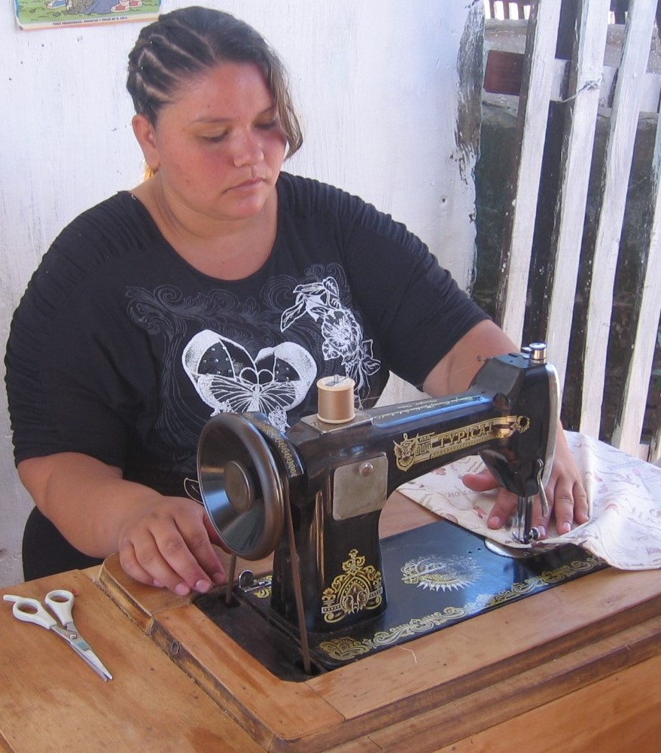
- providing materials for the sewing workshops which have operated for the last six years in locations in Asunción, Concepción and occasionally at Rio Verde in the Chaco to encourage self sufficiency;

- supplying medical items for Nurse Beryl Baker working in the Chaco.

Thank you to everyone who has supported our work through
your prayers and generosity.
Mission Paraguay 2014

It is planned that during the summer of 2014 once again there will be three Mission Paraguay groups of volunteers based at Asunción, Concepción and in the Chaco.

For those interested in joining a group an application form and further details may be downloaded from the SAMS UK and Ireland website: http://www.samsireland.com/projects/mission-paraguay

Projects for 2014

While the planning of next year’s projects is at an early stage and are dependant upon funding being available, discussions are currently underway concerning the following projects in the Chaco:

- a further underground water storage tank. There is no piped water supply in the Chaco and the storage of rainwater is vital for use during the annual periods of drought;

- at La Patria we plan to fund the construction of brick walls to a school for Indian children which meets under a metal roof and to replace the timber walls of a church with brickwork;
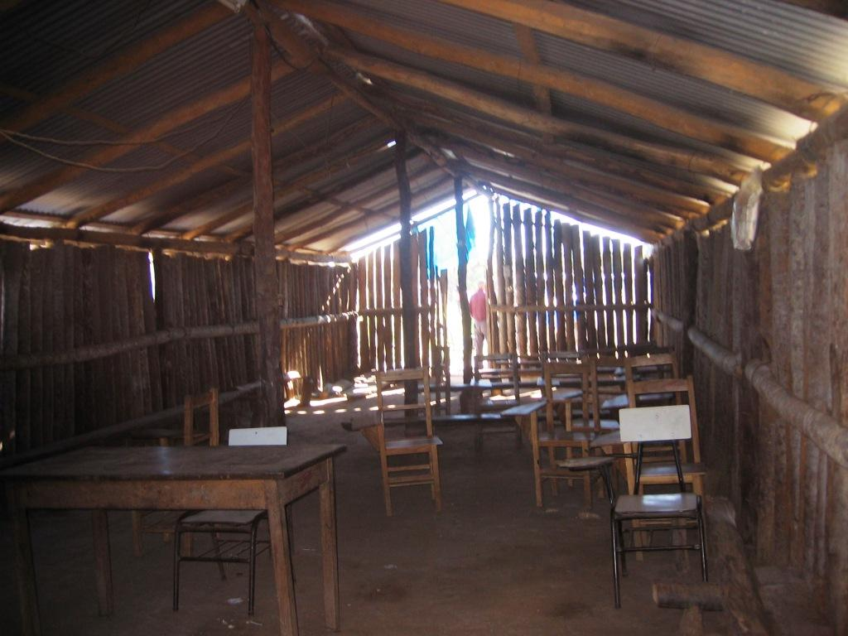
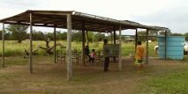

- as in past years Mission Paraguay will work with Chris Hawksbee to provide new homes and improvements to existing homes for the Indian families. This includes promoting the manufacture of bricks within communities.

In Asunción and Concepción we hope to be able to continue to provide funding:

- to assist the general ministry of the Anglican church and, as in past years, to give specific support for work with children and young people including for the mobile toy library;

- over recent years a number of church members have been assisting to improve the homes of some of the poorest families in their communities we plan to continue to assist in this work by supplying building materials;

- to support the sewing workshops.

For further information please contact:

David Orritt, Coordinator. Tel: 01704 892566, email: davidinparaguay@hotmail.com

Or

SAMS UK and Ireland, 1 Irwin Crescent, Lurgan, Craigavon, Northern Ireland, BT66 7EZ
Tel: 028 3831 0144, email: info@ samsukireland.com

