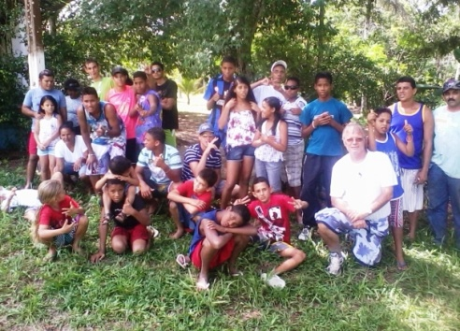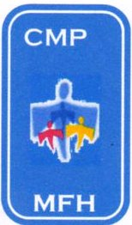CASA DE MEU PAI

My Father`s House

Av. Ministro Marcos Freire – 5657

Rio Doce – Olinda / PE CEP: 53.030-000
CNPJ: 07.027.470/0001-98

Fone: 3429.0278

CMASO 140/2006
www.olindamission.no-ip.co.uk

CARNAVAL CAMP-2012

This year I took a smaller group of thirty out to the farm to escape the pre-lent, anything goes, Brazilian carnival. Siméa joined us for a very special moment on the Sunday, and then returned home to do some writing for a book contribution that she has been asked to do!

One of the things that made the camp special for me was the participation of four of our ex boys from MFH.
All are doing well and turning into fine young men. You may remember praying for them in the past.

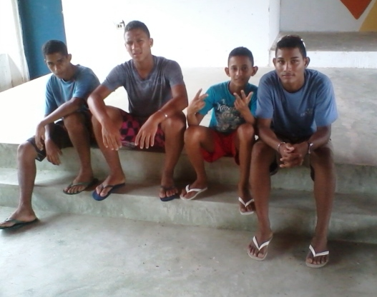From left to right:-

Renato; now 16 yrs old and living in the interior with his mother

Cleiton; now 18yrs old and living with his grandmother in Olinda

Arthur; Now 14 yrs old and living at home with his mother

Michel; Now 18 and living with his married sister. In Paulista.

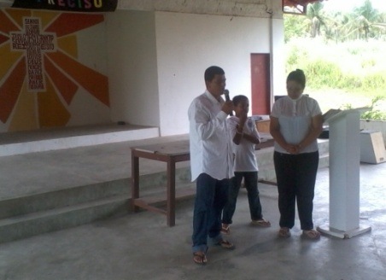
On the Sunday 3 people were baptized using the farm fount.
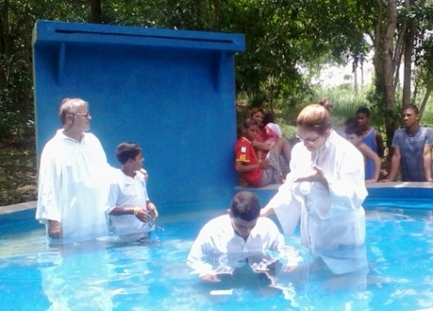Following our morning service at which we heard inspiring testimonies, we moved through the farm to the fount , where first Eduardo, whom we have been supporting during a six month drug withdrawal program, and is now being considered for as an educator at MFH.

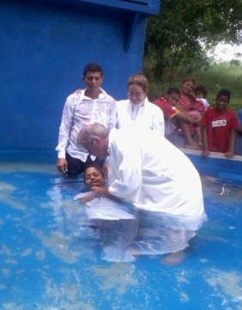

Then it was the turn of Mateus, one of the newer boys at MFH but already very determined to follow Jesus, and thirdly it was the turn of Isabela, as she is only aged less than one year and has been adopted by a couple, members of Agua Viva church, she only got a sprinkling!!

We praise God for all his blessings, especial for those who renewed their commitment to the Lord at this time

More News, soon Ian, Siméa

