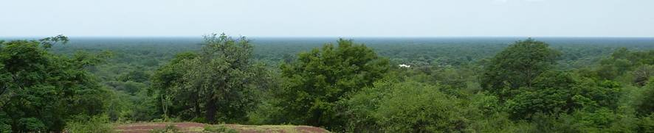
Land for Life
Fundación Refugio
Circular No. 12 October 2011

A quiet but busy few months
Andrew has been tied down for the past weeks with travel and report writing, and will resume his trips to the Chaco later this week. Marcelo, through his contract work with the government agency for protected areas has kept tabs on events in the Chaco. The registration for Fundación REFUGIO with the tax authorities has moved forward. Our accountant hopes to have that completed in the next few weeks.

For Sale: Saladillo (24 000 acres of Chaco Forest)
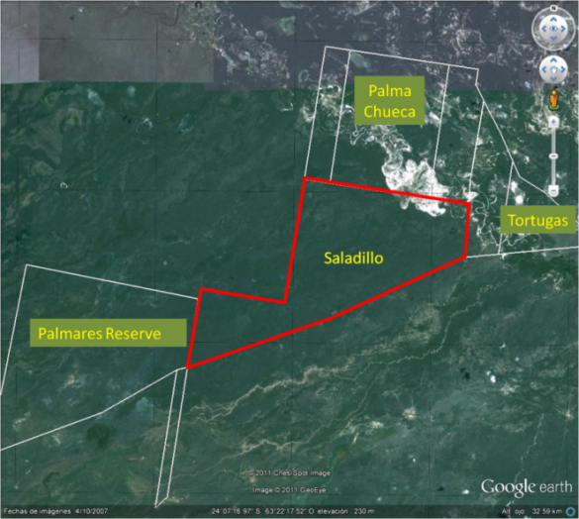
Our search for land has led us to Saladillo (see map on the left). It is next-door to Tortugas, the land we had previously been looking at, but which has some complications with the title deed. It also shares a border with the Los Palmares nature reserve, and another plot, Palma Chueca, which could eventually become a private reserve.

Saladillo covers an area equivalent to over 16 000 football fields, (24 000 acres). If acquired, it would add to what is already being protected and effectively help to create the single largest protected area in the western Chaco. Its location makes it ideal for the implementation of income generation projects (e.g. eco-tourism), as well as for initiatives aimed at encouraging neighbouring land owners to protect and manage their lands.

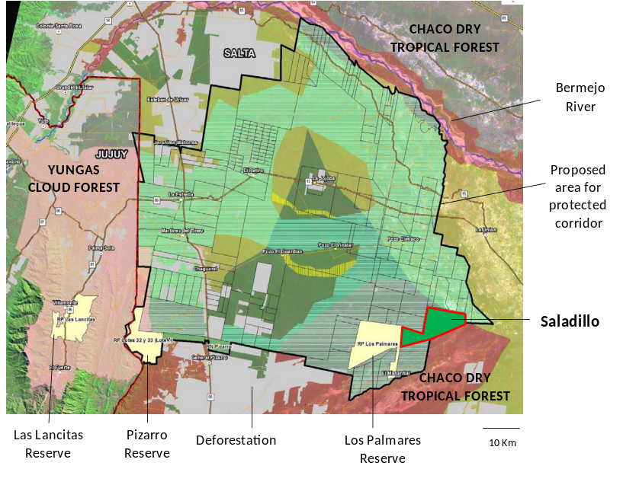
If Saladillo can be protected and managed effectively, it would make a significant contribution towards helping protect a broader region that connects the dry tropical forests of the Chaco with the more humid yungas (cloud forest) of the Andean foothills. It is also in a strategic location with regard to the advancing deforestation front, as shown in the map on the right.

Government conservation authorities would be keen to see Saladillo protected, but political inertia means there is little appetite for doing anything themselves. However, it may be possible to get the government to give the initiative its moral backing, which may help with attracting funding, both to purchase and manage the land.

The map shown here was produced by a CEBIOS, a conservation organization with whom Marcelo works closely. They have done much of the ground work in researching the conservation needs and potential for the region, and are a group we are keen to work closely with in the future.

The challenge ahead
The owners of Saladillo are asking for somewhere in the region of 95 pounds per acre (approximately 950 000 thousand pounds). We are making informal enquiries about potential donors, and will in the meantime develop a detailed prospectus and business plan. We are learning as we go here, as we have little to no experience in how to go about this particular challenge! We would value help and advice from anyone out there who could help us put together a plan.

Future Work
- Having just secured permission from Saladillo’s owners, we will be undertaking a rapid assessment of Saladillo, to determine its potential for conservation work. This will require walking the land, taking photos and conducting mapping work to be used in developing a prospectus for fund raising. If funds allow, we would also like to fly over the region and take air photos.

- Andrew and Marcelo have been invited to contribute a chapter to a Christian book on the environment to be published by Fundación Kairos.

- We hope to attend the upcoming Land Forum 2011- ILC LA Regional Meeting "Land, territories, management and social inclusion”, which is to be held in Salta in November.

Bird Survey
We are currently waiting to hear from the St. Pauls Church building tithe on the outcome of our request for financial support for the Chaco bird survey project we have previously mentioned. We are very pleased for the park rangers in Los Palmares who have managed to secure a grant to monitor the rare Orinoco Goose (Ganso de Monte) Neochen jubatus.

Family news
Cecilia and Carolina are very much looking forward to the UK after Christmas, a fact that has them very excited. Ceci will be gaining some work experience in biological research at the University of Hertfordshire and making enquiries about the possibilities for her to study in the UK. Carolina will be spending time with her grandparents and cousins in Norfolk. Tomas may travel to Spain, but this is subject to exam dates (and results!). He continues to enjoy his course, though it is a lot of hard work and not much play at the moment.

Since July Andrew has been in El Salvador, Bolivia, England, Ethiopia, Sydney, and Singapore on contract with Compassion International. He was also in Peru, where he was invited to speak at a gathering of the Anglican Communion´s Environmental Network meeting, which provided a good opportunity to share our vision for Land for Life internationally. His next trip overseas may be in January, to Cambodia.

Prayer Pointers
Please pray:
1) for Andrew and Marcelo to be able to make the assessments of Saladillo quickly (as rainy season is approaching)
2) for speedy production of a prospectus
3) for much wisdom for the L4L team
4) for patience and flexibility from the owners of Saladillo

Contact: andrewleake@gmail.com

