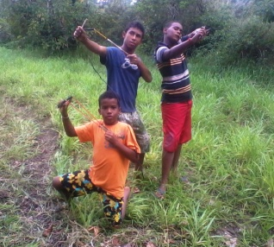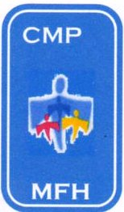CASA DE MEU PAI

My Father`s House

Av. Ministro Marcos Freire – 5657

Rio Doce – Olinda / PE CEP: 53.030-000
CNPJ: 07.027.470/0001-98

Fone: 3429.0278

CMASO 140/2006
www.olindamission.no-ip
MFH Prayer Points – July 2012
July is coming to an end as so are the school holidays! School holiday, as you well know means that children have those extra things to do! Here it is also winter school holidays, which means rain [rather like the British summer] So off to the farm for camp, yes it rained hard and heavy, but at least here the rain is warm so activities continue as normal, while we try to cope with lots of muddy wet clothing hanging “in” to dry!
Seriously this gave us a chance to teach our town boys a little about rural life, as well as lots of physical activities. Great for the boys, but needing lots of energy from the team.
Too much of a good thing! Yoghurt! We have managed to be awarded a contract with a government agency which receives and distributes food donated by firms as it gets too near to its sell by date to be sold to commercial out lets. However we never know what or when, so when they ring for us to go and receive from the wholesale food market, it’s a bit of a blind date! Much of what they receive is normally given to schools in needy areas, however it was school holiday so in july it was Yoghurt! 50 cases of expensive Activia and Danone Yoghurts! Which our contract says “must be consumed on the premises” so no distribution to needy families! Try Yoghurt for breakfast, dinner and tea! For a month! And they still keep coming!
We have just held our fund raising event, a happy hour afternoon tea type event held at Dayse´s reception place. We managed to sell over 100 tickets and it proved to be a great moment to raise the local profile of MFH, An excellent tea, fashion parade for the so called mature figure, and lots of tome to talk about the project. Thanks to all who prayed for this moment.
A Casa de Meu Pai = House of my Father. A Christian support group has produced an internet site for us free of charge. It is now up and running, and although in Portuguese it has a Google instant translation button which turns it into a “Computer” English site. So you can either try out your Portuguese, or understand most of it on the English version. All you need to do is click on the following reference while holding down the Ctri button on your computer
http://casademeupaipe.blogspot.com.br/

As you will see it is still in its early stages, so keep watching as we continue to build on what we have.
For those who are following the vans progress, we can report that it is now up and running, so we have transport back, principally for taking the boys to church [ and , of course, fetching yoghurt]. Next step try and sell, or part exchange on something more reliable.
News of some of the boys.
Emerson has been with us on and off since he was 2yrs old and part of Emanuel Crèche. He is now strong 13 year old, and has had to return to us due to difficulties at his aunts home where he had been staying. He well used to our routine and is feting in well assuming a leadership role amongst the other boys.
João Vitor is just turned nine, and comes from the interior. We have little information about him except that his mother has no fixed home. He came with very little clothing and has had to be kitted out by MFH.
Artur 13 returned home to live with his mum and step father at the end of last year, and for the first few months everything went well. However more recent visits have shown that things were not so good. His mum does her best with him but goes out to work during the day, and he rejects his step father’s authority. On 1st July he left home very early without his mum knowing and vent on his bike towards a local exchange market, he intended to try and raise some money. We have since learned that he was back selling and using drugs! Unfortunately he was hit by a car and spent 6 day in intensive care with “unknown internal Injuries” His mum claims that he has drifted back into bad company, missing school, and selling drugs! We have sent our report to the Child Judge and are waiting her decision.
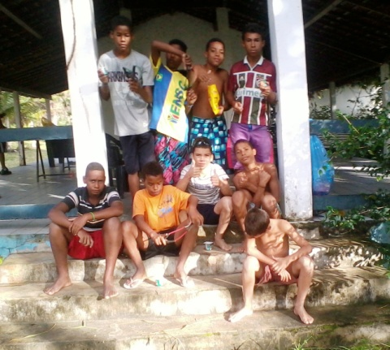

Boys at MFH July 2012.
Emerson, Genivaldo, Gabriel, Vitor, Mateus, Diogo, Daniel, Deybson and Jamerson.

Ian, Siméa, Tim, John and Hudson.
“ People were bringing little children to Jesus for him to place his hands on them, but the disciples rebuked them. ¹⁴ When Jesus saw this, he was indignant. He said to them, “Let the little children come to me, and do not hinder them, for the kingdom of God belongs to such as these. ¹⁵ Truly I tell you, anyone who will not receive the kingdom of God like a little child will never enter it.” ¹⁶ And he took the children in his arms, placed his hands on them and blessed them.” Mark 10 v 13-16

