Bishop Mike Chapman consecration - September 18, 2010
frianm | September 20, 2010 at 7:13 am |

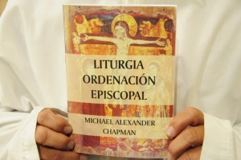

Ordenación del nuevo Obispo Sufragáneo

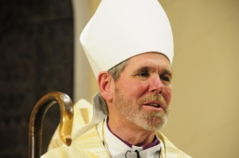

Monseñor Michael Chapman

La primera ordenación de un Obispo Sufragáneo (Asistente) de la Iglesia Anglicana en el Perú.

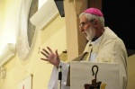On Saturday evening Bishop Mike Chapman was consecrated suffragan missionary bishop of Peru. In a stirring address our diocesan, Bishop Bill Godfrey spoke of how Apostolic it was to send out a missionary bishop. This was the way of the apostles. It is the way of the missionary Church. He recalled an African province where recently nine missionary bishops were consecrated. Their bicycles were awaiting them at the door so that they could evangelize the areas to which they were commissioned.

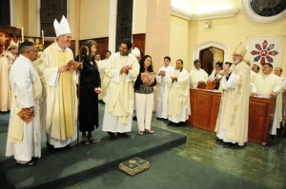
Bishop Miguel and his team
Monseñor Miguel, as he will be known, is sent with a strong team of priest, deacon and lay ministers to continue to develop and to open up for Christ the Ayacucho/Ica/Huancavelica area of south central Peru. Ministry there began in 2007 following the devastating Ica earthquake when the Anglican Church brought in relief workers, food and God's love in very practical ways. From this beginning new congregations have been founded.
Please pray for Bishop Chapman and his team. This is a thrilling new initiative here in Peru where God is powerfully at work. It is a privilege to be part of what God is doing here. Glory be to God in the highest.
Chapman consecration This is a powerpoint presentation of highlights of the service - click to load (this may take some time - please be patient!)

